



Computer Graphics

Computer Graphics is a field extensively used in gaming, film, and a variety of other applications. Even the text you are currently reading is presented through a computer graphics algorithm executed by the GPU and displayed on your screen. Modern video games and movies rely heavily on computer graphics. This includes the realistic illumination and reflection on wet surfaces, the motion blur in racing games, and the creation of enormous procedurally generated armies in epic films.

Moreover, computer graphics also encompass computer-generated art, CAD software in engineering, data visualization, and simulations.

Introduction

Since computers function based on mathematical principles, we must define our graphics in mathematical terms. There are several levels of computer graphics software and APIs. At the most fundamental level, we have machine commands executed by the GPU. These commands vary between GPU manufacturers, and programming at this level is very time-consuming, which is why it is rarely done. Middleware such as WebGL, OpenGL, and DirectX are used to expose and wrap these graphics-related calls. There are even more advanced libraries built on top of these middleware APIs. Higher-level libraries simplify the use of specific algorithms and methods that the GPU itself cannot handle directly. For instance, in a scene with a cube and a light source, the GPU cannot inherently calculate the light intensities on the cube. Therefore, APIs like OpenGL do not handle such calculations. Higher-level libraries like THREE.js provide common methods for these tasks, so programmers do not need to rewrite frequently used methods.

We can also consider the highest levels of 3D modeling software and game engines. These tools typically include a renderer that knows which algorithms to execute when instructing the GPU to render specific elements. Given the multitude of algorithms, there are numerous parameters and methods to utilize, all depending on your input data (assets).

Technologies

There are various methods to program graphics on a computer. As previously mentioned, different layers can utilize underlying graphics algorithms. For example, when a Java application is instructed to draw a button, it will eventually communicate with the GPU to render the different colors and borders. Even text is transformed into lines and curves, which are then converted into pixels on the screen.

In this course, we will explore two approaches in distinct environments.

C++ Program

Many computation-intensive applications use C++ for critical components because it compiles into machine code and undergoes extensive optimization. Although C++ may not be the simplest or quickest language to implement, it offers imperative and object-oriented features. This makes it easier to follow the code execution of a C++ program if you are familiar with another imperative language. As a general-purpose language, C++ allows for a wide range of applications.

For 2D graphics, we will use the Allegro game development library. Given the importance of graphics in games, Allegro comes equipped with various features that facilitate the implementation of graphic algorithms.

For 3D graphics, OpenGL is our middleware of choice due to its active use, ongoing development, popularity, and extensive documentation.

JavaScript Program

In some scenarios, it may be more beneficial to render graphics on a web page. This approach has gained popularity recently with the rise of WebGL. Initially, JavaScript was designed to create more dynamic web pages without constant server interaction. Alongside HTML, servers provided JavaScript code that modified the web page based on user activity. Eventually, there was a need to render images on the client side using data from the server or the client itself. Various methods were attempted, but HTML5 ultimately introduced a standardized canvas element for this purpose. Although HTML5 was officially released on October 28, 2014, major browsers had implemented its features well before that date.

We can create 2D graphics by directly drawing on the canvas element using JavaScript.

For 3D graphics, we can use WebGL, which is based on OpenGL ES 2.0 (Embedded Systems). Additionally, the THREE.js library, built on top of WebGL, offers higher-level functionality..

Related Math

We will introduce most of the relevant mathematical concepts as they become necessary. Computer graphics draw upon principles from geometry, linear algebra, calculus, and other fields, making this a great opportunity to refresh your knowledge in these areas.

To start, let's recall vector spaces. A primary example is the Euclidean space with Cartesian coordinates, which you likely encountered in high school. This involves drawing a coordinate system with x and y axes, an origin point, and evenly spaced numbers along the axes. A point on this system is represented by its x and y coordinates.

This setup forms a vector space with basis vectors e0 = (1, 0) and e1 = (0, 1). The coordinates of our points define a linear combination of these vectors. For instance, point A with coordinates (2, 1) is defined by 2 * e0 + 1 * e1.

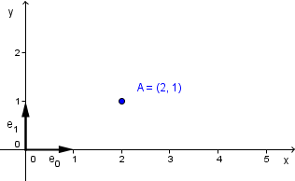

You might wonder if such a linear combination results in a vector, even though we referred to A as a point. Indeed, the terms "vector" and "point" can be confusing. In a vector space, elements are sometimes called vectors because they can be defined by a series of coordinates, resulting in a vector with specific coordinates.

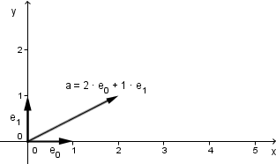

Thus, point A is essentially another vector, often called a location or position vector, indicating its position in space. However, when depicting multiple elements, drawing them as points is more practical and less cluttered than using vectors originating from the origin.

Vectors are not merely aesthetic equivalents of points. In geometry, vectors typically refer to direction vectors, which indicate direction rather than position. These vectors can be thought of as elements from a different vector space with the same basis vectors but without a fixed origin. Direction vectors are omnipresent and can be represented by their coordinates relative to the basis, indicating direction rather than position. For example, a vector (2, 1) might represent light shining from the southwest.

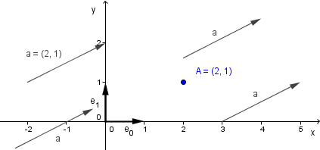

To define a square, we need four points as vertices. However, the computer only recognizes these as distinct locations without understanding their significance. To form the square, we must connect these points. For instance, the bottom edge of the square would start at point A and end at point B, including all points in between.

Using the basis vectors, we can represent any element in the space through a linear combination. To represent the bottom edge, we can use a convex combination of points A and B:

edge = coefficient * A + (1 - coefficient) * B

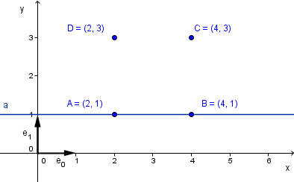

By restricting the coefficient to the range [0, 1], we obtain the segment between points A and B, satisfying two properties: non-negative coefficients and a sum of coefficients equal to 1. This is known as a convex combination.

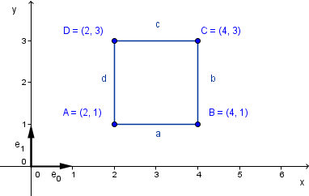

We can apply the same formula to other segments, such as B to C, C to D, and D to A. To fill the square, we use a convex combination of all four points:

square = coef1 * A + coef2 * B + coef3 * C + coef4 * D

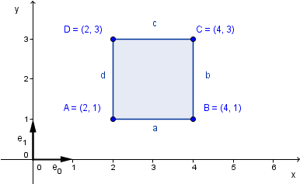

This formula, with coefficients satisfying the convex combination properties, represents the entire filled square, also known as the convex hull of the four points.

These concepts will be useful as we proceed, especially when interpolating values between points. Remember that vectors and points, though represented similarly, have different meanings. Later, we will see how these representations change based on properties unique to vectors and points. For instance, we might want to move a point but not a vector, which we will achieve through specific operations.

Introduction to Geometry

Geometry plays a crucial role in computer graphics. As previously mentioned, computers excel at performing mathematical operations. Geometry, a branch of mathematics, enables us to describe the physical layout of our everyday world. We can represent this layout in three spatial dimensions, typically denoted as x, y, and z. Additionally, we can describe certain aspects in two spatial dimensions. For instance, two-dimensional space can represent a drawing on paper or a photograph. While this is somewhat accurate, these mediums also contain additional information such as lines in the drawing or color values in the photo. When discussing geometry alone, we focus solely on geometric concepts like points, lines, and polygons. A cube in 3D can be represented as a square in 2D, depending on the orientation and the projection method used to transition from 3D to 2D.

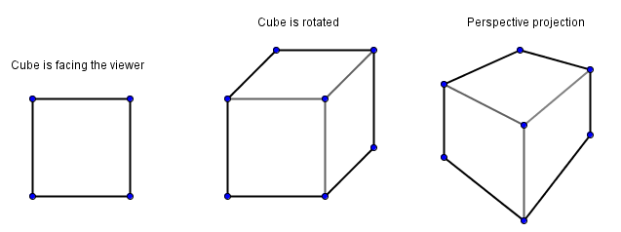

In the introductory chapter, we discussed how to construct a geometrical space. This requires an origin point and vectors that serve as the basis. For a 2D space, we use two basis vectors; for a 3D space, we use three basis vectors. All points within that space are represented through a linear combination of these basis vectors.

In a constructed Euclidean space, distinguishing between points and vectors can become cumbersome. The concept of homogeneous coordinates addresses this by extending our space by one dimension. If the value in this extra dimension is 0, we are dealing with a vector. Any non-zero value in the extra dimension indicates a point in the original space. We will revisit this concept later. The key takeaway is that both points and vectors can be represented in a higher-dimensional space using homogeneous coordinates.

Definitions

**Point** – A set of values that denotes a location in a space. Example: (1, 1), in homogeneous coordinates (1, 1, 1).

**Vector** – A set of values that denotes a direction in a space. Example: (1, 1), in homogeneous coordinates (1, 1, 0).

**Orthogonal Vectors** – Perpendicular vectors, where the angle between them is 90°.

**Line** – A set of points that satisfy a linear equation of two variables. Example: x + y = 2.

**Line Segment** – A part of a line that is bounded by two distinct points.

**Plane** – A set of points that satisfy a linear equation of three variables. Example: x + y + z = 2.

**Dot Product** – Also called scalar product and inner product. Defined as:

v · u = |v| · |u| · cos(θ)

where θ is the angle between vectors v and u.

---

Transforming Geometric Shapes

We can define a coordinate system and a set of points within it. Depending on the order of these points, we can create various polygons and objects. Larger polygons can be represented as a set of triangles, which can be defined as a list of triangles, a triangle strip, or a triangle fan.

What if we want to change the locations of some points? For example, if some objects we defined are rotating around another point or changing their size?

Imagine we have defined an approximation of a sphere to represent a bubble. Not all bubbles are the same size. We would want to reuse our defined geometry for many bubbles of different sizes.

For simplicity, let's see how to change the size of a 2-dimensional triangle. The same principles apply to 3-dimensional geometry and more complex shapes, but it is easier to visualize in 2D.

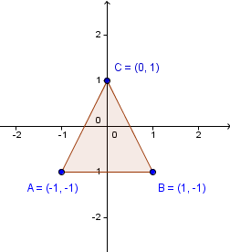

So, we have a triangle with vertices (-1, -1), (1, -1), (0, 1). Notice that there is a kind of center point (not any of the traditional centers) of the triangle at the origin. To make the triangle bigger, we stretch it with the origin as a fixed point. Since this transformation maps our space onto itself (we are not creating or losing space), there will always be at least one fixed point. This means that the point (0, 0) will remain the same if we stretch the triangle.

How do we stretch it? If we try to draw a triangle twice as big, we might wonder whether we want the area to be twice as large, the lengths of the edges to be twice as long, or the coordinate values to represent twice the size.

It turns out that it is easier and more uniform to simply double the coordinate values. The coordinate value 1 will become 2, and the coordinate value -1 will become -2. The coordinate value 0 will remain unchanged.

So, we can multiply all the coordinate values by 2 to get a triangle that is, in some sense, twice as big.

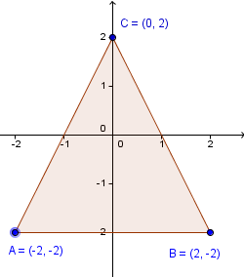

Here, we multiplied both the x and y coordinates of each point by 2. Our algorithm would go through all the points we have sent to the GPU and multiply the coordinates.

Sometimes, we might want to multiply only the x coordinate and keep the y coordinate the same. We might also have different non-unit coefficients for both coordinates. Or we might want to add to the x coordinate some multiple of the y coordinate value.

This seems like a lot of requirements. Some readers might have already guessed that a general way to represent these kinds of transformations is with a matrix. Applying the transformation involves multiplying the specific point by a concrete matrix.

Our previous example would look like this:

[ 2 0 ] [ x ] [ 2x + 0y ] [ 2x ]

[ 0 2 ] * [ y ] = [ 0x + 2y ] = [ 2y ]

As you can see, when we apply such a matrix to all the points, we will have transformed our objects. This is the purpose of the vertex shader in the GPU. It will process all the vertices in parallel and apply a number of matrices to them.

There are other ways to think about transformations. For example, you can achieve the same shape if you keep the coordinates the same but consider the basis vectors to be twice as large (represented as (2, 0) and (0, 2) in the original coordinate system).

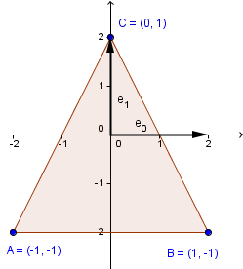

You might also notice that this is exactly what we have in the columns of our transformation matrix. To understand what a transformation does, you can look at the columns of the transformation matrix to see how a new basis would look.

---

Definitions

**Vertex Shader** – Code that is executed in parallel for each of the vertices.

**Transformation Matrix** – A matrix that holds a specific transformation of the geometry.

**Column Major Format** – A convention to hold the space elements (points, vectors) as algebraic column vectors. This allows multiplication with a transformation matrix from the left.

**Row Major Format** – A convention to hold the space elements (points, vectors) as algebraic row vectors. This allows multiplication with a transposed transformation matrix from the right.

Understood. I'll ensure the text and equations are formatted in a way that should work well when pasted into a Word document.

---

Linear Transformations

There is a concept of linearity in various transformations. As you might recall from previous studies, the linearity of a transformation is defined as:

T(α₀ · u₀ + α₁ · u₁) = α₀ · T(u₀) + α₁ · T(u₁)

where α₀ and α₁ are scalars, and u₀ and u₁ are elements of our space.

This definition indicates that the transformation is distributive over addition (additivity) and scalar multiplication (homogeneity of degree 1).

While this property alone may not seem particularly useful, it implies that every linear transformation can be represented as a transformation matrix. Additionally, all matrices with fixed scalars define linear transformations. We can also prove this with relative ease. Consider the following:

[ a b ] [ α₀ [ x₀ ] + α₁ [ x₁ ] ]

[ c d ] * [ [ y₀ ] [ y₁ ] ]

We will proceed without assuming the linearity of the transformation:

[ a b ] [ [ α₀ x₀ ] + [ α₁ x₁ ] ] [ a b ] [ α₀ x₀ + α₁ x₁ ]

[ c d ] * [ [ α₀ y₀ ] [ α₁ y₁ ] ] = [ c d ] * [ α₀ y₀ + α₁ y₁ ]

= [ a(α₀ x₀ + α₁ x₁) + b(α₀ y₀ + α₁ y₁) ]

[ c(α₀ x₀ + α₁ x₁) + d(α₀ y₀ + α₁ y₁) ]

Now we have applied the transformation and can use the distributive properties of scalar multiplication and addition:

= [ a α₀ x₀ + a α₁ x₁ + b α₀ y₀ + b α₁ y₁ ]

[ c α₀ x₀ + c α₁ x₁ + d α₀ y₀ + d α₁ y₁ ]

= [ α₀ (a x₀ + b y₀) + α₁ (a x₁ + b y₁) ]

[ α₀ (c x₀ + d y₀) + α₁ (c x₁ + d y₁) ]

We can see that this result is a vector-to-vector addition, and we can bring the scalars in front of the vectors:

= α₀ [ a x₀ + b y₀ ] + α₁ [ a x₁ + b y₁ ]

[ c x₀ + d y₀ ] [ c x₁ + d y₁ ]

The last step is to recognize that these vectors are the result of other vectors multiplied by a matrix:

α₀ [ a b ] [ x₀ ] + α₁ [ a b ] [ x₁ ]

[ c d ] * [ y₀ ] [ c d ] * [ y₁ ]

This demonstrates the linearity of a transformation.

Many transformations can be represented as linear transformations. We will explore some key examples next. However, there are some transformations in computer graphics that are not linear. We will examine these later and see how they can be represented.

SCALE

We previously explored a simple scaling example in the introduction, where we scaled both the x and y directions by a factor of 2.

In general, a scaling matrix is represented as:

```

[ scaleX 0 ]

[ 0 scaleY ]

```

It is applied as follows:

```

[ scaleX 0 ] [ x ] = [ scaleX * x ]

[ 0 scaleY ] * [ y ] [ scaleY * y ]

```

This operation multiplies the x and y coordinates by their respective scalar values. Notice that if both scaleX and scaleY are 1, the matrix becomes an identity matrix, resulting in an identity mapping that does not alter the coordinates.

Scalars in the range [0, 1) can be used to shrink the space. If both scaleX and scaleY are 0, the transformation will shrink everything to an infinitely small point, effectively losing all geometric information.

If scaleX or scaleY have negative values, the matrix will reflect the geometry across the corresponding coordinate axis.

You can experiment with this in the example on the right, which features a square with vertices (1, 1), (-1, 1), (-1, -1), and (1, -1). Although there is a 4x4 matrix shown, you can focus on the upper-left 2x2 part for scaling purposes.

Explanation

This JavaScript code dynamically scales a square element on a webpage based on user input from two sliders. Here's a detailed breakdown of how the code works:

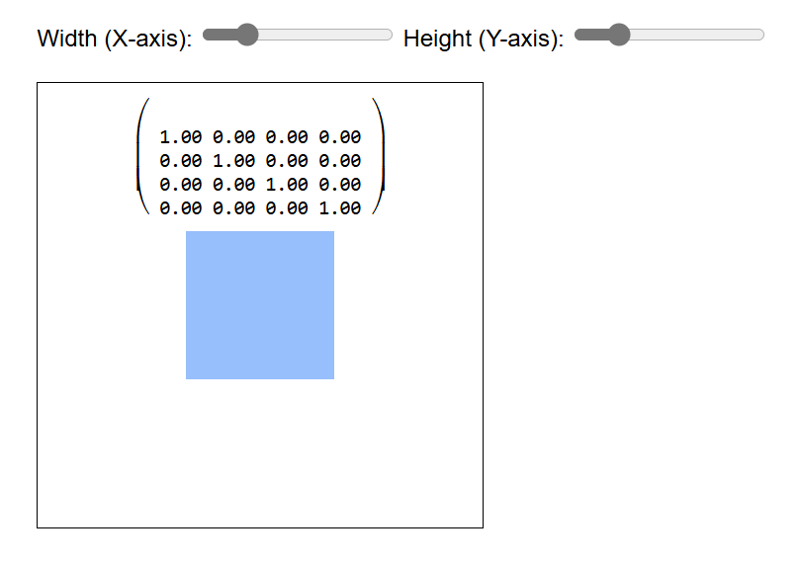

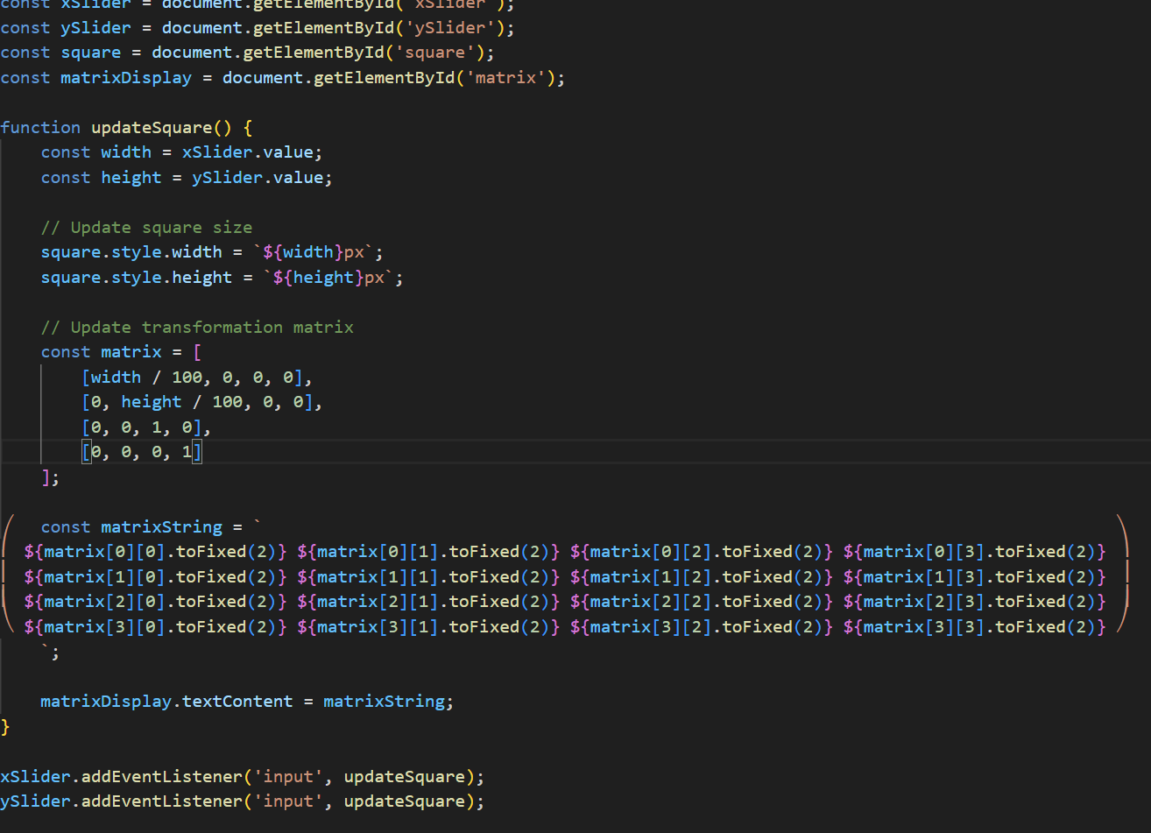

This code provides an interactive way to scale a square element on a webpage using two sliders. The transformation matrix is updated and displayed in real-time, allowing users to see the effect of their adjustments. The matrix representation helps in understanding how the scaling transformation is applied to the square

Rotation

Another fundamental transformation is rotation. Rotation involves turning around a point or a line. In 3D, rotation typically occurs around a specified line, such as the Earth's rotation around its axis. In 2D, rotation can be thought of as occurring around the origin, or alternatively, as rotation around the z-axis when viewing the 2D plane as the xy-plane in 3D.

The basic way to define a rotation, given a coordinate system, is around one of its axes. Rotation around an arbitrary line involves first aligning that line with one of the axes, then rotating around that axis, and finally reversing the initial alignment. Another method for defining rotation around an arbitrary axis is through the use of quaternions.

Here, we will construct a rotation transformation matrix in 2D around the origin (or the imagined z-axis). We can derive this matrix by considering the properties we want in a rotation and using trigonometric identities. This derivation is covered in the learning materials of the Computer Graphics Seminar course.

For now, let's use the fact that the columns of the transformation matrix represent the transformed basis vectors. Initially, we have basis vectors \( e_0 = (1, 0) \) and \( e_1 = (0, 1) \). With rotation around the origin, we want to preserve the length of these vectors and maintain a 90-degree angle between them. The following image illustrates this concept.

As shown, the transformed basis vectors are \( (a, b) \) and \( (a', b') \). To determine the values of \( a, b, a', \) and \( b' \), we can use the Pythagorean theorem:

```

cos(α) = a / |e'_0| = a / 1 = a

sin(α) = b / |e'_0| = b / 1 = b

cos(α) = b' / |e'_1| = b'

sin(α) = -a' / |e'_1| = -a'

```

Since the basis vectors are normalized, their length is 1. Notice that \( a' \) is represented by \( -sin(α) \).

Thus, \( e'_0 = (cos(α), sin(α)) \) and \( e'_1 = (-sin(α), cos(α)) \).

Using these values as the columns of the transformation matrix, we obtain the rotation transformation matrix:

```

[ cos(α) -sin(α) ]

[ sin(α) cos(α) ]

```

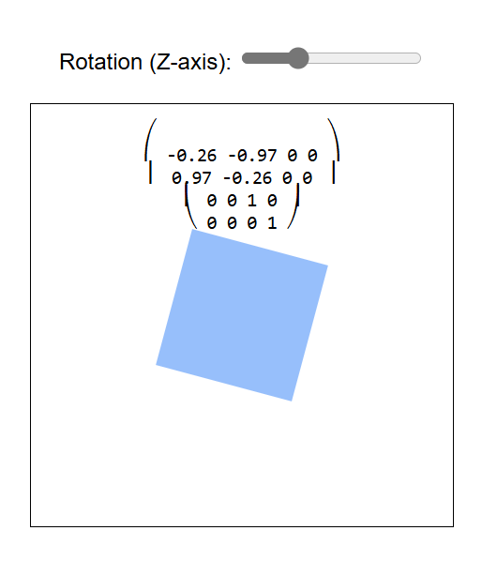

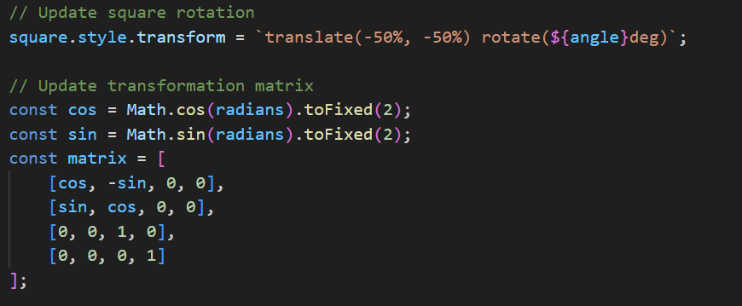

This code effectively allows the z-slider to control the rotation of the square element, updating both the visual rotation and the

corresponding transformation matrix in real-time.

Shear

There is one more linear transformation that might initially seem quite mysterious. We will see later how something quite useful is derived using this transformation. For now, let us define shear with the following matrices:

**Shear x**:

```

[ 1 tan(ϕ) ]

[ 0 1 ]

```

**Shear y**:

```

[ 1 0 ]

[ tan(ϕ) 1 ]

```

Similar to the rotation transformation, the value of ϕ should be fixed for a specific transform.

Shear transformation essentially tilts one of the axes. For example, if tan(ϕ) = 1 and we are using shear x, then the y coordinates of all points are shifted by the value of their x coordinates. You can test this out in the example on the right.

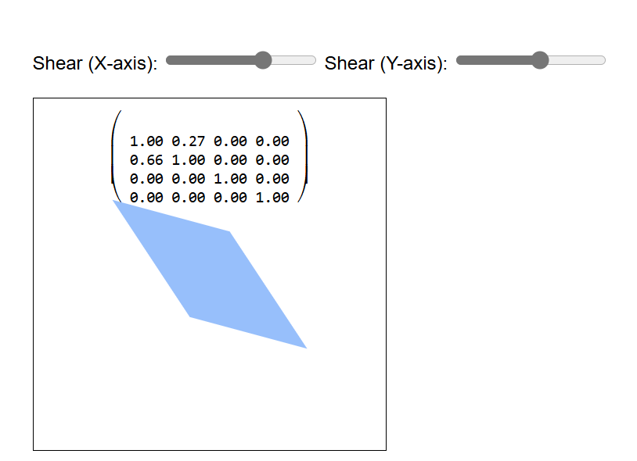

Translation

This is where homogeneous coordinates and the shear operation come together to allow for translation and thus affine transformations. It is important to note that an affine transformation may not be linear anymore, meaning it does not satisfy the linearity property. This will become clearer when we look at one way to construct the translation.

For this construction, imagine a very simple 1D world where everything is located at a \( y = 1 \) line:

All of those objects have a single coordinate in their 1D world:

```

John = (2)

Jane = (5)

Jerome = (6)

```

We could apply a scaling linear transformation to it if we wanted. This would be identical to scalar multiplication because our transformation matrix would be of size 1×1.

However, we can view this world in a higher dimension, the 2D space. In that higher space, the coordinates would be:

```

John = (2, 1)

Jane = (5, 1)

Jerome = (6, 1)

```

This resembles homogeneous coordinates that we discussed earlier, and indeed it is just that. In this higher space, we could also perform some transformations. As you might notice, rotation and scaling will generally move our objects out of the 1D world located at \( y = 1 \). But we could try the shear-y operation, which will keep the y coordinates the same but tilt the y-axis, thus changing the x coordinates.

We will perform the shear-y with 45°, because \( \tan(45°) = 1 \).

As you can see, all our points have moved 1 unit to the right (positive x direction). The general matrix for the shear-y would be:

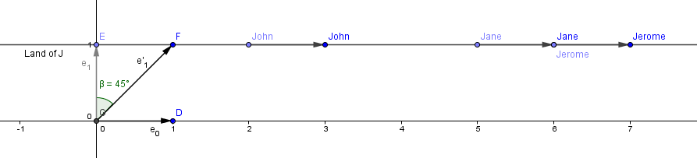

```

[ 1 shearY ]

[ 0 1 ] [ x ] = [ x + 1 * shearY ]

[ 1 ] [ 1 ]

```

This is exactly what we want. We want to add a coordinate-independent scalar value to the corresponding coordinate of each of our points.

Next, we do not have to care about the exact angle we use for the shear. We can just put our desired translation value in the corresponding position. For higher dimensions, the construction is the same. We will go to one dimension higher space and perform the corresponding shear operation there.

4x4 Translation Matrix

The letters \( a, b, \ldots, i \) represent the linear transformation part; the last column is called the translation column, and the last row should always be \( (0, 0, 0, 1) \). Later, we will see that some of the values in the last row can be used for a perspective projection transformation, but for usual affine transformations, you should not change it.

Consider the example on the right. I have positioned the vertices to be at coordinates \( (1, 1, 1) \), \( (-1, 1, 1) \), \( (-1, -1, 1) \), \( (1, -1, 1) \). So we have a 2D world located at the \( z = 1 \) plane in 3D space. To perform the shear-z operation in 3D, we need two values: how much shear in the x direction and how much in the y direction. These two values are in the translation column.

As you might have guessed by now, the reason for a 4×4 matrix is that in 3D space, if we want to perform the translation, we need to go to a 4D space and shear there.

```

⎛ a b c translateX ⎞

⎜ d e f translateY ⎟

⎜ g h i translateZ ⎟

⎝ 0 0 0 1 ⎠

```

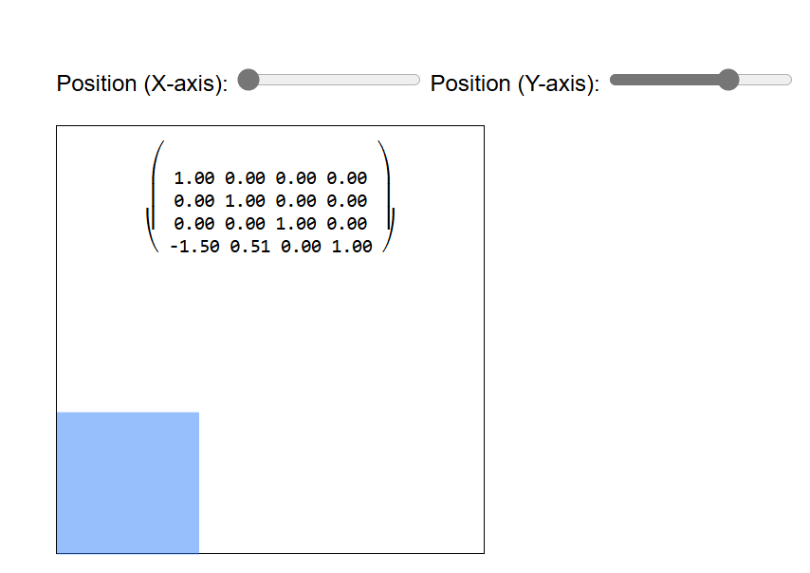

Multiple Transformations

A natural question arises here: how can we perform multiple transformations? For example, if we want to rotate our object and then translate it, or perhaps translate it and then rotate it. Will there even be a difference?

One can figure out that we can construct multiple transformation matrices and then apply them sequentially: using the next one on the results of the current one. Note that matrix multiplication is associative, and we can regard our column-vectors as matrices with width 1. Because of that, we could multiply our transformations together and then perform only one matrix-vector multiplication for each of our vertices.

In other words, suppose we have transformation matrices \( T_1 \), \( T_2 \), and \( T_3 \). Our vector will be \( v \) - remember that this transformation will be applied to all of the vertices you have sent to the GPU in the vertex shader.

```

T_1(T_2(T_3 \cdot v)) = (T_1 \cdot T_2 \cdot T_3) \cdot v

```

As you can see, we can multiply the transformations together once before transforming any of the vertices. After that, we can perform just one matrix-vector multiplication in the shader. Instead of sending 3 (or more) transformation matrices and performing a number of matrix-matrix multiplications for all of the vertices.

In other words:

```

T = T_1 \cdot T_2 \cdot T_3

```

Send the matrix \( T \) and our vertex set \( V \) to the vertex shader. Let \( v \in V \). In the vertex shader, for each \( v \), we only perform:

```

T \cdot v

```

However, as you know, matrix multiplication is not commutative. This means that the order in which we apply the transformations generally makes a difference. There is a different result depending on whether we say that \( T = T_1 \cdot T_2 \cdot T_3 \) or \( T = T_3 \cdot T_2 \cdot T_1 \).

A simple example would be to perform rotation and translation. Let us rotate 90° around the z-axis and translate by a vector \( (1, 2, 0) \).

```

⎛ 0 -1 0 0 ⎞ ⎛ 1 0 0 1 ⎞ ⎛ x ⎞ ⎛ -y - 2 ⎞

⎜ 1 0 0 0 ⎟ ⋅ ⎜ 0 1 0 2 ⎟ ⋅ ⎜ y ⎟ = ⎜ x + 1 ⎟

⎜ 0 0 1 0 ⎟ ⎜ 0 0 1 0 ⎟ ⎜ z ⎟ ⎜ z ⎟

⎝ 0 0 0 1 ⎠ ⎝ 0 0 0 1 ⎠ ⎝ 1 ⎠ ⎝ 1 ⎠

```

If we apply the transformations the other way:

```

⎛ 1 0 0 1 ⎞ ⎛ 0 -1 0 0 ⎞ ⎛ x ⎞ ⎛ -y + 1 ⎞

⎜ 0 1 0 2 ⎟ ⋅ ⎜ 1 0 0 0 ⎟ ⋅ ⎜ y ⎟ = ⎜ x + 2 ⎟

⎜ 0 0 1 0 ⎟ ⎜ 0 0 1 0 ⎟ ⎜ z ⎟ ⎜ z ⎟

⎝ 0 0 0 1 ⎠ ⎝ 0 0 0 1 ⎠ ⎝ 1 ⎠ ⎝ 1 ⎠

Multiple Transformations

As you can see, the rotation will rotate our geometry to be the same in both cases, but the actual translation will take the object to different places. You can think about two scenarios:

1. First rotating the geometry in place and then translating it.

2. First translating the geometry to a new location and then rotating it.

You can try it out in the example on the right. Try choosing a different order for the translation and rotation. Then change the translation values (for x and y) and the \( \alpha \) for the rotation angle.

Keep in mind that the transformations are applied from right to left. The matrix near the vertex is applied first. So if the rotation matrix is the right-most, then the vertices are first rotated and then translated. If the translation matrix is the right-most, then the vertices are first translated and then rotated (around the origin).

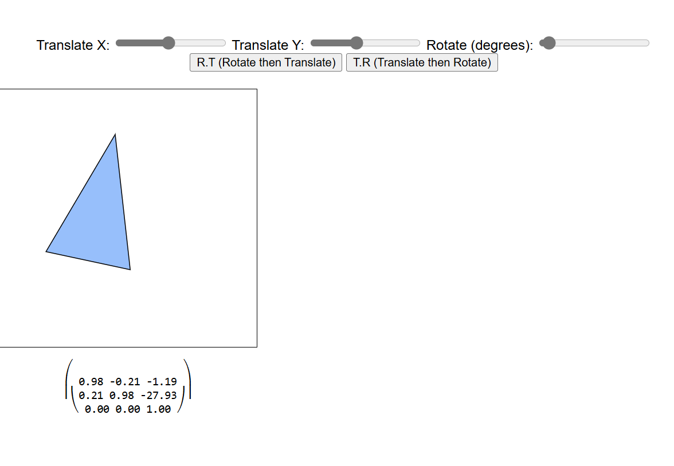

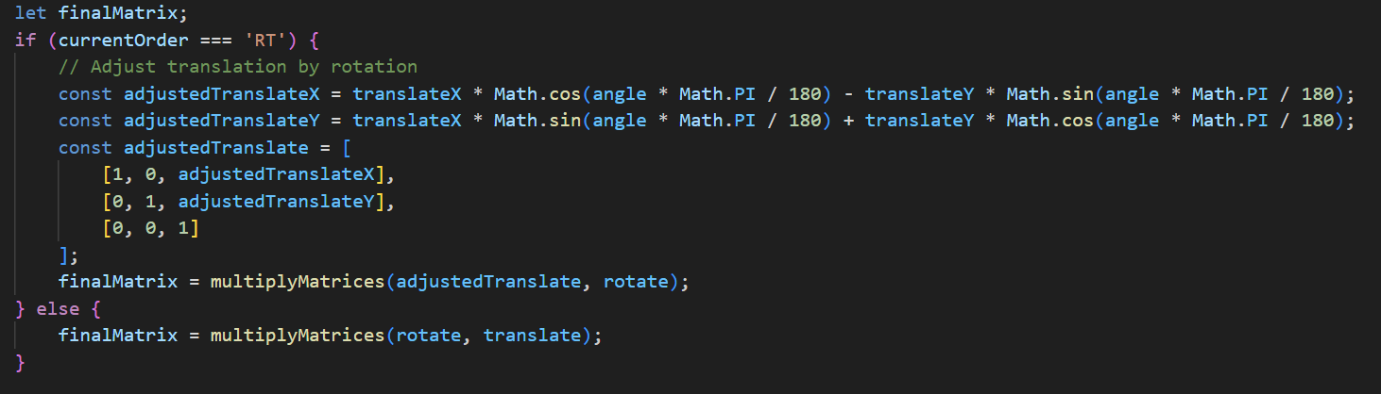

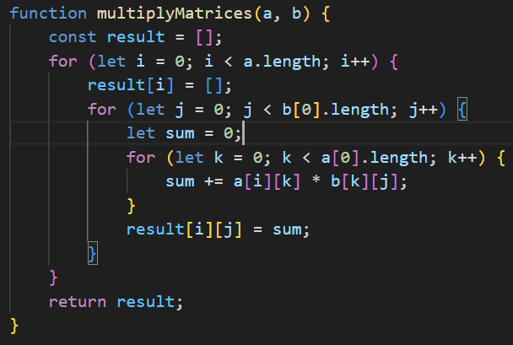

Matrix Stack

Besides applying multiple transformations to a single object, we might also have multiple objects in our scene with different transformations. There might be dependencies between the transformations of some objects. For example, what if we have triangles that should rotate around another triangle?

In the next chapter, we will explore more about frames of reference, but the idea is that there are actually many coordinate systems. As you might have seen from the previous example, if we perform the rotation before the translation, the rotation occurs around the initial origin. If we change the rotation, then the triangle rotates around a different point in the result. Technically, the rotation still occurs around the initial origin, and the object is then translated. However, mathematically, you can also think that we have first shifted the d then rotated around another origin (\( O' \)). So, the moved triangle actually has a different frame of reference (coordinate system).

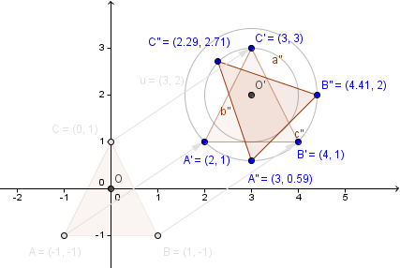

Consider the example on the right. We have a big triangle and two smaller ones. There is a notion of a scene graph that defines the smaller triangles to be children of the first one. When parsing the scene graph, we want to save our intermediary matrices because we need to come back to them after a branch has been parsed.

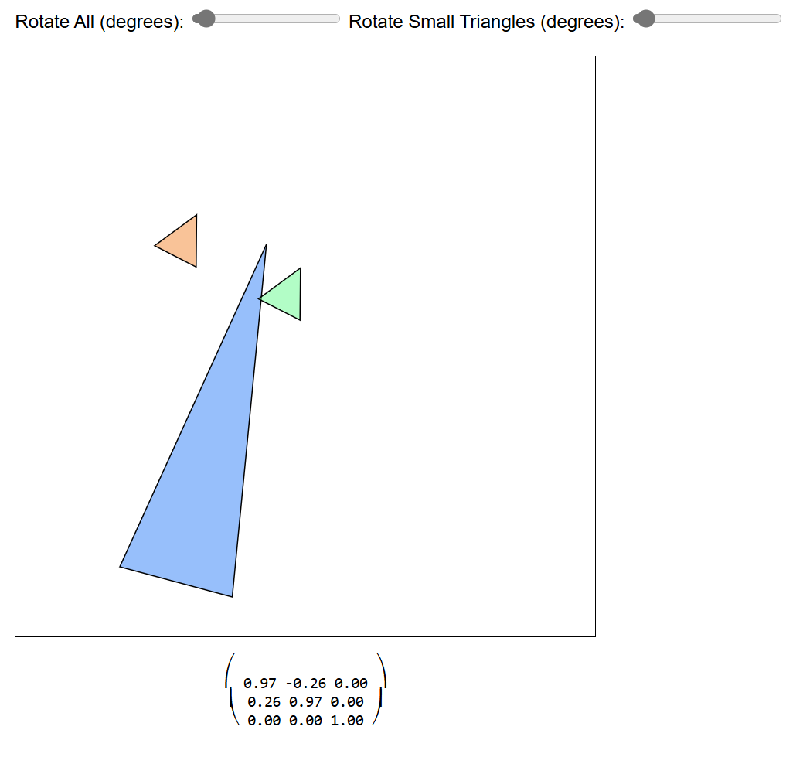

Gimbal Lock

The gimbal lock problem can occur when you have defined the rotation of an object using Euler angles. These three rotation values need to be applied in a specific order. For example, if the order is defined as XYZ, then the rotation is defined as:

1. Rotate around the X axis.

2. Rotate around the transformed Y axis (rotated by step 1).

3. Rotate around the transformed Z axis (rotated by steps 1 and 2).

This is because the rotation will be applied in the space you are currently in. After step 1, you have already changed the space. If you happen to rotate exactly 90° around the Y axis in step 2, then the Z axis will be aligned with the original X axis, and you will have lost a degree of freedom.

The example on the right shows exactly that. You can choose the order of your Euler angles, which define the rotation of the object, and then press Lock to align the first and third axes.

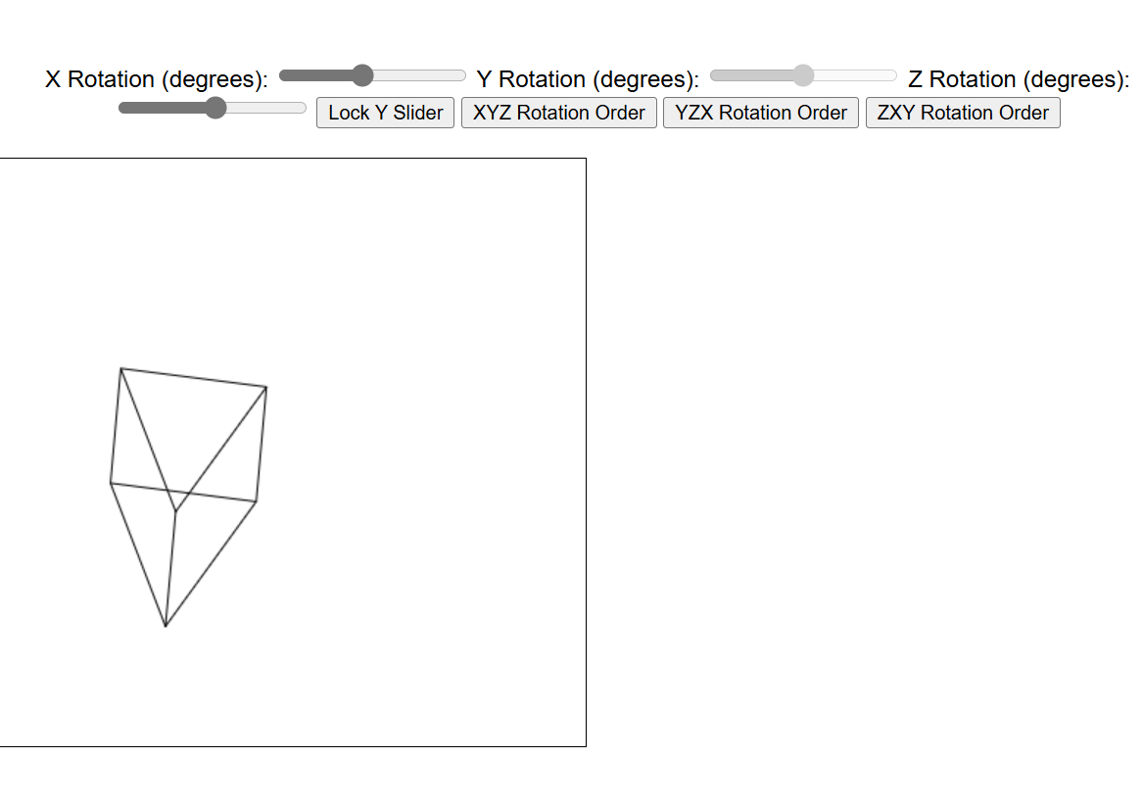

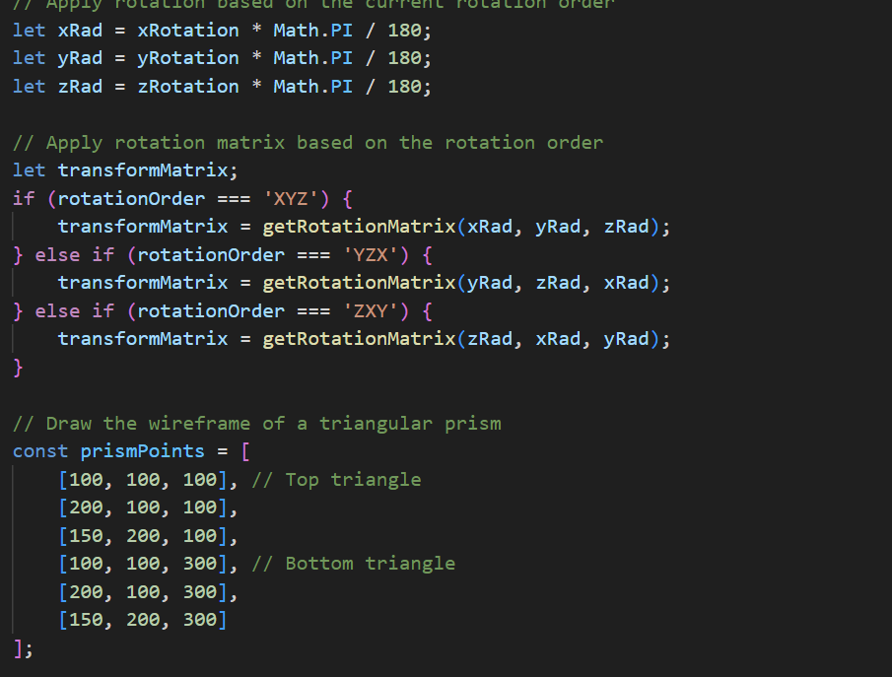

Axis-Angle (Rodrigues' Rotation Formula)

Rodrigues' Rotation Formula is used to rotate a vector in 3D space around a specified axis by a given angle. The formula is particularly useful for implementing rotations in computer graphics.

Given:

- A vector \( v \) to be rotated.

- An axis of rotation \( k \) (a unit vector).

- An angle of rotation \( \theta \).

The rotated vector \( v' \) is given by:

\[ v' = v \cos(\theta) + (k \times v) \sin(\theta) + k (k \cdot v) (1 - \cos(\theta)) \]

Where:

- \( k \times v \) is the cross product of \( k \) and \( v \).

- \( k \cdot v \) is the dot product of \( k \) and \( v \).

In the code:

- The axis of rotation is set to the Z-axis: `new THREE.Vector3(0, 0, 1)`.

- The angle is controlled by the `alphaSlider`.

- The `setRotationFromAxisAngle` method in Three.js applies Rodrigues' Rotation Formula to rotate the triangle.

Summary

This code allows you to animate a triangle by rotating it around the Z-axis using an alpha slider. The rotation is implemented using the Axis-Angle method, specifically Rodrigues' Rotation Formula, which ensures smooth and accurate rotation based on the specified angle.

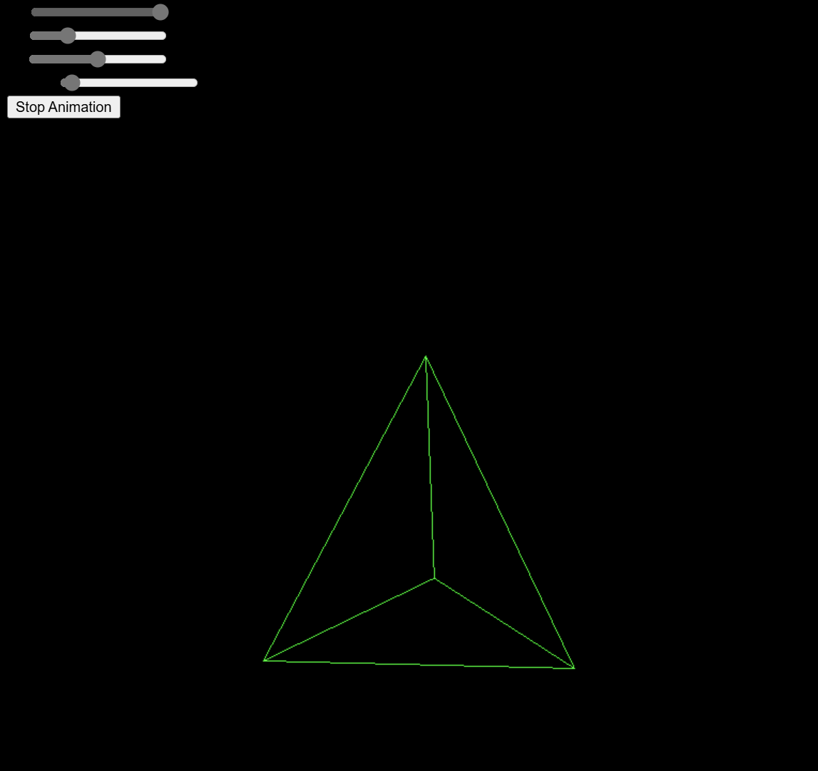

Projections

There are several steps involved when transforming our 3D space to a 2D screen. Essentially, three things need to happen:

1. **View Transformation**: Represent our coordinates in the camera basis.

2. **Convert Clip Space to Canonical View Volume**.

3. **Project the Canonical View Volume to the Screen or Viewport of Specific Dimensions**: This is known as the viewport transformation.

There is actually an intermediary step between steps 2 and 3 – the perspective division. This step converts our homogeneous coordinates back to points. Coordinates in the form \( (x, y, z) \), where \( x = \frac{x_{hom}}{w} \), \( y = \frac{y_{hom}}{w} \), and \( z = \frac{z_{hom}}{w} \), are called normalized device coordinates at this stage. The perspective division, as the name suggests, is essential for the perspective projection.

The view transformation depends only on the camera. The viewport transformation depends on the size of our viewport (e.g., screen). The place where we determine what kind of projection we are actually performing is in defining the clip space. Note that from the computer's point of view, there is a matrix that performs the described conversion: it converts a frustum, parallelepiped, or cuboid into a cube \([-1, 1]^3\).

There are three main projections that are commonly used: orthographic, oblique, and perspective projections.

Orthographic Projection

This is the simplest projection that uses another cube as the clip space. This cube is defined by six planes: \( x = \text{left} \), \( x = \text{right} \), \( y = \text{bottom} \), \( y = \text{top} \), \( z = \text{near} \), \( z = \text{far} \). The projection matrix needs to transform that area into the clip space. There is no requirement that the planes are symmetric, e.g., \( \text{left} = -\text{right} \). The projection matrix must take that into account.

To transform the x coordinate into the canonical view volume, we have \( x \in [\text{left}, \text{right}] \). First, we want to scale that range to be of length 2. So our matrix will perform the scaling first. We scale by a value that first creates a range of unit length (divides by the length of the previous range) and then multiplies that by 2.

\[

\begin{pmatrix}

\frac{2}{\text{right} - \text{left}} & 0 & 0 & 0 \\

0 & 0 & 0 & 0 \\

0 & 0 & 0 & 0 \\

0 & 0 & 0 & 1

\end{pmatrix}

\]

Notice that this is the same thing that we also need to do with y and z coordinates. With the latter, the \(\text{near}\) actually has a bigger value than \(\text{far}\), because the z-axis is inverted.

\[

\begin{pmatrix}

\frac{2}{\text{right} - \text{left}} & 0 & 0 & 0 \\

0 & \frac{2}{\text{top} - \text{bottom}} & 0 & 0 \\

0 & 0 & \frac{2}{\text{near} - \text{far}} & 0 \\

0 & 0 & 0 & 1

\end{pmatrix}

\]

Now we have scaled everything to be of the correct length, but we might be positioned wrongly. Next, we need to translate it so that the midpoint would be mapped to 0 in our scaled system. The midpoint of the range \([\text{left}, \text{right}]\) would be \(\frac{\text{left} + \text{right}}{2}\). Because we have already scaled our world, we also need to scale this midpoint first. So we will multiply it with our scale factor:

\[

\frac{\text{left} + \text{right}}{2} \cdot \frac{2}{\text{right} - \text{left}} = \frac{\text{right} + \text{left}}{\text{right} - \text{left}}

\]

This is the distance we need to translate (in the opposite direction) for the midpoint of the current space to be at 0 of the target space. Because our range is of length 2, then \(\text{left} \rightarrow -1\) and \(\text{right} \rightarrow 1\).

\[

\begin{pmatrix}

\frac{2}{\text{right} - \text{left}} & 0 & 0 & -\frac{\text{right} + \text{left}}{\text{right} - \text{left}} \\

0 & \frac{2}{\text{top} - \text{bottom}} & 0 & -\frac{\text{top} + \text{bottom}}{\text{top} - \text{bottom}} \\

0 & 0 & \frac{2}{\text{near} - \text{far}} & -\frac{\text{near} + \text{far}}{\text{near} - \text{far}} \\

0 & 0 & 0 & 1

\end{pmatrix}

\]

This is the same result you would get if you first translated the midpoint and then scaled. In that case, you would have to multiply the matrices together, and the resulting matrix is the same as we just derived.

Depending on how one chooses the clip planes, orthographic projection transforms a cube or a parallelogram into a cube. Objects further away from the camera are the same size as those closer. As you can see from the example below, a projected cube has both the face near the camera and the one in the back projected to the same coordinates.

Sometimes one might also want to add a zoom capability to this projection. If the planes are symmetric, then the zoom can just be a factor that divides the plane values. This will make the clipping box smaller and thus the projected objects larger.

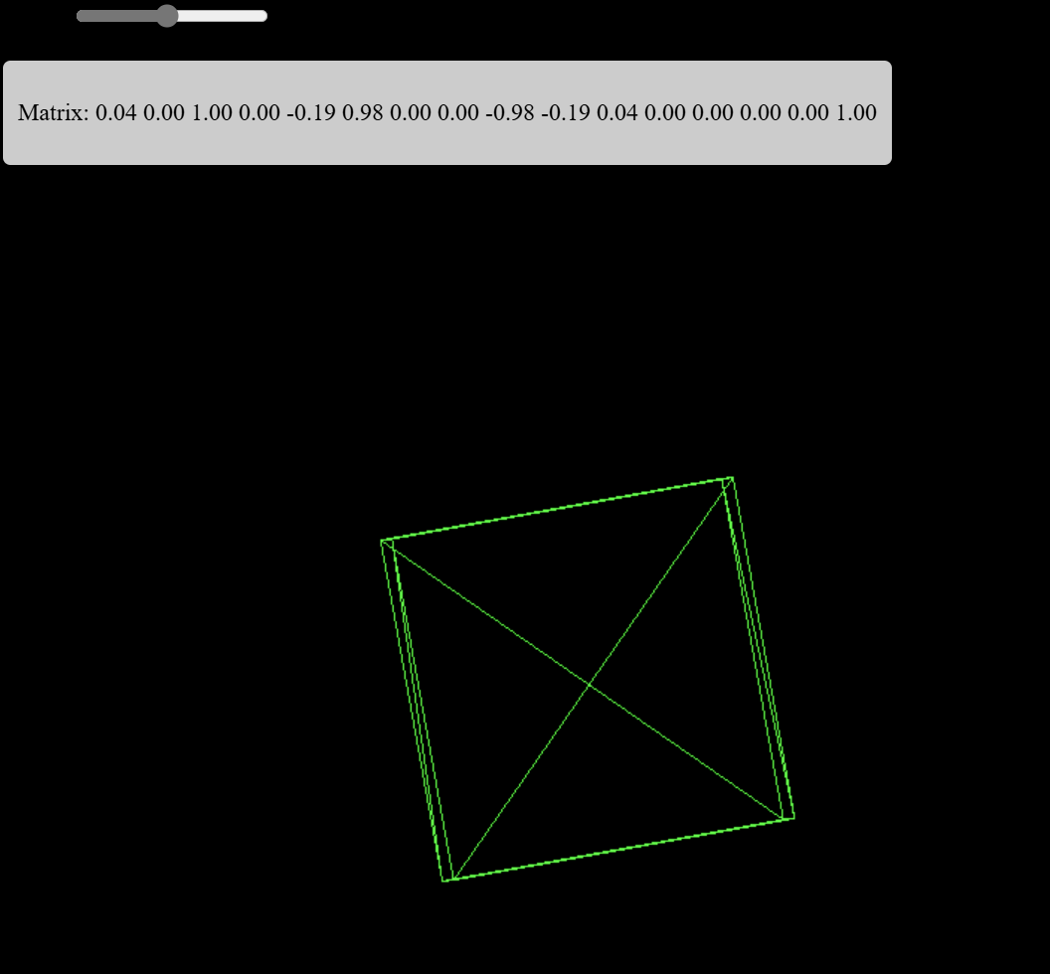

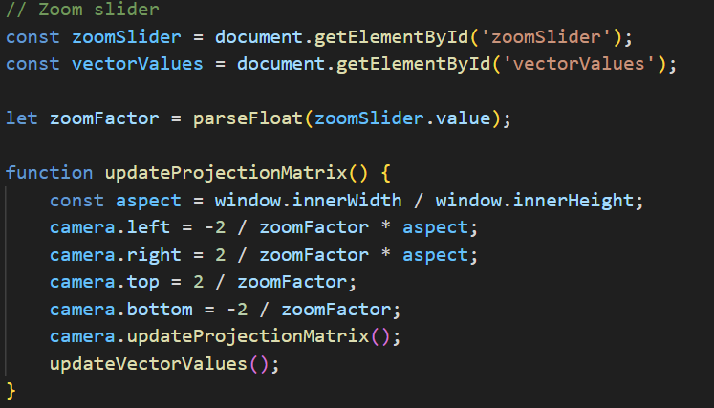

Oblique Projection

This is quite similar to orthographic projection, but a shear-xy is applied to the space beforehand. The clip space is thus a parallelepiped. For the shear-xy transformation, we can have values \( \alpha_x \) and \( \alpha_y \) for the x and y axis tilt angles. Sometimes the cotangent of those angles is used. It does not really matter because \( \cot(\alpha) = \tan\left(\frac{\pi}{2} - \alpha\right) \), so just the direction of the shear would be different.

Although we could shear by an arbitrary amount, there are two \( \alpha \) values that are most commonly used:

1. **Cavalier Projection**: One angle is fixed at \( \alpha_y = 45^\circ \). Another angle is free, but lines perpendicular to the z-plane must preserve their length.

2. **Cabinet Projection**: One angle is fixed at \( \alpha_y \approx 64.3^\circ \). Another angle is free, but lines perpendicular to the z-plane must be half their length.

To satisfy the conditions for the lengths of the perpendicular line segments, we can use the sine and cosine functions for the shear value calculations. So instead of:

```

| 1 0 tan(α_x) 0 |

| 0 1 tan(α_y) 0 |

| 0 0 1 0 |

| 0 0 0 1 |

```

We would have for Cavalier projection:

```

| 1 0 cos(α_x) 0 |

| 0 1 sin(α_x) 0 |

| 0 0 1 0 |

| 0 0 0 1 |

```

Or for the Cabinet projection:

```

| 1 0 cos(α_x)/2 0 |

| 0 1 sin(α_x)/2 0 |

| 0 0 1 0 |

| 0 0 0 1 |

```

---

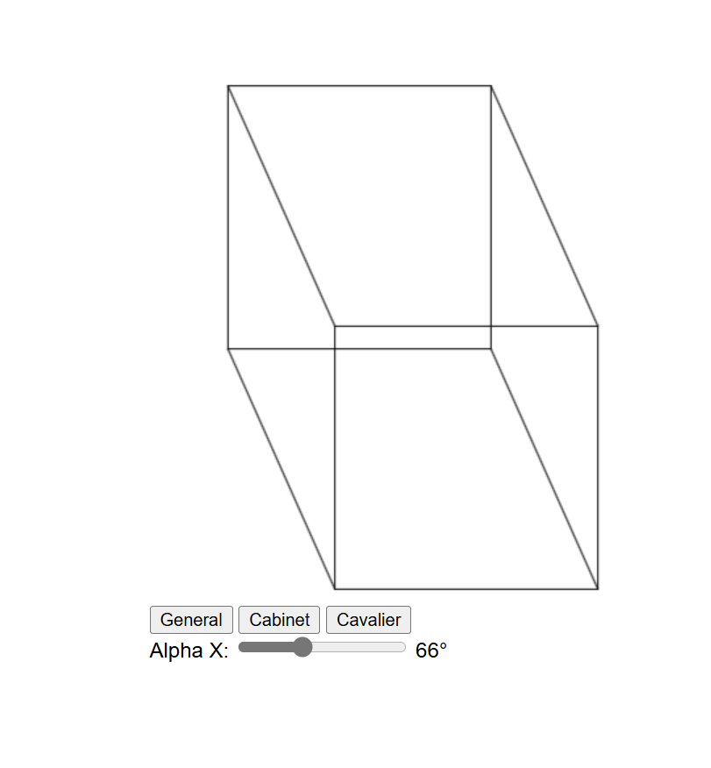

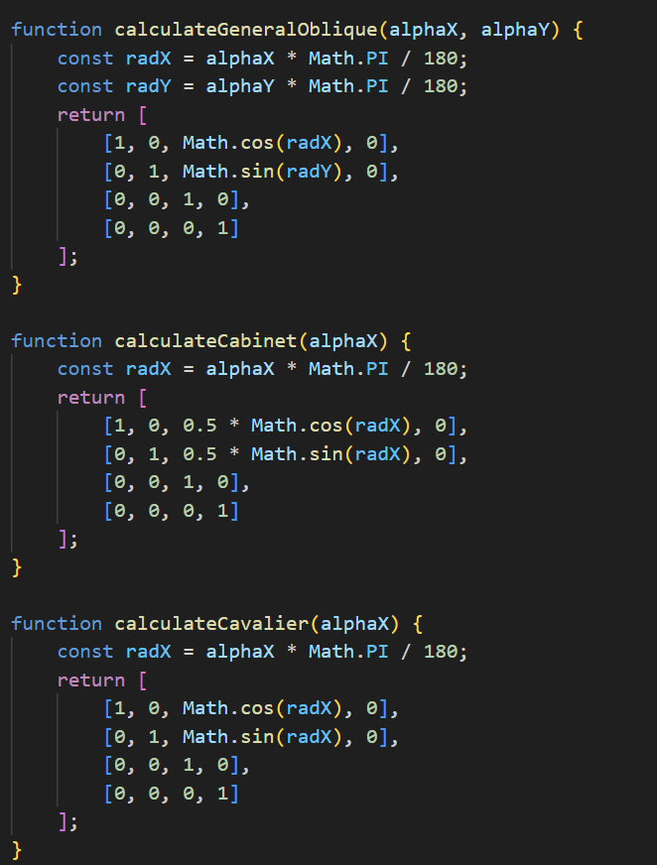

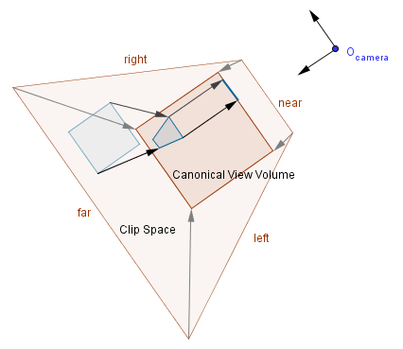

Perspective Projection

This is probably the most common projection because it emulates the way we see the world around us. When we talk about 3D graphics, we usually want to create an immersive illusion that resembles our own view of the world. As mentioned, this is also where homogeneous coordinates give us a simple way to achieve the desired projection. We want the final coordinates to be directly dependent on the z coordinate. With ordinary affine transformations, they are not; we can add a multiple of the z coordinate to the values, but we cannot have the whole coordinate be a factor of the z value. With homogeneous coordinates, all coordinates are a factor of the w value, which has until now been 1 for points.

The homogeneous point (x, y, z, w) is actually a point (x/w, y/w, z/w).

Because of this, we have to leave the world of affine transformations and change the bottom row of our projection matrix. We can assign the negative z value to the w value. This will also invert the z-axis. In OpenGL, the positive z-axis in the clip space will point in the opposite direction as the z-axis in the camera space. That is also why the scale factor for the z coordinate has been a negative value in the previous matrices.

Here again, we have the near, far, left, right, top, and bottom values. The near and far values are the corresponding planes, but the left, right, top, and bottom values are the boundaries of the near plane. These values will define the whole frustum that has a peak in the camera's position. We can think of this projection as transforming the frustum into a cube like before.

So our final matrix would be:

```

| 1 / (aspectRatio * tan(α / 2)) 0 0 0 |

| 0 1 / tan(α / 2) 0 0 |

| 0 0 (near + far) / (near - far) (2 * far * near) / (near - far) |

| 0 0 -1 0 |

```

Now, this does map to the correct range for z values, but the mapping is not a linear one. Previously we had a linear mapping, but with perspective projection, a linear mapping is not possible. The best we can do is have it map to the correct range and keep the order between points.

Imagine that our near plane is at 1 and far plane is at 10. This is how the z values would be mapped:

| | 1 | 2 | 3 | 4 | 5 | 6 | 7 | 8 | 9 | 10 |

|------------|-----|------|------|------|------|------|------|------|------|------|

| Linear | -1 | -0.77| -0.55| -0.33| -0.11| 0.11 | 0.33 | 0.55 | 0.77 | 1 |

| Perspective| -1 | 0.11 | 0.48 | 0.66 | 0.77 | 0.85 | 0.90 | 0.94 | 0.97 | 1 |

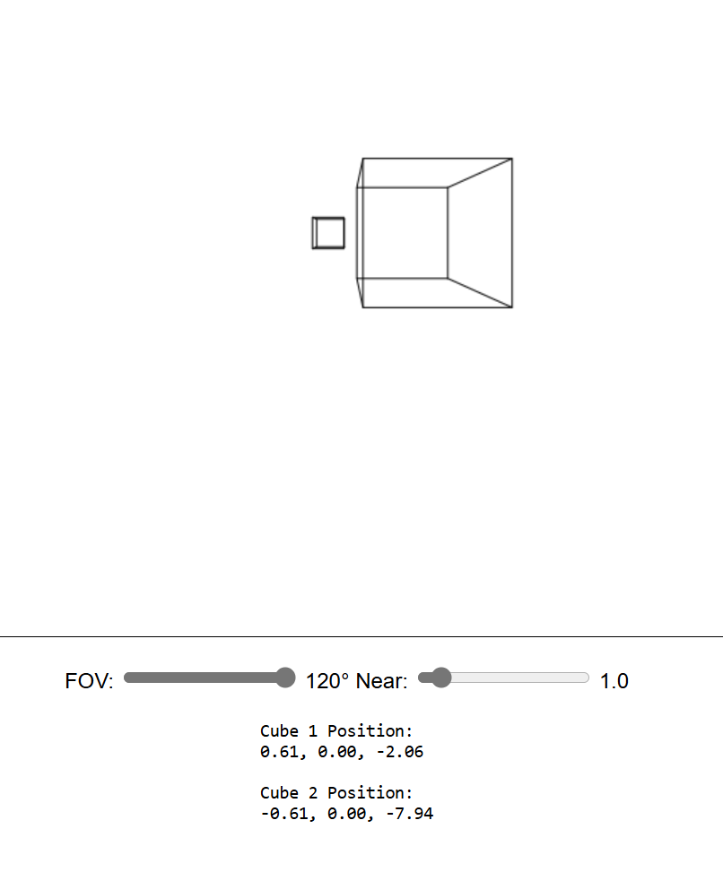

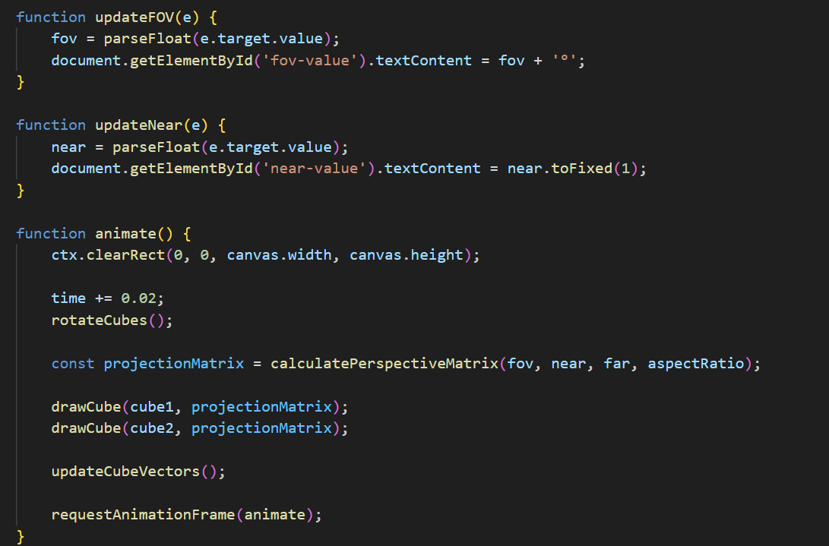

Shading and Lighting

So far, we have looked at geometry, transformations, and projections. These are all done in the vertex shader. Our examples have been white wireframes of the geometry. Now we will proceed to the fragment shader, where the geometry has been rasterized, and we can calculate the color our pixels should have. This is the main job of the fragment shader - to give out a color value for a pixel. In OpenGL, the fragment shader gets, among other values, the `gl_FragCoord` value as input. This value is the coordinate in the screen space (also called window space).

Usually, with basic 3D geometry, we do not care that much about the screen space coordinate. Rather, we are interested in values sent directly or interpolated from the vertex shader. This is because with vertices, we can also send a color value and/or a surface normal from our program code. We do not know how many pixels are rasterized between the vertices, but we can interpolate values between them.

There are different techniques on how to assign a color to the rasterized pixels. In this chapter, we will take a look at those techniques and see the differences between them.

Definitions:

- **Shading model**: Technique that defines when and where we calculate the components needed for light calculations.

- **Lighting model**: Technique that defines how we calculate the final color given all the components required for it.

- **Material properties**: Properties of the material that determine how much an object with this material reflects light from different channels.

- **Light properties**: Properties of a light source that determine how much this light source emits light from different channels.

- **Point light source**: A light source where light is originating from a single point in space.

- **Directional light source**: A light source that defines light originating from a single direction in all of the space.

Shading Models

There are three main shading models that are used for different results: flat shading, Gouraud shading, and Phong shading.

Flat Shading (per polygon)

This is the simplest and most efficient way to specify color for an object. It defines a single color for a face. Implementations may vary, but the main idea is that we use only one surface normal per polygon. The color itself is uniform (unchanging) on that polygon.

Gouraud Shading (per vertex)

This was invented as an improvement to allow for smoother transitions of the color on round objects. The main idea is that there is a different normal per vertex, and the color is calculated in the vertex shader. That color is then interpolated over the polygon. Because there are fewer vertices than there are fragments, calculating the color per vertex and interpolating it is more efficient than calculating it per fragment. This approach handles materials with specular reflection poorly. This reflection might occur inside the polygon but not on any of the vertices. Thus, this shading would not show it if it does not happen to be on the vertex.

Phong Shading (per fragment)

This was another improvement to account for specular reflection. The main idea is that the normal from the vertices is interpolated. Color is calculated per fragment, taking into account the interpolated normal. For an approximation of a sphere, this is quite ideal because the interpolated normals would be exactly those that a perfect sphere would have. Because the color is calculated based on the normals, it will be calculated as if it were a perfect sphere.

On the right, there is an example with all three shadings. These shapes have only the diffuse reflection (no specular). As you can see, there are still quite noticeable differences with the sphere. For the cube, there are actually 24 vertices. Each face has its own 4 vertices with normals pointing in the same direction as the surface normal. In that case, there is no difference (as far as the result is concerned) which shading is used.

Next, we will look at how the actual color is determined. It does not matter which shading is used as long as we have a surface normal, material properties, light source properties, and the light direction.

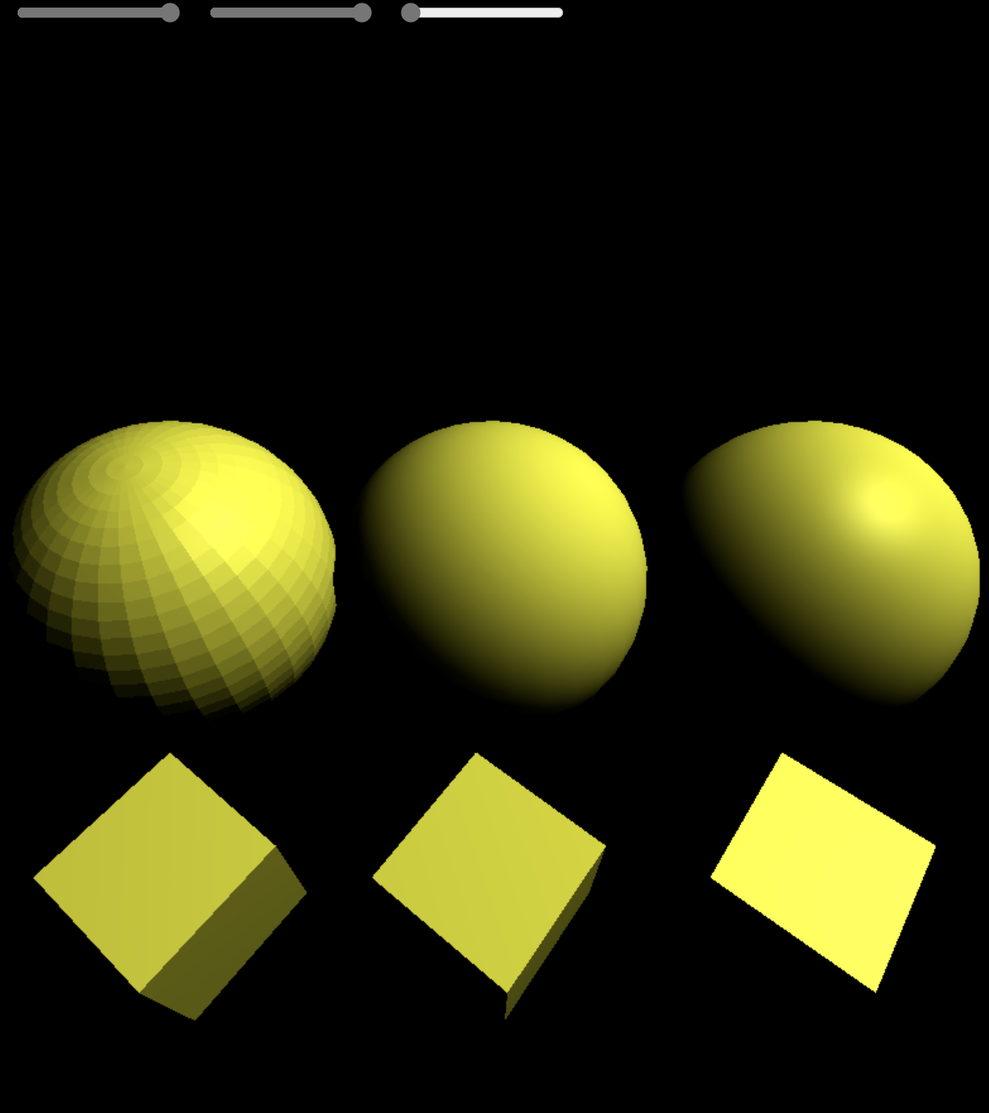

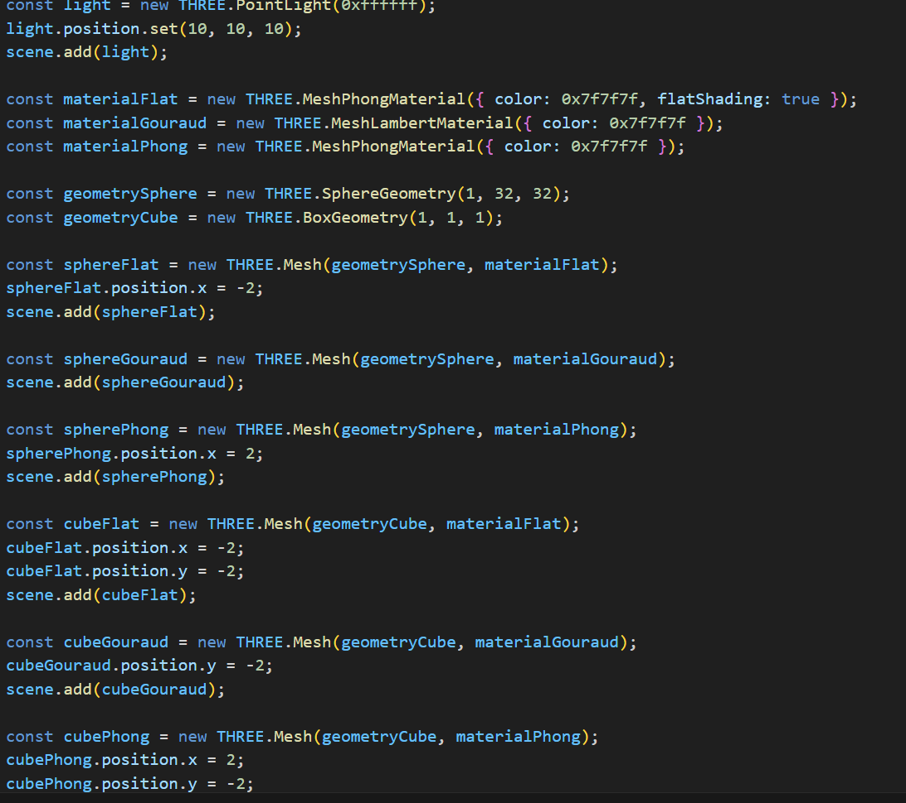

Ambient Light

The cubes and spheres shown before kind of appear to be in space. The non-illuminated sides of them are totally in darkness. In reality, this is not the case; there is almost always some light coming from every direction. That is because light will reflect from nearby surfaces, bounce around, and reach the areas not directly illuminated.

This is called indirect illumination and is one of the things that global illumination techniques try to do accurately, which may be computationally quite expensive. In our simple model, we can do a very rough approximation and just add an ambient term to the reflected intensity. That way, the non-illuminated areas will not be totally black. Although this means that the other parts will become a bit more illuminated as well.

Now, you might notice that this might cause the intensity to be above 1. Because of that, the values are usually clamped to be in the range \([0, 1]\). The clamp operation makes the values above the maximum be the maximum, and values below the minimum be the minimum. Often, if you assign a value higher than 1 to the pixel's color in code, the output will still be the same as if it were 1.

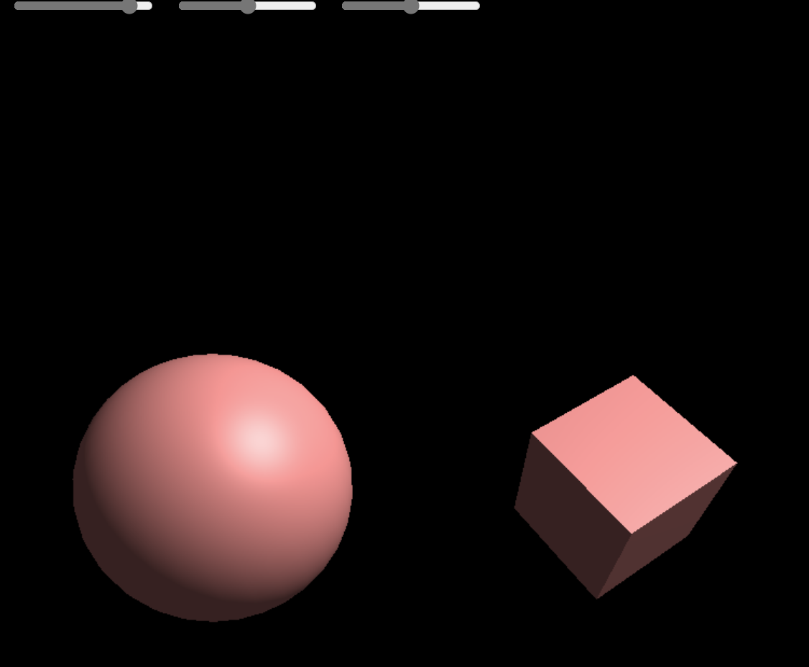

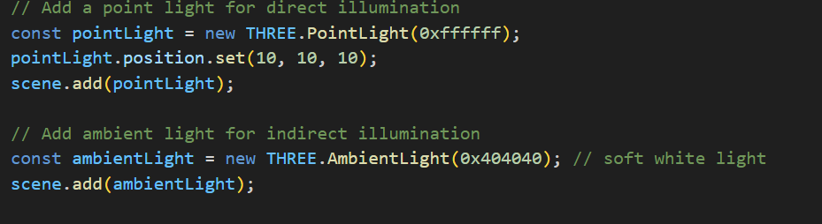

Phong Lighting Model

As mentioned before, there are very few surfaces that are only diffusely reflective. Most surfaces have an amount of specular reflection. This means that some part of the incoming light will reflect in the reflected direction. If the viewer is looking from that direction, the area of the surface will seem lighter than the rest of the surface.

Notice that the viewer's position is the same. The viewer might look at different parts of the surface, but sees the specular reflection only in the area where the reflected light would be shining directly towards the viewer.

So, some part of the light is absorbed by the surface and reflected at an arbitrary angle. Another part is directly reflected from the surface. If the directly reflected part were 100%, then we would have a perfect mirror.

In reality, we would have to take into account the reflected indirect light as well, but for a simple model, we account only for the direct light. This will produce a specular highlight that is sort of a reflection of the light source.

But how do we calculate that? Let us have a more concise drawing to find that out.

As you can see, there are two vectors: the direction towards the viewer and the direction of the reflected light. If those vectors are pointing in the same direction, then our fragment (number 4) should be more illuminated. To determine if they are pointing in the same direction, we can look at the angle between them. If the angle \( \alpha \) is 0, then they are. If the angle differs from 0, then they are pointing in different directions. Now, if the angle is really small, then we still have to illuminate the fragment a bit.

So, we need some kind of way to illuminate based on the angle between the viewer direction and the reflected light. Bui Tuong Phong thought in 1975 that a good enough approximation would be to use the cosine of that angle. Assuming that the vectors are normalized, we can find the cosine by just taking the dot product again. If the vectors are not normalized, then we have to normalize them first.

Now, the cosine function is 1 when the angle is 0. It is also symmetric and becomes 0 when the angle is at 90°. We already saw a good use of that in the diffuse reflection case. However, because the cosine decreases so slowly, it would produce a really big and spread-out highlight on the surface. Phong proposed to take a power of the cosine. Taking the power causes the cosine to decrease more rapidly while still preserving the value 1 at 0 and the overall shape. The exact value of the power is left to the programmer and is called the shininess value. This is Phong's lighting model. It includes the ambient term, Lambertian/diffuse term, and Phong's specular term. There are 2 colors for each of those terms: the color of the light and the material. So, all in all, 6 colors. There are also 4 vectors that indicate directions towards: surface normal, light, reflected light, and viewer. Those vectors should all be normalized.

As for the behavior of Phong's specular highlight, consider the example on the right. You can see that when the shininess is 1, the specular highlight is really big and does not look good. You can also see that it might not be a good idea to use the same color for the specular reflection as the diffuse color. A white specular reflection color gives a more pleasing result. The color slides linearly interpolate between red (left) and white (right).

You can try first increasing the shininess to some higher value. Then move the diffuse color to 0 (red). You can see that the highlight is barely visible. If you move the specular color also to 0 (red), then you cannot see the specular highlight because the area cannot get any more red. Move the specular color to 1 (white) to see a white specular highlight.

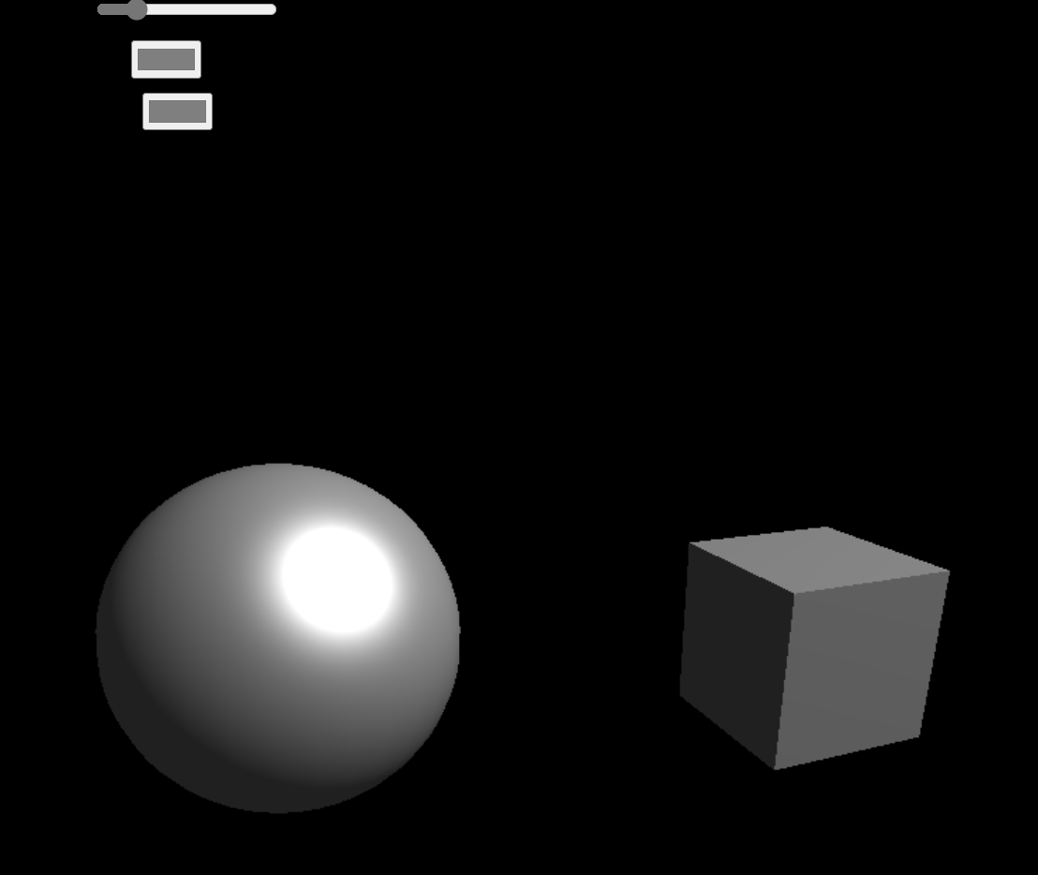

Blinn-Phong Lighting Model

Another, slightly more realistic, lighting model is the Blinn-Phong model, which calculates the specular term somewhat differently.

In the Blinn-Phong model, we use a halfway vector between the light source and the viewer. This vector will coincide with the surface normal if the reflected light coincides with the viewer direction.

Everything else is the same, but we are now using the cosine of the angle between the halfway vector and the surface normal. The shininess exponent of this is about 4 times larger than in Phong's model for roughly the same sized highlight.

Also, the highlight will behave a bit differently when the viewer is looking at a grazing angle towards the surface. The highlight will be more oval-shaped, thus projected circularly, rather than being circular and projected as an oval. This is more realistic.

You can try this out in the example on the right. First, pick a good shininess value and then try to rotate the light's direction. The left sphere has Phong's specular and the right one has the Blinn-Phong specular.

Currently, we are using the orthographic projection and a directional light source. This means that the viewer direction and the light direction are always the same. Because of that, we can calculate the halfway vector beforehand and send it to the shaders. The halfway vector will always be the same, and we do not have to recalculate it in the shaders all the time. We just take the cosine of the angle between the surface normal (which is different) and the halfway vector (which is the same).

This kind of optimization could not be done with Phong's model because the reflected light would have been in a different direction all the time, and we would have to recalculate it for each fragment. Alas, it will only work here if the light source and viewer are considered to be at infinity (e.g., directional light, orthographic projection).

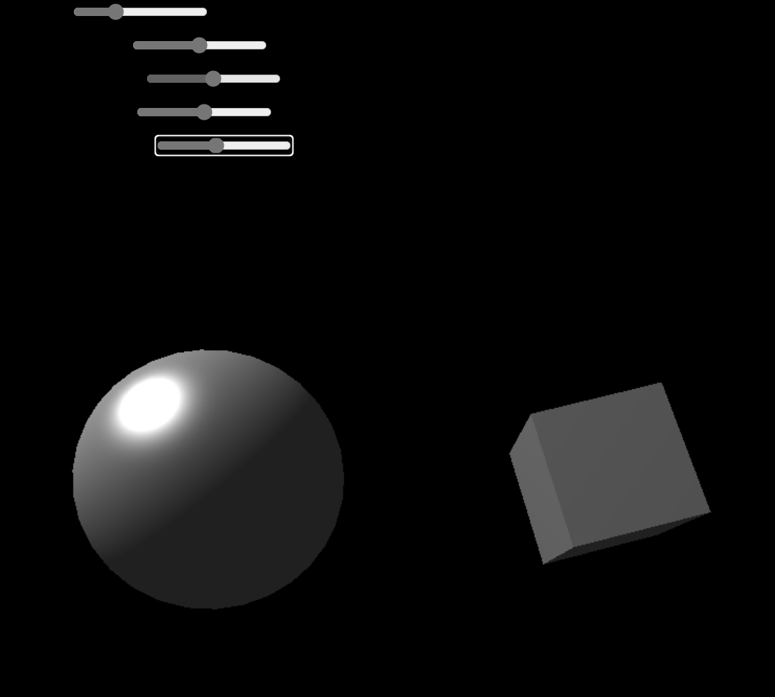

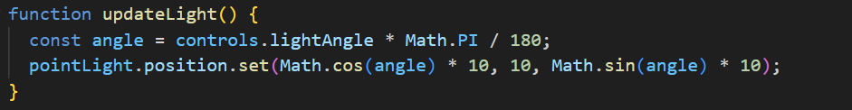

In order to get more detail in the object's color, a texture is used to pick color values from. Previously we defined a single color for the whole objects. We could define separate colors for each of the vertices and then interpolate between them to get a color for the fragment. In fact we could define all sorts of different attributes for the vertices and send them to the GPU. Still, defining colors for the vertices will not suffice, we again have a limited granularity of the color. We could add more vertices, but this means more unnecessary work for the GPU and we would have to add quite a lot of vertices.

That is why we would rather have an image mapped to our object and pick the colors from that image. Images can be regarded as mathematical functions and in fact you do not have to use an image, but could just sample some interesting function. We will see those kinds of techniques in the Procedural Generation topic, because those functions are usually generated to produce some random-looking but specific pattern. Here however we will see how can we use just an image (that you can draw in an image editing program for example) as the storage of color information on some object's surface.

Definitions:

Sampling – process of getting a finite number of values from a function, map, image.

Texture – an image meant for the storage of some information that is later mapped to an object.

UV Mapping – the mapping between texture coordinates (uv) and vertex coordinates (xyz).

Interpolation – process of finding a previously unknown value between a number of known values.

Linear Interpolation – an interpolation technique that assumes there is a straight line between the known values, the unknown value is taken from that line.

Nearest Neighbour Interpolation – an interpolation technique that takes the nearest known value to be the unknown value.

Interpolation

We saw interpolation before when we interpolated normal vectors in Phong's shading or colors in Gouraud's shading. Here our goal is somewhat different. A digital image is a discrete sample of an analogue signal. Images are usually stored as raster graphics. If we take an image with a camera or draw one in a raster graphics editor, then it is usually saved as a discrete set of color values. Although you can save the direct sensor data from your camera or draw vector graphics, it is often not the case. In raster graphics, the individual pixels of an image represent point values of the signal sampled at some coordinates.

Now, if we have such a raster image stored, we would like to map it to our geometry. With a corresponding UV mapping, we can specify which image coordinates correspond to which vertices of our object. But we want to rotate, scale, and project our object. There is nothing that would indicate that the image will be projected to the screen as it is. An image mapped to geometry is called a texture. Note that currently we are discussing rasterized images. A texture might well be just a mathematical function that we can sample (calculate) at desired coordinates.

There are two cases we can distinguish when scaling the image:

- **Upscaling**: We want to render it bigger than it is.

- **Downscaling**: We want to render it smaller than it is.

Upscaling

Let us first see upscaling. Assume we have a 4×4 texture and we want to render it to a 5×5 area.

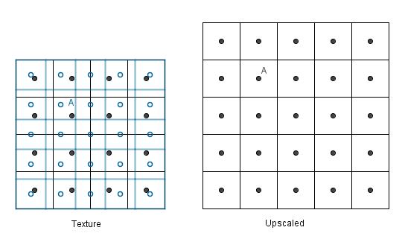

Consider the pixel A. We would need to have a value in the texture located at the mapped A (left image, blue, empty dot). Alas, we have no value there, but we have values near it (the black dots).

There are two simple ideas on how we could get that value. The simplest is that we could look at the nearest neighbor and take its value.

This is really fast, but usually, the result is blocky and not desired. Remember, the image was a discrete sample from an analogue signal. This means that there is a value between the samples, and it is most probably not the ones we sampled, but something in between.

In order to get a value in between in 1D, we can look at the closest values and take the weighted average depending on the distance to those values. The unknown value would be a convex combination of the neighboring values; this is called linear interpolation.

With our 2D texture, we could calculate the direct distances to the 4 neighbors and use the same approach. However, calculating the distances would include a square root. A faster but still effective way would be to use bilinear interpolation. That means that we first interpolate linearly in one direction and then interpolate the results linearly in the other direction.

We will get the same result no matter which way we interpolate first. The result has the color values considered by the \((1 - \text{distanceX}) \cdot (1 - \text{distanceY})\) factor if the known values are unit distance apart from each other.

Downscaling

What about the other way around? Let us have an 8×8 texture that we want to render to a 5×5 area.

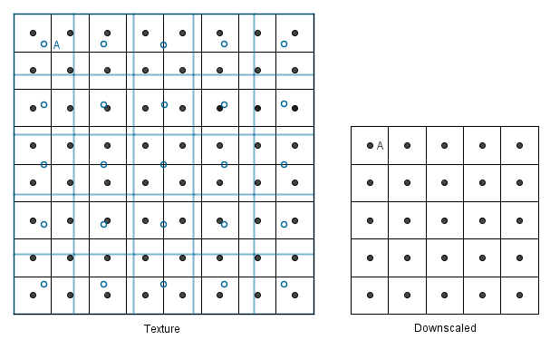

We have again the same two simple approaches. We first map our downscaled coordinates to the texture, then we can find the nearest neighbor to each of the unknown values (again blue empty circles).

Or we could find the nearest 4 neighbors and do the bilinear filtering again.

But there is a problem. With upscaling, it does not matter how much we upscale; there are always 4 neighbors that we can interpolate. However, with downscaling, it might happen that our new value should involve more than 4 neighbors to be correct. This will happen if we want to downscale more than 2 times the known texture size.

Consider if we would want to render the 8×8 texture to a 2×2 area with bilinear filtering.

We would have to consider all of the 16 values that should be in the mapped pixel; otherwise, we will miss out on a lot of data and produce artifacts. Think if the 1st, 4th, 5th, and 8th columns consisted of black values and everything else is white. With just the bilinear approach, we would not see anything that would indicate those black lines in the 2×2 area. Even though exactly half of the original image was black. We could even have some rows black, and still, the final image would be totally white. This is not desirable, and next, we will see what can be done about it.

Mipmap

As you saw, there is a significant problem if we downscale an image more than 2 times with bilinear interpolation. This is why usually there are mipmaps accompanying the texture (our image). Mipmaps are precalculated exactly 2 times smaller versions of the texture.

Even though our initial texture was 8×8, we can now use the mipmaps 4×4 to downscale to 3×3 and avoid the problem of missing out on some values. Notice that when generating mipmaps, exactly 2 times smaller mipmap holds for each value the equal weighted average of all 4 neighboring pixel values from the bigger image. This will, of course, create some other problems; for example, the checkerboard texture will at one point just be an equally gray image.

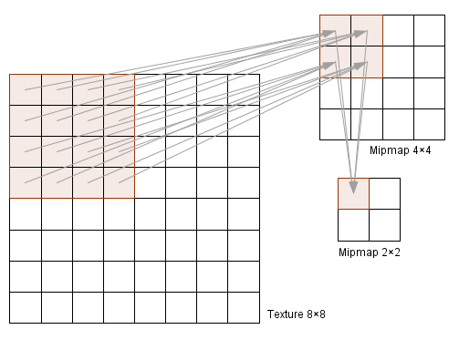

As you notice, the sizes are a power of two. This is because this way, the GPU can divide the dimensions more efficiently, and the texture always divides by 2 (down to 2×2 or 1×1). This means that the dimensions of the textures should always be a power of two. If they are not, the mipmaps may not be automatically calculated for you. Of course, you could always find the mipmaps yourself and send them along with the texture to the GPU.

Now, when we generate the mipmaps, we will solve the problem that the downscaled images are missing values from some pixels.

The values are there, but the number of pixels is too small to represent the pattern, so the smaller mipmaps just have gray values (instead of the black and white pattern).

Ok, but what about if we want to render the image with a size somewhere between the mipmaps? Do we use a larger mipmap and downscale or the smaller mipmap and upscale? It would make more sense to use the larger one because it contains more data we can use. On the other hand, if we are closer to the smaller mipmap, then we should perhaps use that because the result will resemble that one more (we will just calculate quite a similar result again from the larger one).

This comes back to getting to know unknown values from between known values; thus, we can interpolate between the mipmaps. With interpolation, we again have two simple choices: just take the nearest neighbor (no meaningful interpolation) or interpolate linearly between them. The last option will be trilinear filtering if bilinear filtering is applied in both of the mipmaps.

Below is an example when we want to render the image in a 5×5 area, and we have mipmaps 4×4 and 8×8. The value 5 is three-quarters away from the value 8 and one-quarter away from the value 4. So we can do bilinear filtering in both of the mipmaps and then do another linear filtering on the results, resulting in a trilinear filter.

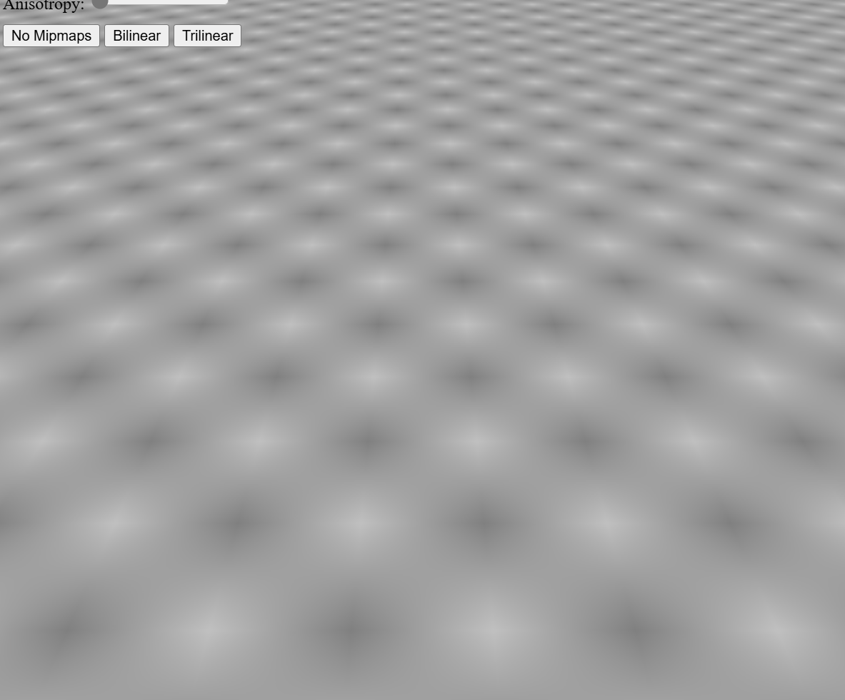

here is another example where you can try out different minification, magnification filters and anisotropy levels.

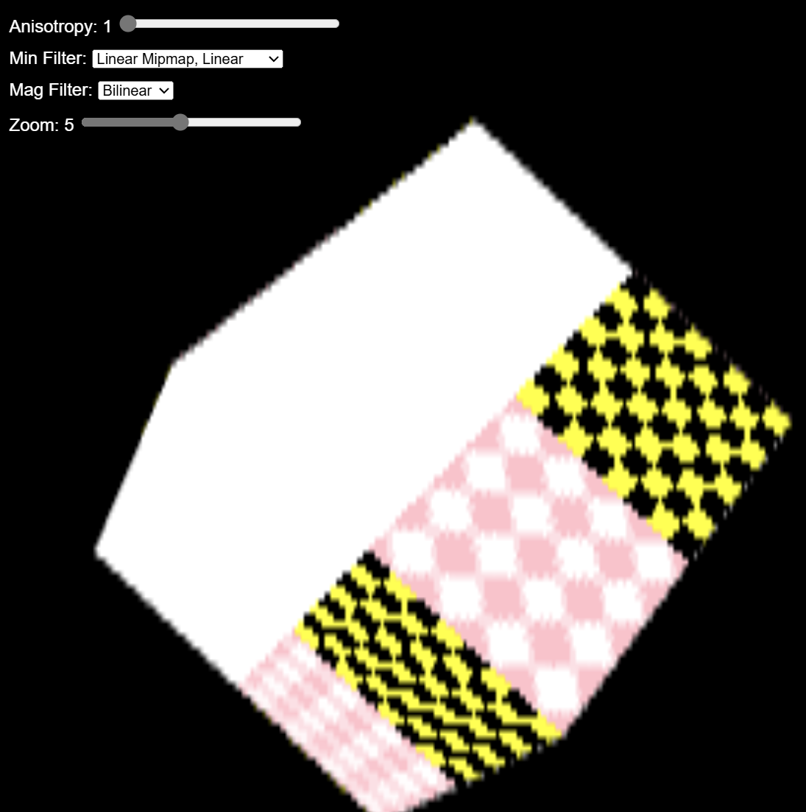

Aliasing

As you might have noticed in the previous examples with the checkerboard pattern there were some weird effects if we tried to map it to a small area. You can try it out by making the cube in the previous example small and not use any mipmapping (min. filter linear or nearest neighbour). You can use mipmapping and even anisotropy also, the effect is still there, although not that clearly visible.

It comes from the fact that our signal in the image has a too high frequency to be displayed correctly with such a small amount of samples. Nyquist-Shannon sampling theorem says that in order to be able to fully construct a periodic signal, we should sample more than two times in a period. Of course more is better, but if we sample less we will definitely not get the original signal back, we will get something else - an alias of it. Aliases are artifacts in the image that are not supposed to be there: we are seeing something that was not originally there.

In the example on the right we will render it to 300×200 area (the size of the graphical box of the example). But this is an infinite function, we have to decide how much of we will render. The slider below controls the sample step. For readability it denotes a factor or the coordinates. So if it is 1, we will render 1×1 area to the viewport. If you increase it to 2, it will be a 2×2 area of the aforementioned function. As you can see, increasing it over 10 will start to produce a lot of Moire patterns. This is exactly because we are trying to fit a high frequency signal to our 300×200 area without having enough pixels to represent the signal correctly.

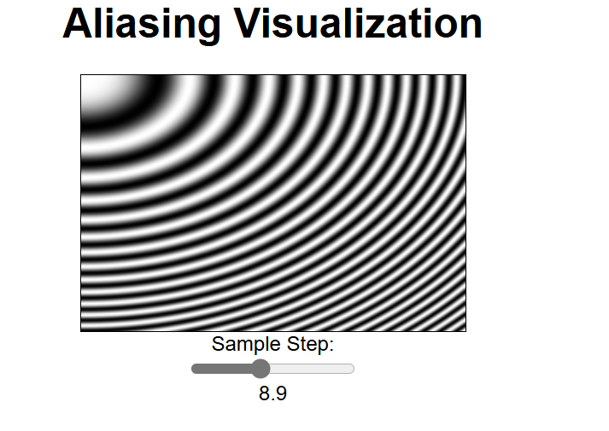

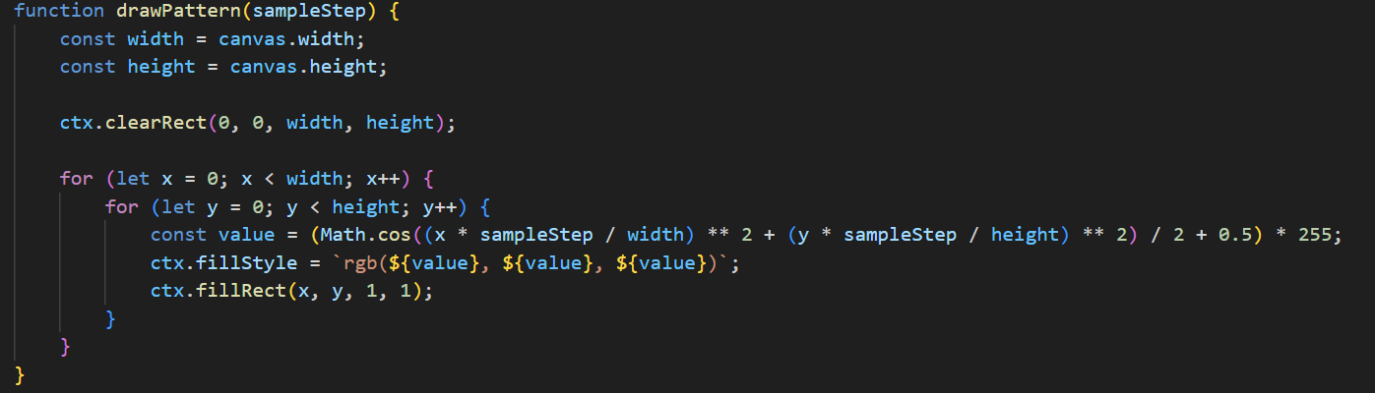

previously we studied geometry calculations and texture sampling. In this chapter we are going see how to determine which pixels are visible and how to draw partially visible pixels.

At first let us imagine we have a scene with geometric objects. After rasterizing those objects we have to determine, which rasterized pixel is in front of another and therefore which one should be drawn to the screen.

Definitions:

depth buffer

framebuffer

depth testing

z-fighting

color blending

conventional (straight) alpha vs premultiplied alpha

blend function

additive blending

multiplicative blending

Depth Buffer

Depth buffer (also known as z-buffer) is a way to keep track of the depth of every pixel (fragment) on the screen. The buffer is usually arranged as a 2D array with one integer value for each screen space pixel. The depth value is proportional to the distance of the fragment that has been drawn. However there is a lot of precision close to the camera and very little off in the distance.

In the projection chapter we saw how the z′𝑧′ value is calculated using projection matrix. This value was in range [−1,1][−1,1] where -1 corresponds to the near plane and 1 to the far plane. The corresponding equation is: (z is the fragment distance from camera)

z′=far+nearfar−near+1z⋅(−2⋅far⋅nearfar−near)𝑧′=𝑓𝑎𝑟+𝑛𝑒𝑎𝑟𝑓𝑎𝑟−𝑛𝑒𝑎𝑟+1𝑧⋅(−2⋅𝑓𝑎𝑟⋅𝑛𝑒𝑎𝑟𝑓𝑎𝑟−𝑛𝑒𝑎𝑟)

In order to store this value in the depth buffer it is first normalized into to range [0, 1] by substituting conversion:

z′2=(z′1+1)2𝑧2′=(𝑧1′+1)2

Then it is multiplied by the max value of our depth buffer (maxval=2d−1𝑚𝑎𝑥𝑣𝑎𝑙=2𝑑−1, where d𝑑 is the size of the depth buffer, usually 32 bits) and rounded to an integer. Resulting value is stored in the depth buffer.

While objects are rendered one by one the complete image is stored in the framebuffer. The framebuffer has its own depth buffer to keep track on z values of each already drawn pixel. Depth test is performed when new portion of geometry is processed (by vertex and fragment shader) and ready to be drawn to the framebuffer. Depth test compares each pixel z value to the corresponding pixel value in the framebuffer. If it is bigger the new pixel value is discarded otherwise it is overwritten or blended together (depending on whether blending is enabled or not).

Sometimes the source and the destination pixels happens to have exactly the same value. This problem was more common on older video cards because they had smaller depth buffer resolution, however it can also appear in current games with very large sight distance. The overall effect is annoying flickering that is called z-fighting. This effect can be avoided by reducing the depth of our view frustum and careful modelling of the distant geometry.

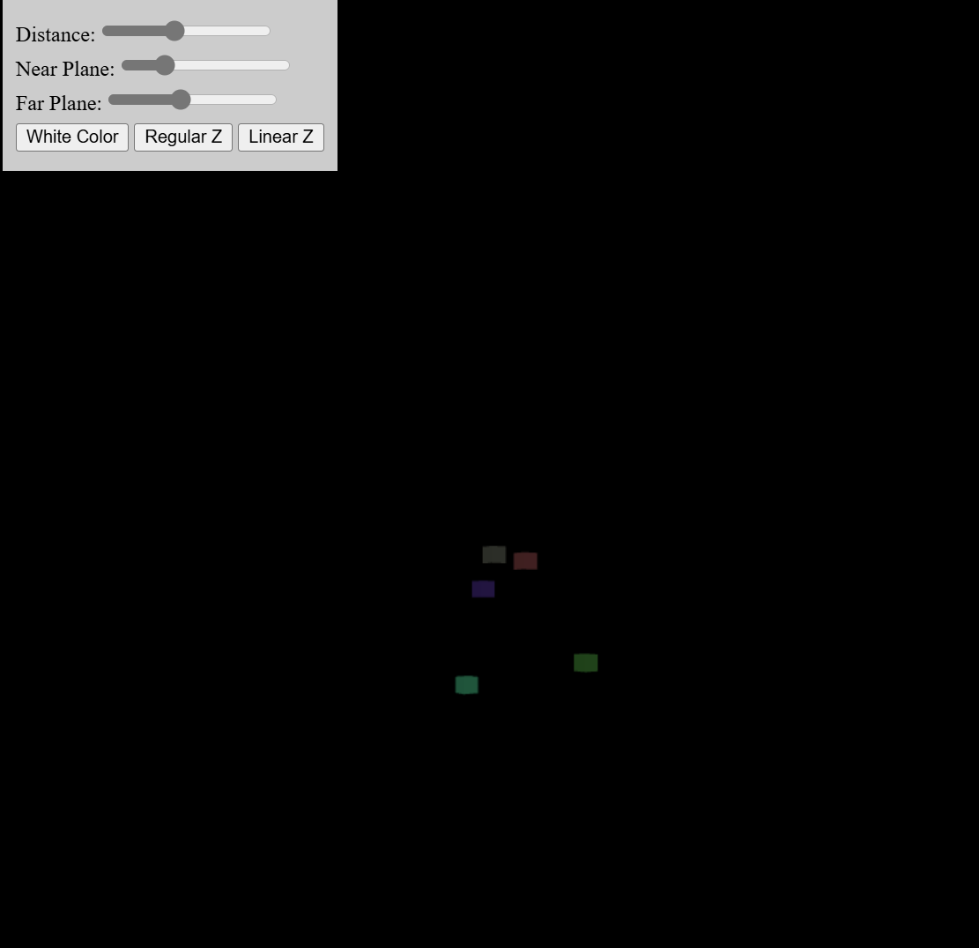

Color Blending

Color blending is a way to mix two colors together to produce to third color. These colors are called source and destination and they are in form [R,G,B,A][𝑅,𝐺,𝐵,𝐴] where R,G,B,A∈[0..1]𝑅,𝐺,𝐵,𝐴∈[0..1]. Usually we use blending to represent semi transparent objects like glass. However we can also create interesting effects by changing some parameters in the blend function.

Alpha

So far we know that the color value is a vector space element that consists of R, G and B channels and sometimes has also an alpha channel. At the fundamental level, alpha has no special meaning therefore we can use it however we need, for example alpha value could be used to store shininess, collision material or whatever we need in particular case. Most often it is used to represent transparency but there are still two different ways to do it.

Conventional (Straight) Alpha

Majority of programs and file formats consider transparency as:

RGB specifies the color of the object

Alpha specifies how solid it is

When we consider blending two colors, we can call the color already in place the destination𝑑𝑒𝑠𝑡𝑖𝑛𝑎𝑡𝑖𝑜𝑛 and the new color we want to blend with it the source𝑠𝑜𝑢𝑟𝑐𝑒.

In math the equation for the conventional alpha blending is quite straight forward:

blend(source,destination)=(source⋅sourcealpha)+(destination⋅(1−sourcealpha))𝑏𝑙𝑒𝑛𝑑(𝑠𝑜𝑢𝑟𝑐𝑒,𝑑𝑒𝑠𝑡𝑖𝑛𝑎𝑡𝑖𝑜𝑛)=(𝑠𝑜𝑢𝑟𝑐𝑒⋅𝑠𝑜𝑢𝑟𝑐𝑒𝑎𝑙𝑝ℎ𝑎)+(𝑑𝑒𝑠𝑡𝑖𝑛𝑎𝑡𝑖𝑜𝑛⋅(1−𝑠𝑜𝑢𝑟𝑐𝑒𝑎𝑙𝑝ℎ𝑎))

This way the transparency is fully independent of the color values. For example we can have fully transparent color that is either red or blue. One of the main problem with this is that if we sample the texture by floating point precision (for example by using bi-linear filtering) we could encounter color bleeding issue.

If we decrease the value of alpha, then the current color is taken less into account when blending.

Premultiplied Alpha

Another way to think about transparency is:

RGB specifies how much color the objects contribute to the scene

Alpha specifies how much it obscures whatever is behind it

In math the corresponding equation is:

blend(source,destination)=(source⋅1)+(destination⋅(1−sourcealpha))𝑏𝑙𝑒𝑛𝑑(𝑠𝑜𝑢𝑟𝑐𝑒,𝑑𝑒𝑠𝑡𝑖𝑛𝑎𝑡𝑖𝑜𝑛)=(𝑠𝑜𝑢𝑟𝑐𝑒⋅1)+(𝑑𝑒𝑠𝑡𝑖𝑛𝑎𝑡𝑖𝑜𝑛⋅(1−𝑠𝑜𝑢𝑟𝑐𝑒𝑎𝑙𝑝ℎ𝑎))

Now the RGB and alpha values are linked together. For example the only way to represent full transparency is to set both RGB and alpha channels to zero. In order to convert straight alpha color into the premultiplied alpha color we have to multiply the RBG values with the alpha value.

premulitpliedAlphaColor=(R⋅A,G⋅A,B⋅A,A)𝑝𝑟𝑒𝑚𝑢𝑙𝑖𝑡𝑝𝑙𝑖𝑒𝑑𝐴𝑙𝑝ℎ𝑎𝐶𝑜𝑙𝑜𝑟=(𝑅⋅𝐴,𝐺⋅𝐴,𝐵⋅𝐴,𝐴)

Advantages of using premultiplied alpha:

No bleeding issues. With bilinear filtering the result with mixed color and alpha values is incorrect, because all fully transparent pixels also have an arbitrary color assigned to them. If we use conventional alpha blending the arbitrary color is also blended to the result. The example on the right illustrates that. The color of the fully transparent pixels is white. With premultiplied alpha blending the only possibility is black and the interpolated values will be correct.

The blend function has one less multiplication, therefore it is slightly faster (the multiplication has already been done when the image was saved)

Both normal and additive blending can be done with one step without breaking the batching

By decreasing only the alpha value we can transform smoothly from normal to additive blending which allows some cool effects for example fire transforming into smoke.

NB! Usually the information whether an image straight or PMA is not stored in the image file itself and it has to be made sure by ourselves. If we mix those two things together (for example export image as premultiplied alpha but render it as straight alpha) we would get strange artifacts like thick black border around the image.

If we decrease the value of alpha here, the current color is still taken into account fully, but the background is considered more and more.

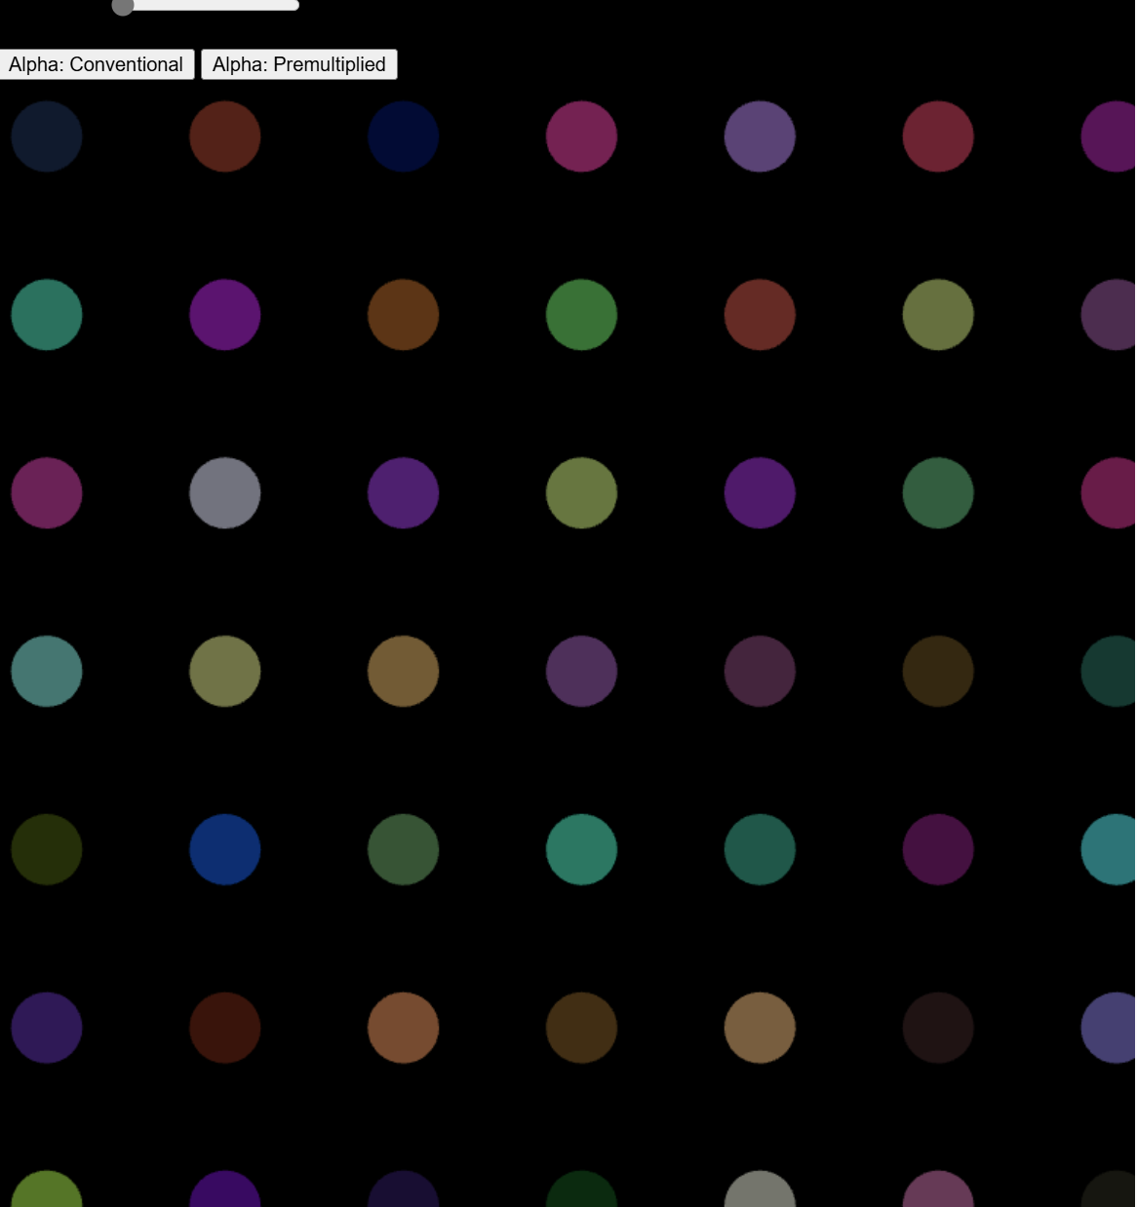

Environment Mapping

Before we talk about environment mapping, let us first think what we would mean by the environment. So far the examples have mostly been with a black background, as if the objects were all located in empty space. This is usually not the case and we want our scene to be located in either a closed environment (e.g. in a room) or in open environment (e.g. outside, with a visible sky). As it turns out it is more efficient to create an illusion of an open environment, rather than having an actual simulation of the Earth, stars, the Sun or the Moon, mountains or whatever we want to see in the distance.

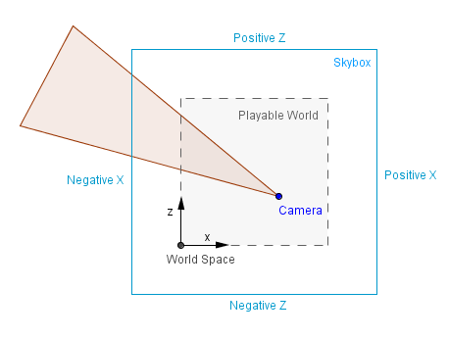

Imagine that there is a mountain in the distance inside a game. A mountain that the player can never travel to, because it is so far away. Modeling the actual geometry of that mountain and then rendering it at some really narrow range of angles all the time would take resources of the GPU. It is much more efficient and quite effective to just have a prerendered image of that mountain to display. The key points here are that the player should never be able to reach that background and that there will always be enough distance between the player and the background. If these requirements are met, we can create the background as it would seem from the center of the scene. Then we can use that background as a texture in either a cube or a sphere (or hemisphere). This is usually called a skybox or a skydome. Because the objects are very far away, moving the camera around has in reality a very small change in the angle on which we look at those objects. So a stationary skybox, where there will be no change at all, kind of approximates that effect.

Definitions:

Reflection – operation where an incident vector (incoming) is reflected from the surface normal, resulting in a reflected (outgoing) vector.

Skybox – large textured box around the world for displaying very distant objects that can not be reached.

Skydome – large textured sphere or a hemisphere around the world for displaying very distant objects that can not be reached.

Cube mapping – idea of mapping all of the surroundings to the six faces of a cube.

Sphere mapping – idea of mapping all of the surroundings to a sphere.

Cube Map

The skybox example above is perhaps the most simplest case of the cube mapping technique. The images that are mapped to the faces of the skybox cube can be constructed so that there is a camera in the center of the skybox that takes 6 snapshots with a 90° field of view. This of course creates distorted images, but the actual perspective projection will undo that distortion and the viewer will see the objects in the distance correctly.

That is already an environment mapping, although the actual environment may have or may have not been there. The images in the skybox could have been drawn by hand, generated procedurally, taken with a real camera in the real world or rendered in an environment that is not rendered later on.

Another thing that we can do with environment mapping is to create reflections. We saw before that there were diffuse surfaces that almost always absorbed all the incoming light (and emitting some of it in a random angle). There were also specularly reflective surfaces, that reflected the specular highlight of the light source. This is an approximation because, as we know, light does not come from only the light source. Light bounces around in our environment and based on it reaches different parts of our scene at different angles. In order to realistically model that, there are global illumination techniques, that we will see later on. Currently we are interested in creating one reflective object that would know about the light coming in from the environment.

Let us assume it is a reflective sphere and all we have in our scene is that sphere, the skybox and the camera. We can find the vector coming from the camera to a fragment of the sphere. We also know the surface normal (interpolated normal in the case of the sphere) at that fragment. Knowing those, we can find the reflected vector as follows:

We know the incident vector and the surface normal.

Let us take the dot product between those. We will get the scalar projection that shows us how much of the normal we need to take if we were to project the incident vector to the normal line.

Now, this vector itself does not help us. We will need 2 times the opposite vector.

Here we can already see that if we were to add the incident vector together with -2 times the scalar projection of it, we will get the reflected vector.

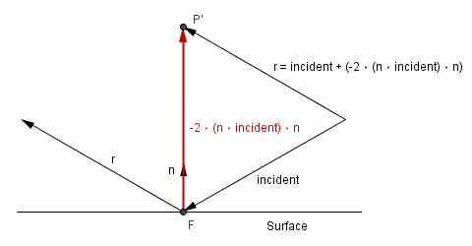

This is quite efficient to find the reflection vector. In global illumination techniques we should now try to find what surfaces this vector will intersect with first. But with cube mapping, as is the case with our current skybox example, we do not have to calculate the exact intersections. We can approximate that the fragment is always located in the center of the cube. It is so, assuming that objects in our skybox are infinitely far away. If we assume that the fragment is in the center, then we can just look at the component of the reflection vector with the greatest magnitude, to determine the face it will hit. The exact hit coordinates will be the other two component, scaled and shifted to texture coordinates [−1,1]→[0,1][−1,1]→[0,1].

Think about the 2D case on the right (which might just be a slice from the 3D world, where y coordinates are all the same). Assume that the reflected vector is something like r=(−0.08,0,1.27)𝑟=(−0.08,0,1.27), when normalized, it becomes rnorm=(−0.063,0,0.998)𝑟𝑛𝑜𝑟𝑚=(−0.063,0,0.998). We can see that the z component has the largest magnitude, it has also the positive value, so we pick the Positive Z face.

We can then use the -0.08 and 0 to find the correct place to sample. After the mapping, UV coordinates will be (0.047,0.5)(0.047,0.5), this is where we will sample from the texture on the Positive Z face.

Now, this works really well if our scene is static and we do not have any other objects in our scene. If we have some other objects in the scene, that need to be reflected from our reflective sphere also, then we need to use another cube map and update it.

Cube map generation here will work exactly as described earlier, we need to take 6 pictures and use those as the textures. You can use one camera, orient it with different axes, or use 6 different cameras. In either case you need to render from inside our reflective object to a buffer / texture. Logically this will consume more GPU resources than a static cube map. It is safe to assume that it will consume at least 6 times more resources than one rendering pass.

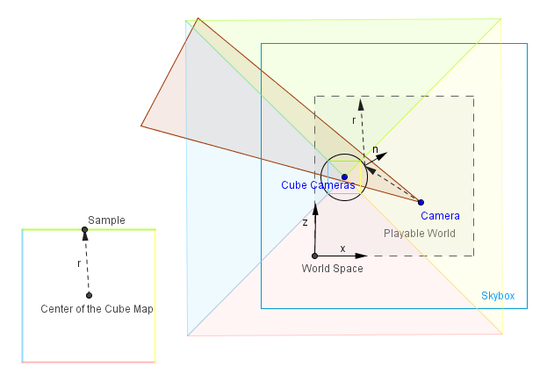

On the other hand it will allow you to reflect your moving geometry and scene accurately. There is one defect though, it can not reflect accurately objects that are themselves reflective. This would include recursive rendering and in the worse case could take a lot of passes to complete (if at all). Much better approach for a multi-hop reflectivity would be techniques based on ray tracing, that we will see later.

You can play around with a dynamic cube map in the example on the right.

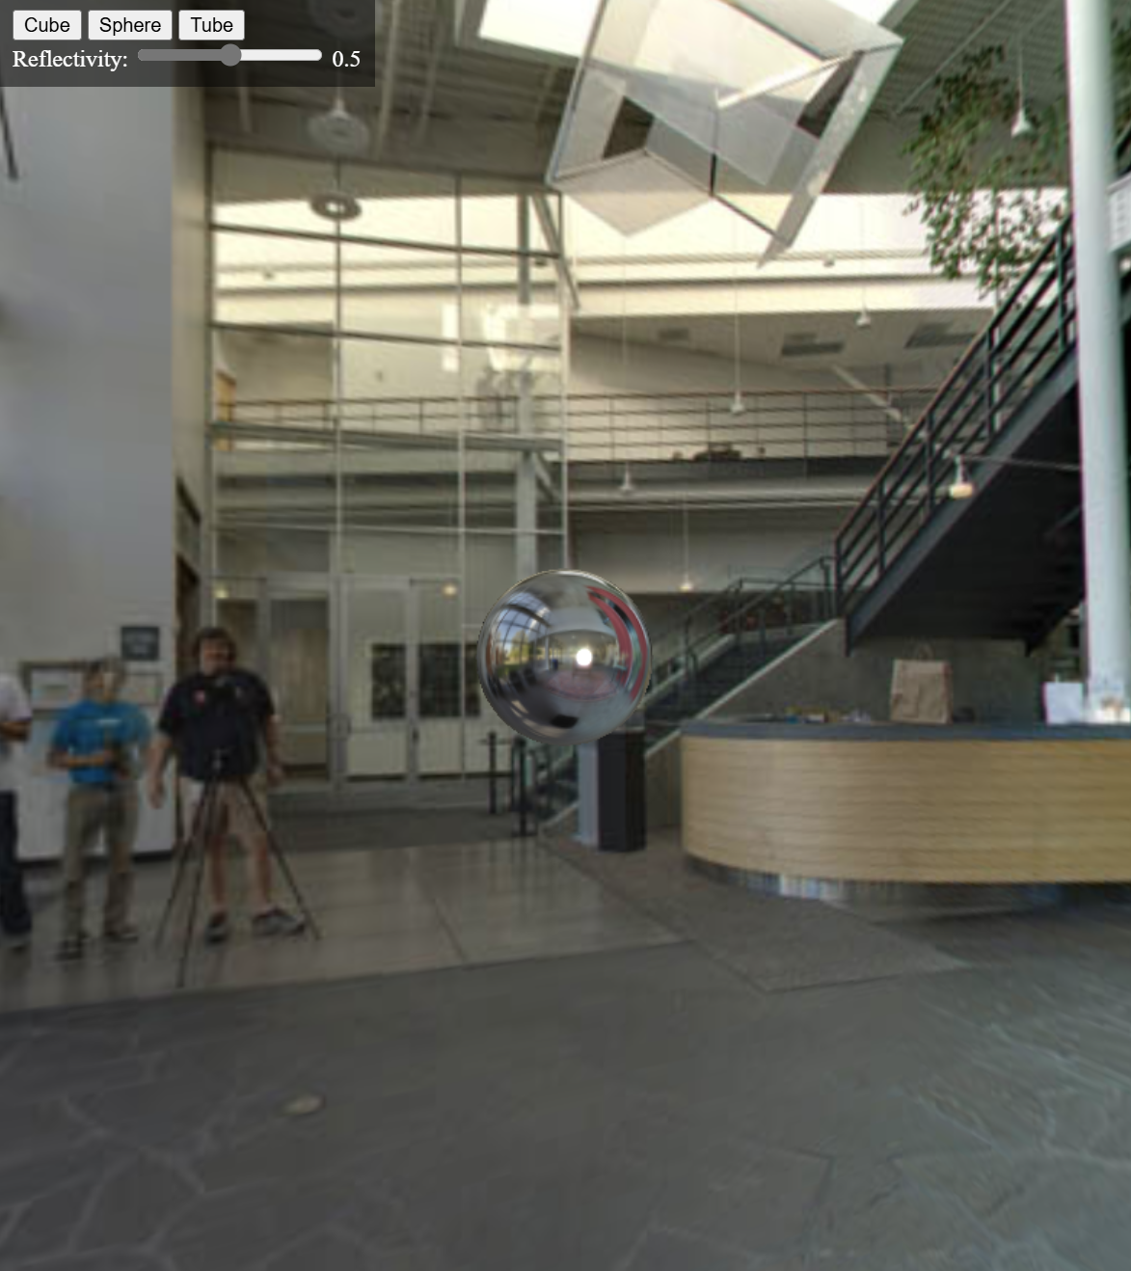

Sphere Map

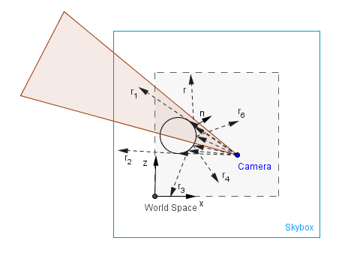

Historically before cube mapping there was first sphere mapping. It consisted of having an image of the environment as if it were reflected off a reflective sphere infinitely far from the camera. This means that almost the entire environment will be mapped to a spherical image from which to sample. There are some pros and cons with that.

Pros:

Entire environment is mapped to one image, we can sample from it, instead of a cube.

The center, where the reflection angle is near 0°, has good resolution.

Cons:

There is a blind spot exactly behind the sphere.

The edges, where the reflection angle is near 90°, may have aliasing, because we do not have enough pixels to hold the data.

Sphere map itself is difficult to generate: for a real photograph you need to have 360° lens and the camera would be also in the image; for programmatical generation you need a reflective sphere (with cube mapping for example).

For a dynamic sphere map you would need to generate it again, just like with the cube map.

Because of the different resolution, it is dependent on the camera position. If the camera position changes, you would need to regenerate it to avoid aliasing.

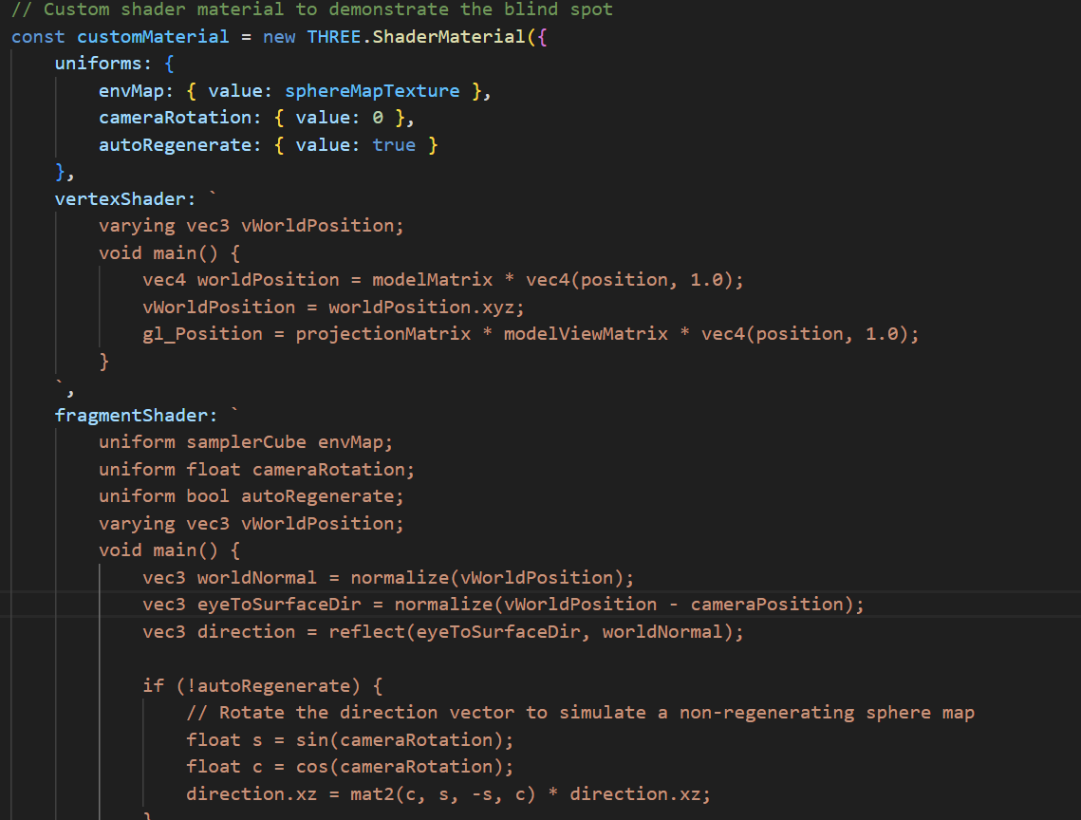

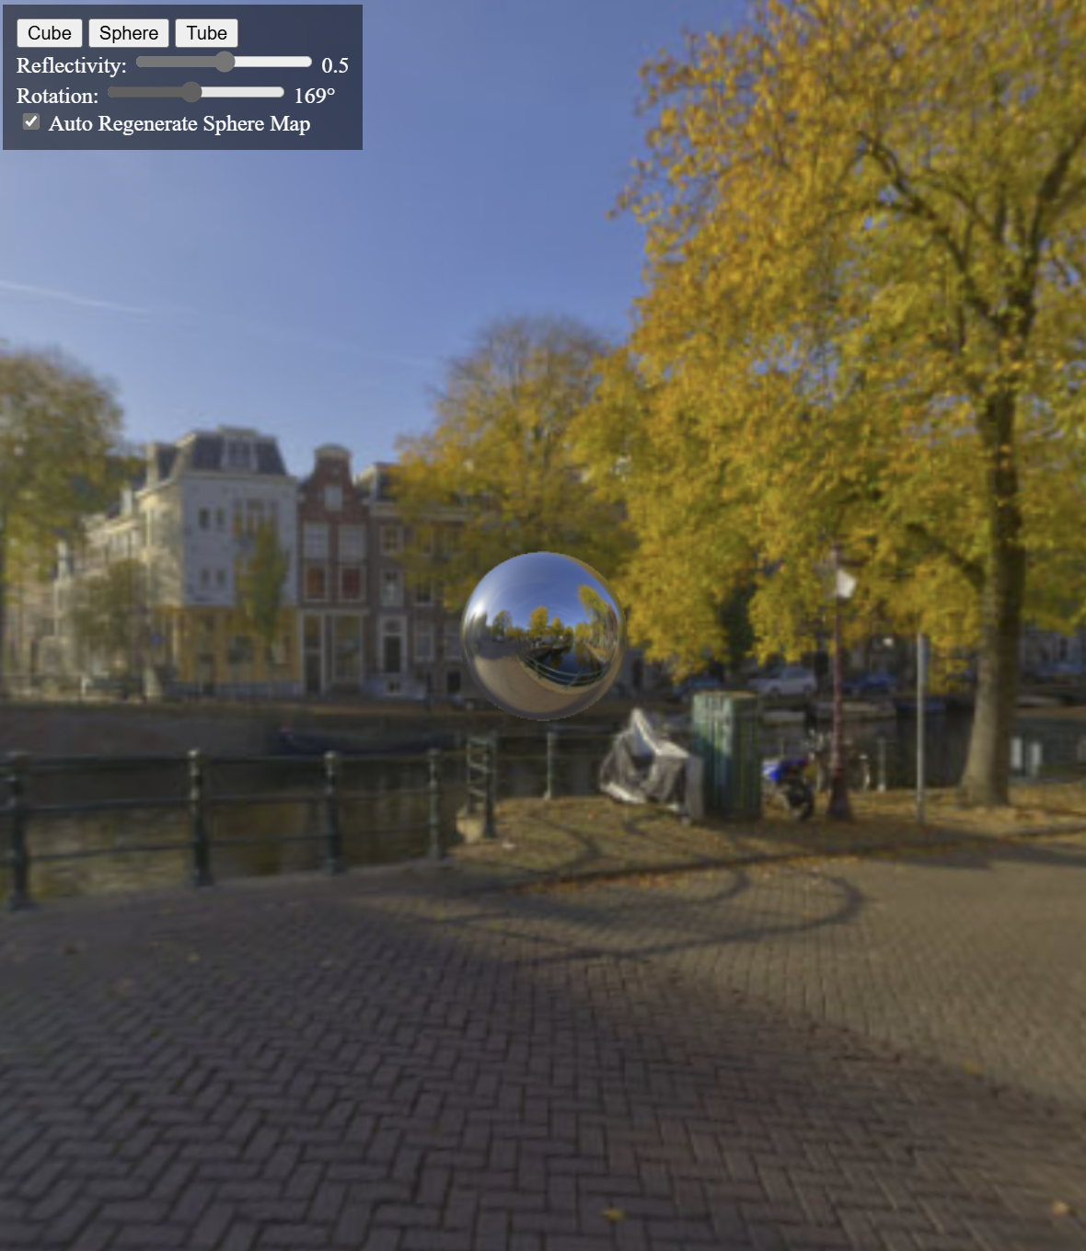

Curves

Modeling everything with straight lines is simple, but tedious. If we want an approximation of a curve, we need to send enough points so that the linear segments connecting the points would resemble the curve enough. By interpolating the normals and doing other tricks (like [bump](http://en.wikipedia.org/wiki/Bump_mapping) / [normal mapping](http://en.wikipedia.org/wiki/Normal_mapping)), we can get the lighting to act like our surface is curved. The outline of the surface however will still indicate that the surface is actually flat and made out of straight lines, especially when the outline is very close to the camera.

So it would be in our best interests to be able to somehow define a curve going through the points of the surface. Here we will look in detail how to get such a curve and what types of curves there are. For a surface you can take two curves in two orthogonal directions that specify the start and end of the surface, this would be called a [tensor product surface](http://luthuli.cs.uiuc.edu/~daf/courses/ComputerGraphics/Week12/tensorproductsold.pdf).

You are probably aware of an implicit way to represent a function. We can also represent curves implicitly to specify an algebraic relation between the coordinates.

For example consider a cubic function:

f(x,y)=a0+a1⋅x+a2⋅x2+a3⋅x3=y𝑓(𝑥,𝑦)=𝑎0+𝑎1⋅𝑥+𝑎2⋅𝑥2+𝑎3⋅𝑥3=𝑦

This will define a relationship between x𝑥 and y𝑦. We could use it to put in values for x𝑥 and get out the values for y𝑦. Or we could put in both the x𝑥 and y𝑦, and see if the equation holds. This would test if a given point is on the curve or not.

What we would want, however, is that we have some other parameter t𝑡 that we input, and we get out the points (x,y)(𝑥,𝑦) that are on our curve. It would be even better, if we would know that for a given t𝑡, where roughly the points will come out. So if we are interested in a certain area of the curve, we can get out the points inside that area. That would be a function:

g(t)=c0+c1⋅t+c2⋅t2+c3⋅t3𝑔(𝑡)=𝑐0+𝑐1⋅𝑡+𝑐2⋅𝑡2+𝑐3⋅𝑡3

where ci∈R2𝑐𝑖∈𝑅2 or ci∈R3𝑐𝑖∈𝑅3 depending if we are in 2D or 3D. Respectively it would give out points in the corresponding dimension. You can notice that depending on the dimensionality we can just think of that many equations in 1D. It is more concise to rather think about vector equations, where the coefficients are from a vector space. I.e. a curve in 2D or 3D is just 2 or 3 curves in 1D for each of the coordinates.

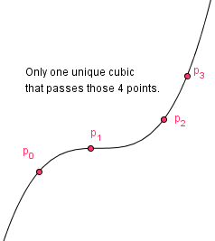

As you know, a cubic curve can be uniquely defined by giving 4 points. It would seem in our best interest to somehow specify those 4 points and have the curve pass through them. We can do this, because a cubic equation has 4 unknowns (our ci𝑐𝑖-s). If we specify 4 constraints, we can find those currently unknown coefficients and thus make g(t)𝑔(𝑡) actually usable.

.

g(t)=tvec⋅B⋅p𝑔(𝑡)=𝑡𝑣𝑒𝑐⋅𝐵⋅𝑝

The product tvec⋅B𝑡𝑣𝑒𝑐⋅𝐵 gives us another vector b𝑏 that has scalar functions as elements. When we multiply it with the parameter vector p𝑝 we will get a sum of the products of corresponding elements of b𝑏 and p𝑝. So each element of p𝑝 is taken into account, or blended, by a scalar

Now we have a cubic curve that interpolates 4 control points. We can just sample t∈[0,1]𝑡∈[0,1] to get the part of the curve starting from the first control point and ending in the last one. Note that if we were to add more constraints, then the system would become overdetermined for a cubic polynomial and we could not find a solution. Similarly we can not have less constraints.

So this is the basic idea of constructing a single curve:

Pick the parameters and constraints for them,

Construct the corresponding constraint matrix,

Find the inverse of the constraint matrix - the basis matrix,

Construct the blending functions for the parameters,

Sample the result.

The cubic curve that we just constructed can be seen in the example on the right. The red values are the control points, you can drag and move them around. The time step is the step we use for sampling the curve. Currently the curve is just a series of points that have been sampled from our function. In practice you can do that, and connect those points with lines. Or in newer OpenGL/GLSL versions there are programmable [tesselation shaders](https://www.opengl.org/wiki/Tessellation). The idea for those is that you can just send to the GPU the control points and those shaders will create the vertices there. Instead of creating the vertices in the application and sending them to the GPU. Sending the data is usually much more expensive then calculating the data on the spot.

But usually we do not want a curve that is specified with just 4 points. We would want more variation and a longer curve. You can see that if we append another cubic curve to this one (by changing the segments count to 2), then there is a sharp turn where the two curves meet.

A curve that consists of many fixed degree curves is called a spline. Currently we would have a spline where each element is an interpolating cubic curve with 4 control points.

When considering curves, we usually want some degree of [smoothness](http://en.wikipedia.org/wiki/Smoothness#Parametric_continuity). There are two types of smoothness or continuity: parameteric (C) and geometric (G). It is said that a curve has Cn𝐶𝑛 continuity if it has a continuous n-th derivative everywhere. You can see that our cubic spline has C0𝐶0 continuity, i.e. where one ends, the other begins. But it does not have C1𝐶1 continuity, the derivatives in the end of the first segment and in the beginning of the second segment do not match. Geometric continuity is a bit less restrictive, it means that the derivatives must have the same direction, but may have a different magnitude.

Next we will see how to achieve a better continuity (or smoothness) for our splines. Here are some definitions:

Curve – continuous set of points in a n-dimensional space.

Spline – curve that piecewise consists of polynomial functions.

Cn𝐶𝑛 smoothness – condition that a curve should have a continuous n-th derivative.

Gn𝐺𝑛 smoothness – condition that in points where the n-th derivative is not continuous, a change can only happen in its magnitude (not the direction).

Control point – a point used to control the shape of the curve.

Interpolating curve – a curve that passes through its control points.

Approximating curve – a curve that may not pass through the control points, but tries to minimize the error to them in regard to other constraints.

Knot - a point where a piece of a curve ends or begins.

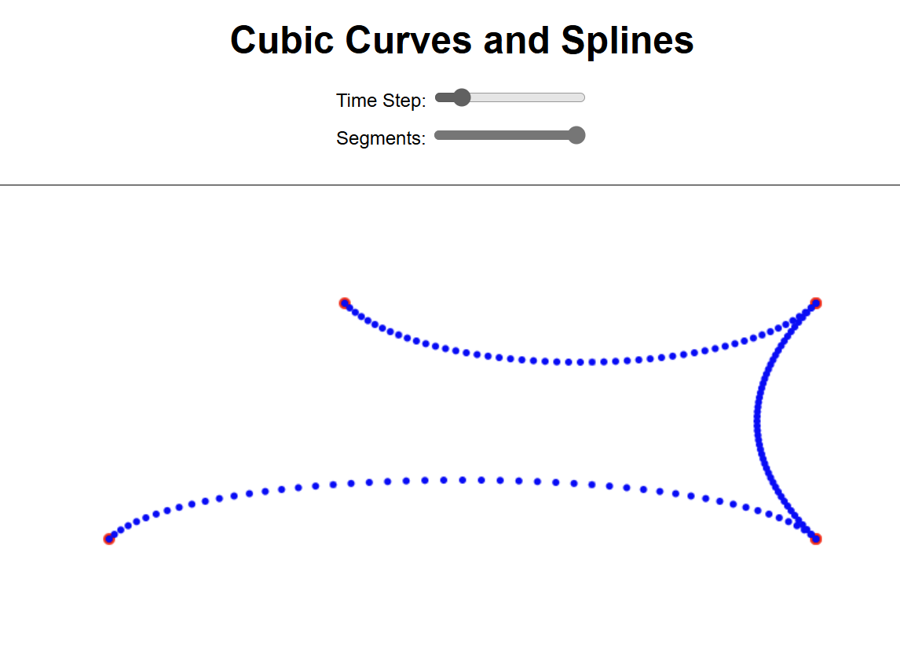

Hermite and Cardinal Curves

As you saw, with 4 points and a interpolating cubic, we got a curve where changing one point affected all of the curve. If we take higher order polynomials, then the the curve will be affected more and although, we would have a curve that interpolates the points, it is hard to control. Another problem was that if we would want to make a spline, then just connecting the end points would not result in higher smoothness than C0𝐶0.

For a spline to be C1𝐶1 smooth, we would want derivatives to be the same where one segments ends and another begins. I.e. the derivative must be continuous in the knots.

We specified the constraints so that a curve must pass all of the 4 parameters. All of the parameters were points that the curve interpolated. This does not have to be the case though.

Finding the inverse B=C−1𝐵=𝐶−1 and multiplying it with our tvec=(1tt2t3)𝑡𝑣𝑒𝑐=(1𝑡𝑡2𝑡3) will give us corresponding blending functions that when used on the parameter vector will give us our curve. Just like we did before.

This kind of curve is called a [Hermite curve](http://en.wikipedia.org/wiki/Cubic_Hermite_spline). You can see the example on the right. The curve interpolates the control points and besides those points you can also change the derivatives in the beginning and end of a curve. When you increase the segments count to get a spline, the next segment has a beginning point the same as the previous segment's end point and the beginning derivative as the previous segment's end derivative.

But manually controlling the derivatives of a Hermite curve might be tedious. There is a way to calculate the derivatives automatically. For this we will have to make a curve such that it sill interpolate only the second and third point. First and fourth point will be used to calculate the derivatives by taking a [finite difference](http://en.wikipedia.org/wiki/Finite_difference) from the third and second point respectively.

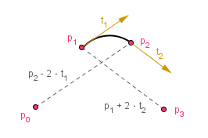

Imagine four control points. The derivative in the second point is half of the vector from the first point to the third point. This will be our constraint. We will parametrize the curve so that at time 0 we are at the second point and at time 1 we are in the third point.

g(0)=c0+c1⋅0+c2⋅0+c3⋅0=p1𝑔(0)=𝑐0+𝑐1⋅0+𝑐2⋅0+𝑐3⋅0=𝑝1

g(1)=c0+c1⋅1+c2⋅1+c3⋅1=p2𝑔(1)=𝑐0+𝑐1⋅1+𝑐2⋅1+𝑐3⋅1=𝑝2

If we specify the derivatives so using finite difference:

g′(0)=0.5⋅(p2−p0)𝑔′(0)=0.5⋅(𝑝2−𝑝0)

g′(1)=0.5⋅(p3−p1)𝑔′(1)=0.5⋅(𝑝3−𝑝1)

We can add two more constraints that specify our two other parameters p0𝑝0 and p3𝑝3:

p0=g(1)−2⋅g′(0)=c0−1⋅c1⋅1+c2⋅1+c3⋅1𝑝0=𝑔(1)−2⋅𝑔′(0)=𝑐0−1⋅𝑐1⋅1+𝑐2⋅1+𝑐3⋅1

p3=g(0)+2⋅g′(1)=c0+2⋅c1⋅1+4⋅c2⋅1+6⋅c3⋅1𝑝3=𝑔(0)+2⋅𝑔′(1)=𝑐0+2⋅𝑐1⋅1+4⋅𝑐2⋅1+6⋅𝑐3⋅1

This has given us 4 necessary and sufficient constraints from which we can construct a constraint matrix.

This is the constraint matrix for a [Catmull-Rom curve](http://en.wikipedia.org/wiki/Cubic_Hermite_spline#Catmull.E2.80.93Rom_spline). For a spline we can connect individual curves together so that the next segment's first three points are the previous segment's last three points. This will ensure that the first derivatives in the knots are continuous (because they are calculated from the same points).

Sometimes there is an argument called tension∈[0,1]𝑡𝑒𝑛𝑠𝑖𝑜𝑛∈[0,1] added. This will change the weight that the derivatives are calculated in the finite difference scheme. Then the derivatives would be:

g′(0)=0.5⋅(1−tension)⋅(p2−p0)𝑔′(0)=0.5⋅(1−𝑡𝑒𝑛𝑠𝑖𝑜𝑛)⋅(𝑝2−𝑝0)

g′(1)=0.5⋅(1−tension)⋅(p3−p1)𝑔′(1)=0.5⋅(1−𝑡𝑒𝑛𝑠𝑖𝑜𝑛)⋅(𝑝3−𝑝1)

Notice that when tension=0𝑡𝑒𝑛𝑠𝑖𝑜𝑛=0, then we have the Catmull-Rom curve. When tension=1𝑡𝑒𝑛𝑠𝑖𝑜𝑛=1 then the derivatives are 0 and we have a piecewise linear curve (which does not look like a curve at all). Generally this is called a [Cardinal curve](http://en.wikipedia.org/wiki/Cubic_Hermite_spline#Cardinal_spline). It would have another constraint and basis matrices that will depend on the value of tension𝑡𝑒𝑛𝑠𝑖𝑜𝑛. [Some authors](http://www.cs.cmu.edu/~462/projects/assn2/assn2/catmullRom.pdf) call the curves with the tension𝑡𝑒𝑛𝑠𝑖𝑜𝑛 parameter also Catmull-Rom curves.

You can see this curve in the example on the right. This curve is C1𝐶1 smooth and interpolates all the points except the first and the last. Also changing the locations of points will not affect the whole curve, but only the segments two hops to each direction.

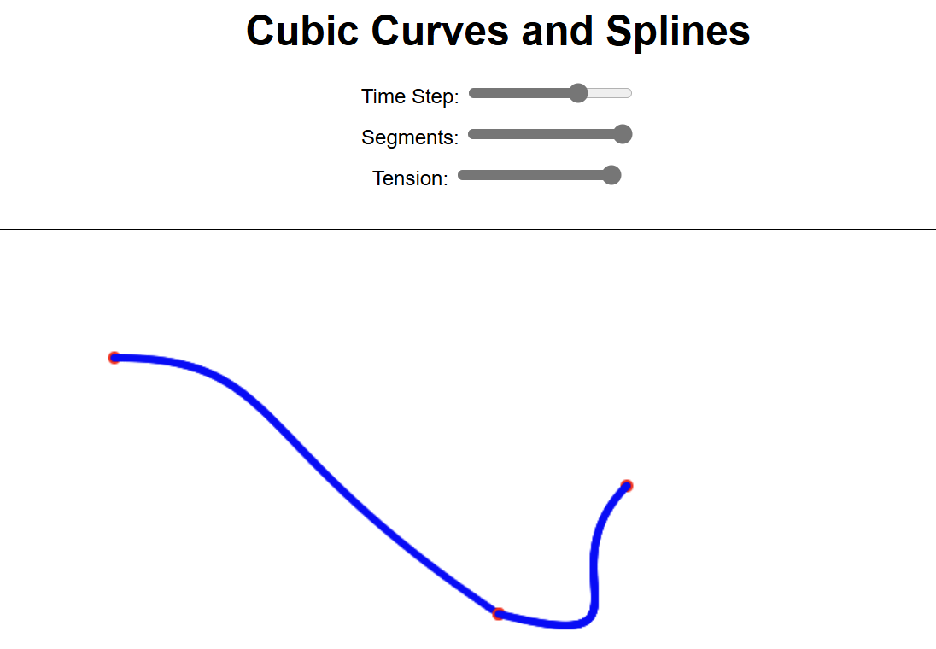

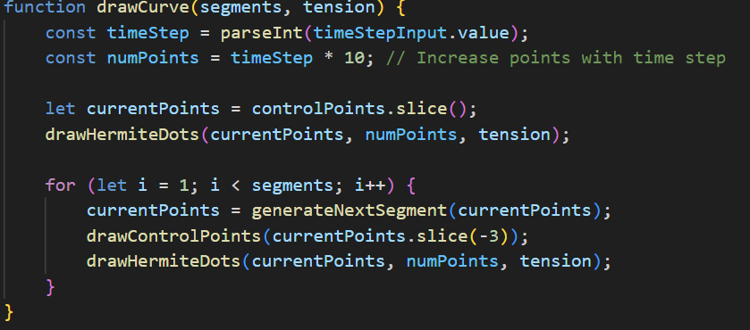

Bezier Curve

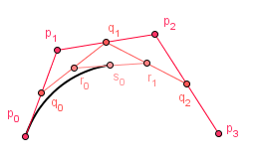

A very important curve in computer graphics is a Bezier curve. We could construct it with a constraint and basis matrices like we did before, but let us try a different approach first. Consider 4 control points p0𝑝0, p1𝑝1, p2𝑝2 and p3𝑝3 like before. Now, take a linear interpolation between two consecutive control points with our parameter t𝑡. We will get 3 points, let us call them q0𝑞0, q1𝑞1 and q2𝑞2. We do the same with those points and find two linear combinations r0𝑟0 and r1𝑟1. One more step to go and we get a point s0𝑠0.

If you consider a pencil to bet at s0𝑠0 and interpolate our t∈[0,1]𝑡∈[0,1] you will get a curve.

On the example to the right you can see different degree curves and their geometric construction. Although, as you notice, when we try to put many curves together in order to form a spline, it is currently only C0𝐶0 smooth. We could get C1𝐶1 smoothness if we fix that the second control point of a segment is a reflection of the point before the last one in the previous segment over the knot. Or we could have G1𝐺1 smoothness if those two points are collinear. We can also have higher degrees of smoothness by finding relations between other control points.

It is important to note that Bezier curves have a lot of useful properties that include:

The entire curve is bounded by the convex hull of the control points.

Affine invariant – doing affine transformations on the control points results in the same effect as doing them on the curve.

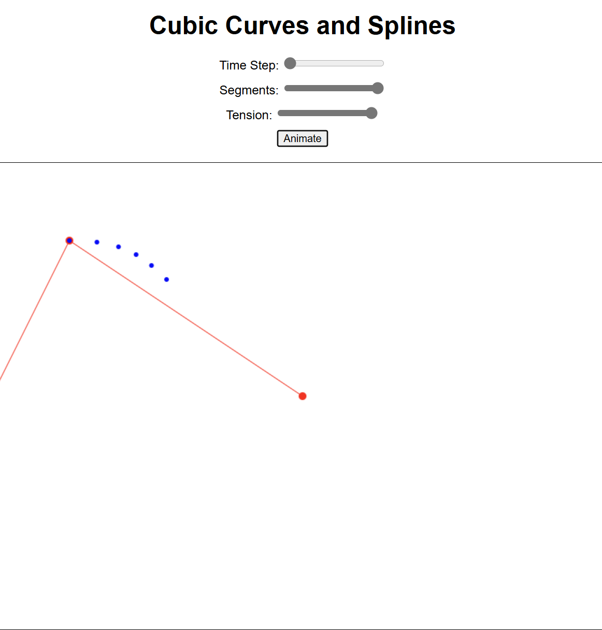

B-Spline Curve

There is another curve called the B-spline curve. Before we talk about that, we need to think about the blending functions (also called basis functions) that we have been using before. Those were the functions bi(t)𝑏𝑖(𝑡) that determined how much of a specific control point we needed to take into a linear combination at a specific time.

Exists a way to generate specific blending functions of degree d𝑑 in order to have a curve approximating n𝑛 control points, where d<n𝑑<𝑛. We are using an approximating curve, because an interpolating curve would be quite unstable for a high degree polynomials.

For the construction of the blending functions we need to understand that there are n𝑛 functions, each one for some control point. During the construction, however, different degree blending functions will affect others ones too.

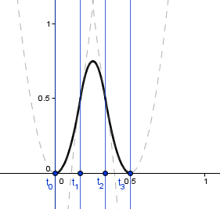

While 1st degree blending functions comprise of lines, 2nd degree blending functions comprise of parabolas. There are three distinct quadradic polynomials that form a C^1 smooth spline at our knots.

This curve, although an approximating curve, has some nice properties:

Any point on the curve is affected by at most d+1𝑑+1 blending functions, thus d+1𝑑+1 control points. So the control points will provide local control. You can see this if you look at the triangular functions. At any given time, there are at most 2 of those functions that have a non-zero value.

We can achieve a high degree n−1𝑛−1 smoothness by doing the approximation with d=n−1𝑑=𝑛−1 degree blending functions. This is the highest value we can use given n𝑛 points.

We can also achieve lower degrees of smoothness. The degree is easily varied.

There are even ways to get a lower degree of smoothness in only specific control points we want.

There is a problem though, as you can see from the n=4𝑛=4, d=1𝑑=1 case, the ranges [0, 0.2) and (0.8, 1] have only one blending function. Even worse, it will tend to zero at 0 and 1. This means that the ranges [0, 0.2) and (0.8, 1] do not have enough support. If we were to vary the time t∈[0,1]𝑡∈[0,1] then our curve would go to a point [0, 0, 0] at the ends. Now, one way would be to just take t∈[0.2,0.8]𝑡∈[0.2,0.8] then. This will work and will give an approximating curve.

Another thing that we would want, would be that the curve would actually interpolate (connect with) the endpoints. The d=1𝑑=1 curve does that by itself, but higher degree curves will not. The range, where they start to get the full support, is after the time where the first blending function was at the maximum and others 0. Think about it, we need 3 blending functions together to calculate a point in a d=2𝑑=2 curve. Those three functions will start at different knots. When the last one starts, the second one already has some value and the first one is past it's maximum.

You can see all 4 of the blending functions there, but the full support is only in a limited range. We can correctly sample our curve only from that range.

In order to have full support in all of the [0,1][0,1] range, there is a technique to repeat the knots at the endpoints. Note that the new knot vector should be of the same length, but the 0 and 1 values are repeated d𝑑 times. This causes the blending functions to act in a way where we have full support over all the unit-range. This means that the curve passes the endpoints. You can try this out in the example on the right. The blending functions are drawn on the bottom-left corner.

Also, if we take the maximum degree of smoothness, e.g. with 8 control points we can have a 7-degree polynomial which is C8𝐶8 smooth. In that case we actually get a Bezier curve.

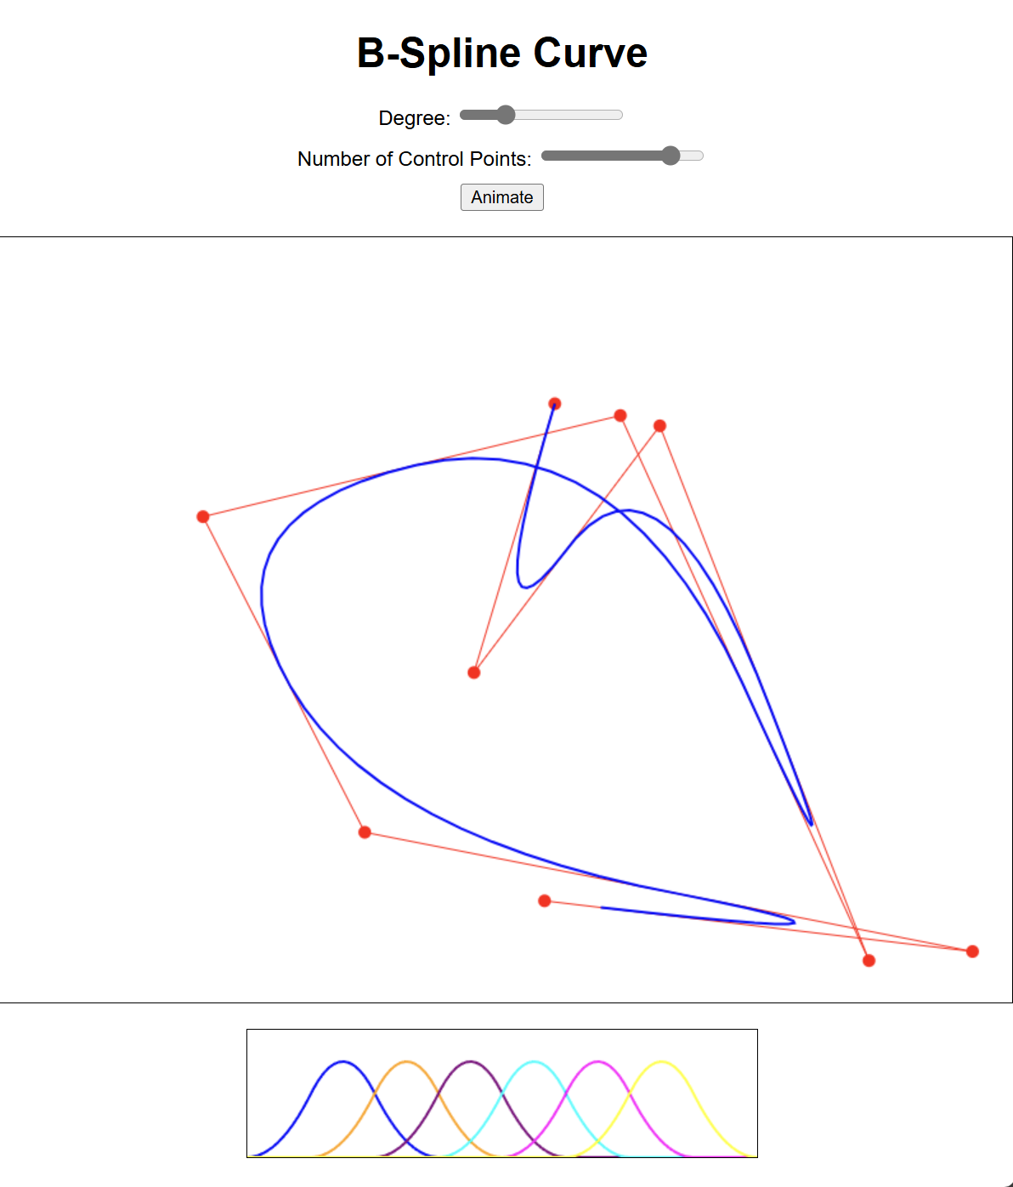

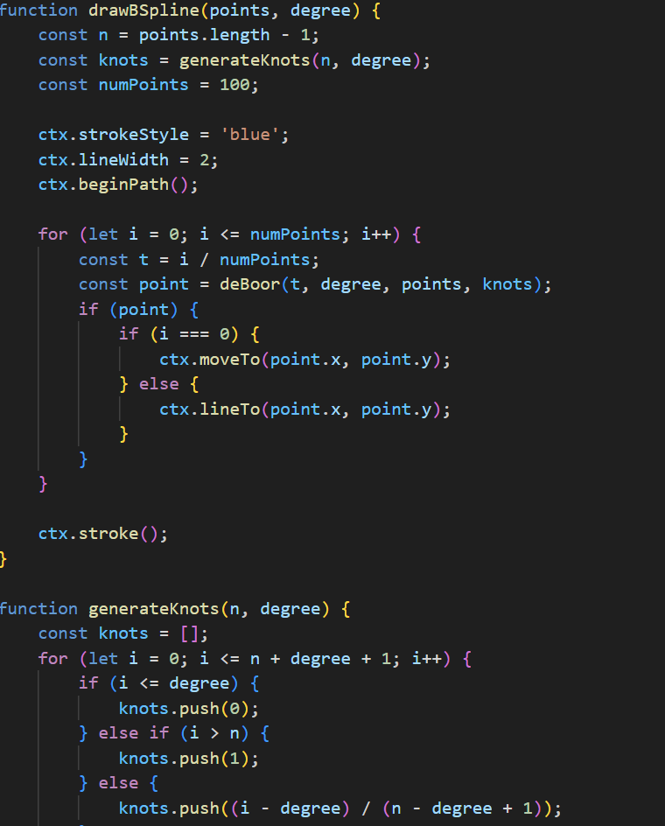NURBS

There is also an extension to B-spline curves called a NURBS (Non-Uniform Rational B-Spline) curve. As you saw before the knots uniformly distributed our time range [0,1][0,1]. This does not have to be so, there can be a non-uniform distribution of knots. Only important thing is that it would be a monotonically increasing sequence.

The rational part of a NURBS curve comes from the fact that each control point can have a weight assigned to it. Those weights need to be normalized with a ratio and thus the name rational. The exact formula is as follows:

C(t)=∑iBi,d(t)⋅wi⋅pi∑iBi,d(t)⋅wi𝐶(𝑡)=∑𝑖𝐵𝑖,𝑑(𝑡)⋅𝑤𝑖⋅𝑝𝑖∑𝑖𝐵𝑖,𝑑(𝑡)⋅𝑤𝑖

The vector w𝑤 is the vector of weights assigned to each control point. If the weights are all 1, then we have a normal B-spline. The example on the right allows you to try out different weights, although the knot vector is still left uniform.

NURBS curves are very often used to model all sorts of curves and surfaces. Not only are they affine invariant like the B-spline and Bezier curves, but if handled correctly, they are also correctly projected via a perspective projection.

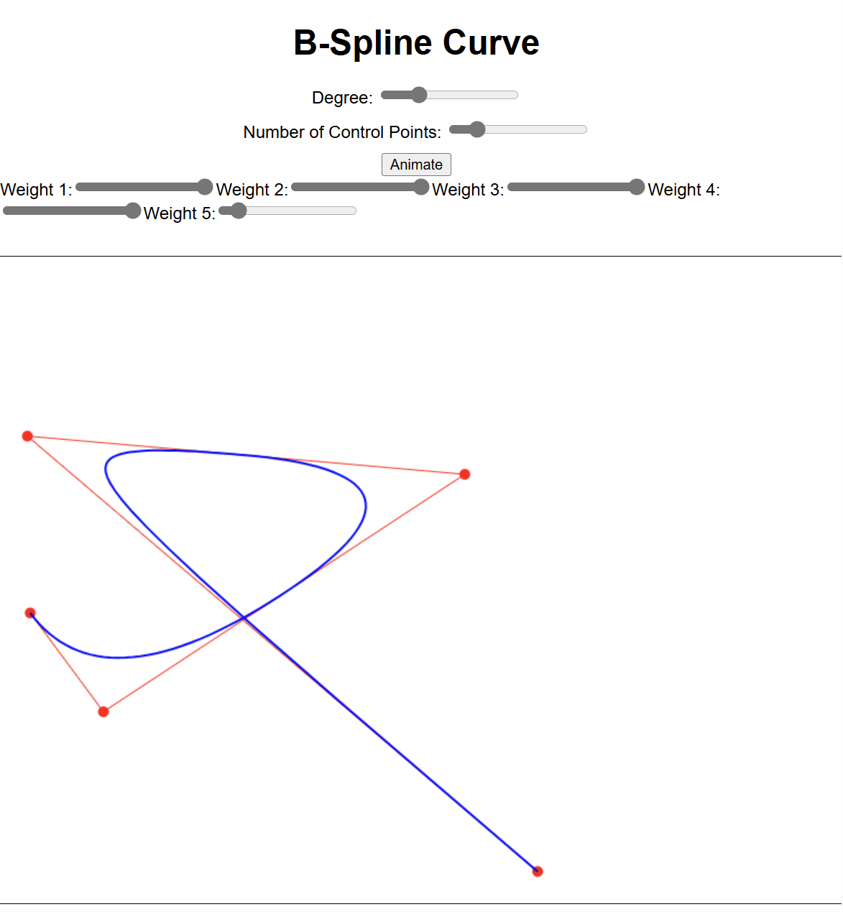

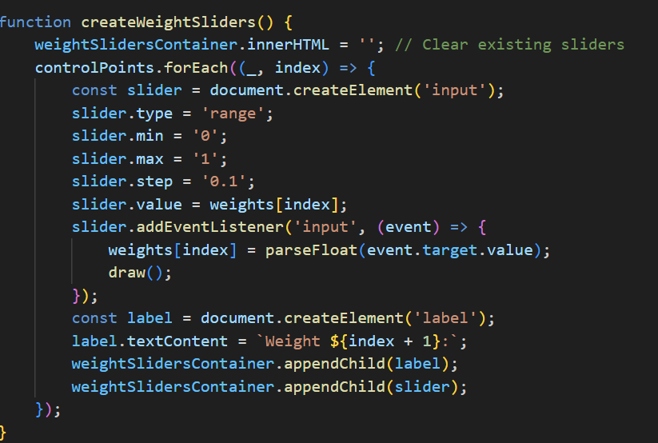

Procedural Generation

We have seen how to define our objects so that a computer understands them. We have also seen how to define some materials for those objects, so that they are colored, shiny or even textured. Still, where does all of this information about the objects and their materials come from? Does a programmer or an artist inputs all those parameters all the time? The answer is no, in a number of cases the input from a human is just a parameter range or an algorithm and either the geometry, the material, or both are generated by the computer on the fly. Usually this involves some randomness and allows to model things that would be either too time consuming or too computationally expensive to generate otherwise.

Examples of these kinds of techniques are effects like fire or energy, materials like clouds or stains, geometry like for terrain or trees. There are of course many things that have a large number of parameters that need to vary slightly or be otherwise determined via an algorithm. There are techniques to achieve the aforementioned stuff. These techniques fall under a wide umbrella called procedural generation. It means generating some objects or specific values via a procedure i.e. an algorithm. If you are philosophical enough than this umbrella might spread across all sorts of effects or objects that are in some way a result of a computer process.

Also, there are a lot of other procedural generation techniques that are not mentioned here. For example one could procedurally generate whole game worlds.

Definitions:

Procedural generation – an act of generating something via a computer procedure (algorithm).

Noise – a pattern of values that will seem somehow random, although might not actually be.

Formal grammar – a set of rules that define derivations from one string to another.

Particle system – a set of point values that have some pattern of change.

Noise

The source of all procedural generation is randomness. We are interested in creating algorithms that produce some reasonable system with a random behavior. Ok, so let us start with a function that gives random values. Note that the random number generators do not give true random values, but sample a function that will look like random. For simplicity it seems good to still call those values random, they could very well be.

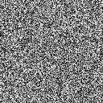

Unfortunately, if we look at random values, they will look back and appear as in the image on the right. So, how could we get something reasonable out of them?

One way would be to create a random spline through the noise values. That would be some spline that will interpolate our random values. The degree of smoothness does not matter much here. This is kind of the same if we were to just zoom in to the noise. There would not be new noise generated between the existing noise, but a transition would appear. With bilinear interpolation we have linear transitions, a C0𝐶0 spline.

Below are some zoom levels of the previous noise image.

|  |  |  |
| --- | --- | --- |
|  |  |  |
| x3 | x9 | x27 |

By themselves they do not seem much, but if we take a weighted sum of them, then the results are more interesting.

This describes a technique called value noise. Take a set of random values in some dimension, interpolate between them. Do it with the values being more apart and more closer together (different frequencies) and sum the results.

There are actually many other things you could also do. Like I mentioned the weighted sum, depending on the application, this might not be needed. Some interesting patterns can be achieved by sending the result values to another function (like sine for example). Sometimes you would like to use some smoothing / blurring on the values.

On the right there is an example that implements one possibility. There are 6 different samples done on the original static noise image. The weights weighti𝑤𝑒𝑖𝑔ℎ𝑡𝑖 define how much of the result we are considering in our sum. The zoom levels zoomi𝑧𝑜𝑜𝑚𝑖 define how much are we zooming in to the texture. Or how far away the known values are in our random spline.

The result is a bit more scaled, because the noise texture was 128×128, but our window is 300×200. Do not let this bother you.

There are plenty of things this result pattern can be used for. You could:

Use it as clouds texture (there is actually a tool called Clouds in some image manipulation programs that generate this pattern)

Generate it on a sphere and call it a planet.

Create marble or rusty metallic surface looks.

Use it as a height map to generate some terrain.

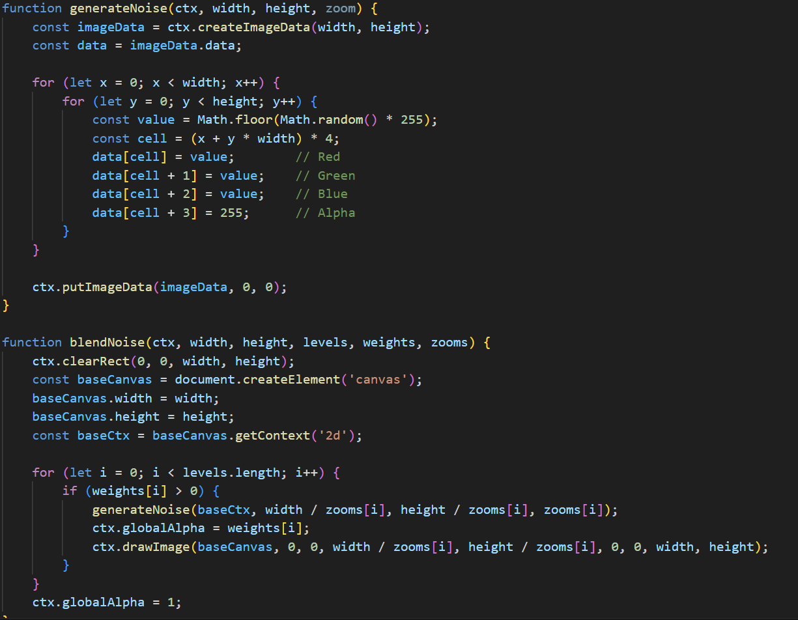

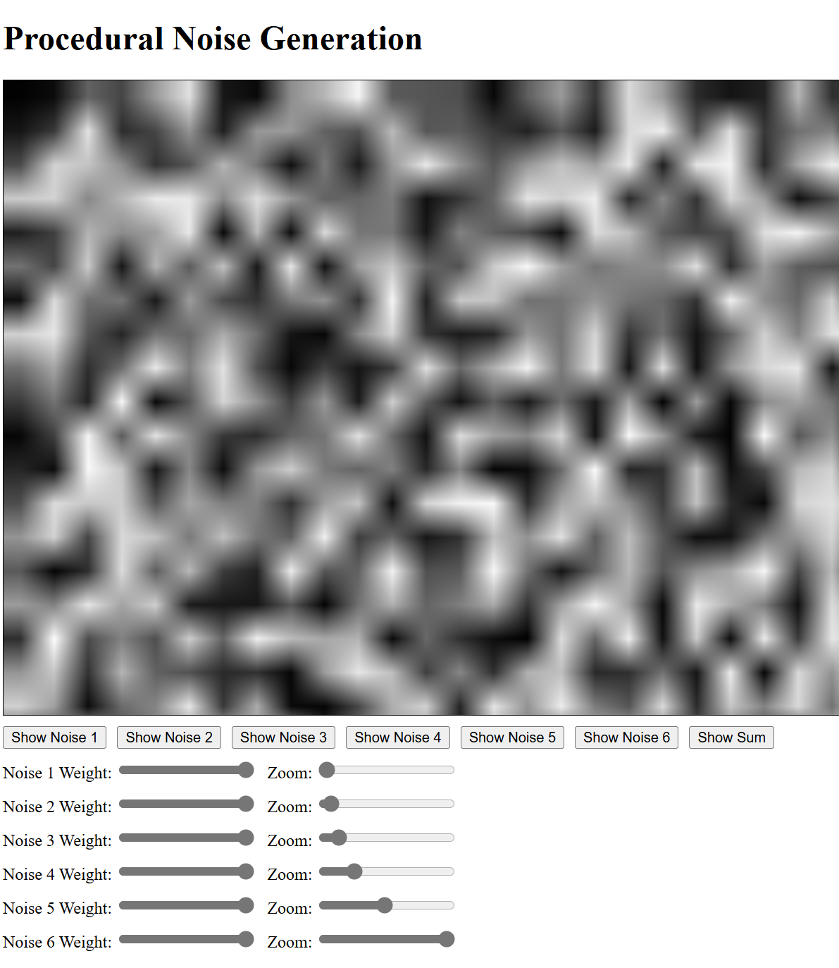

Perlin Noise

Another way to generate a noisy pattern, is not to specify the values from random variables, but instead gradient directions. Even if we were to specify more smoother interpolations than just bilinear, for the value noise, the result would still be blocky. So, instead of value noise, we could create gradient noise instead.

The main idea behind gradient noise is, that we specify a gradient direction (instead of a value) for each grid point. We can assume, that the gradient has 0 at the grid point, and the direction vector points to the increasing direction. Part of a grid line would be something like this:

For simplicity we here assume, that all the random gradient directions are generated randomly from an unit circle. You can use a random choice from some predetermined fixed number of directions (specifying 8 or 12 different directions already would give a good result). Currently the gradient vectors are also normalized (come from an unit circle, like mentioned). Youcantrywithout normalizing them, then the results may vary.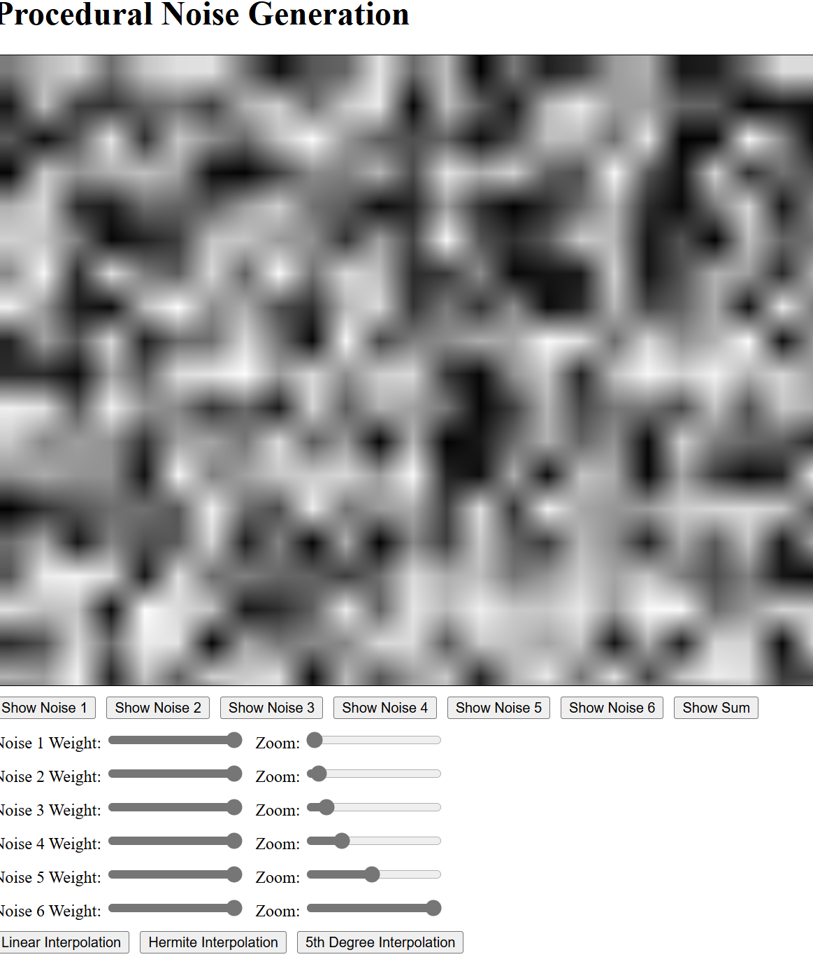

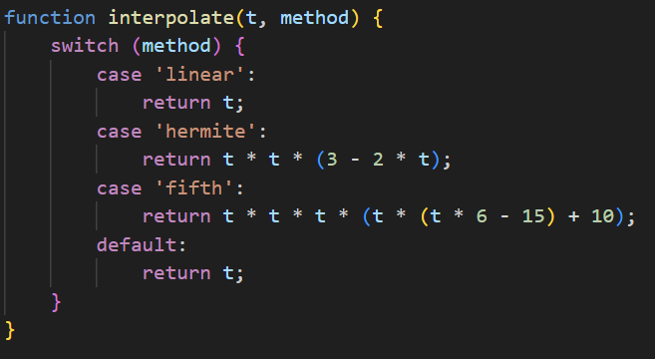

L-Systems

Some objects we would want to have are self-similar. Consider a tree for example. It starts from the trunk and then branches out. At some point along the branch there is another branching, then another branching and so on. We have a specific notion of branching there, although the actual direction of the branch and the point where it occurs, may vary.

You might have learned about formal grammars in a program code translation course. Code of a program is also somehow self-similar (we can have if-statements inside if-statements etc). Here however we will not use formal grammars to analyze a written code, but the other way around. From a formal grammar we can also derive all of the words expressible in that grammar.

Simply put, grammar is a set of rules. Each rule has a left side and a right side. Here we consider context free grammars, where a rule can be applied by matching the left side and not considering what is before or after the left side in our word. 

This means that we will get a fixed word after a number of iterations via parallel rewriting. We want to have a specific result after a specific number of iterations. However we would want some variation in what the actual result will be. We will see why in a moment.

First let us think, how this actually helps us to generate anything? The key is in the interpretation of the word. Consider the following rule:

Now, if we consider trees, then we would want to have some sort of branching. For this, we would need to remember the position in the beginning of the branching and return to it after the branch has ended. This is quite similar to tree data structure representation. We will use square brackets to specify the beginning and end of a branch. We need one more thing, a branch should change the orientation. Let us use the ++ symbol to denote a fixed rotation. Consider now the following rule:

F→F[+F]FF→F[+F]F

After the 2nd iteration from FF we have:

F[+F]F[+F[+F]F]F[+F]FF[+F]F[+F[+F]F]F[+F]F

When we interpret it, we get:

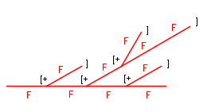

These all already sufficient building blocks to generate self-similar objects. Although, given a grammar and the iterations count, we will always get the same object. In order to provide more variety, we can make the grammar stochastic. This means that each rule has a certain probability attached to it. There can now be many rules with the same left side, but the sum of the probabilities of those must be 1. Otherwise it may happen that no rule will get applied. Of course we could consider that in that case we apply the identity rule, but that might not be that transparent.

You can see what happens when you change the probabilities of those rules. For example change the probability of the last rule (p3𝑝3) to be equal to 1. Then you will not have a stochastic system anymore and you can see that the result is always the same general shape.

A good thing about this kind of approach is that you can easily change how your tree looks like, if you change the probabilities or rules. This provides a common framework for creating many different self-similar objects.

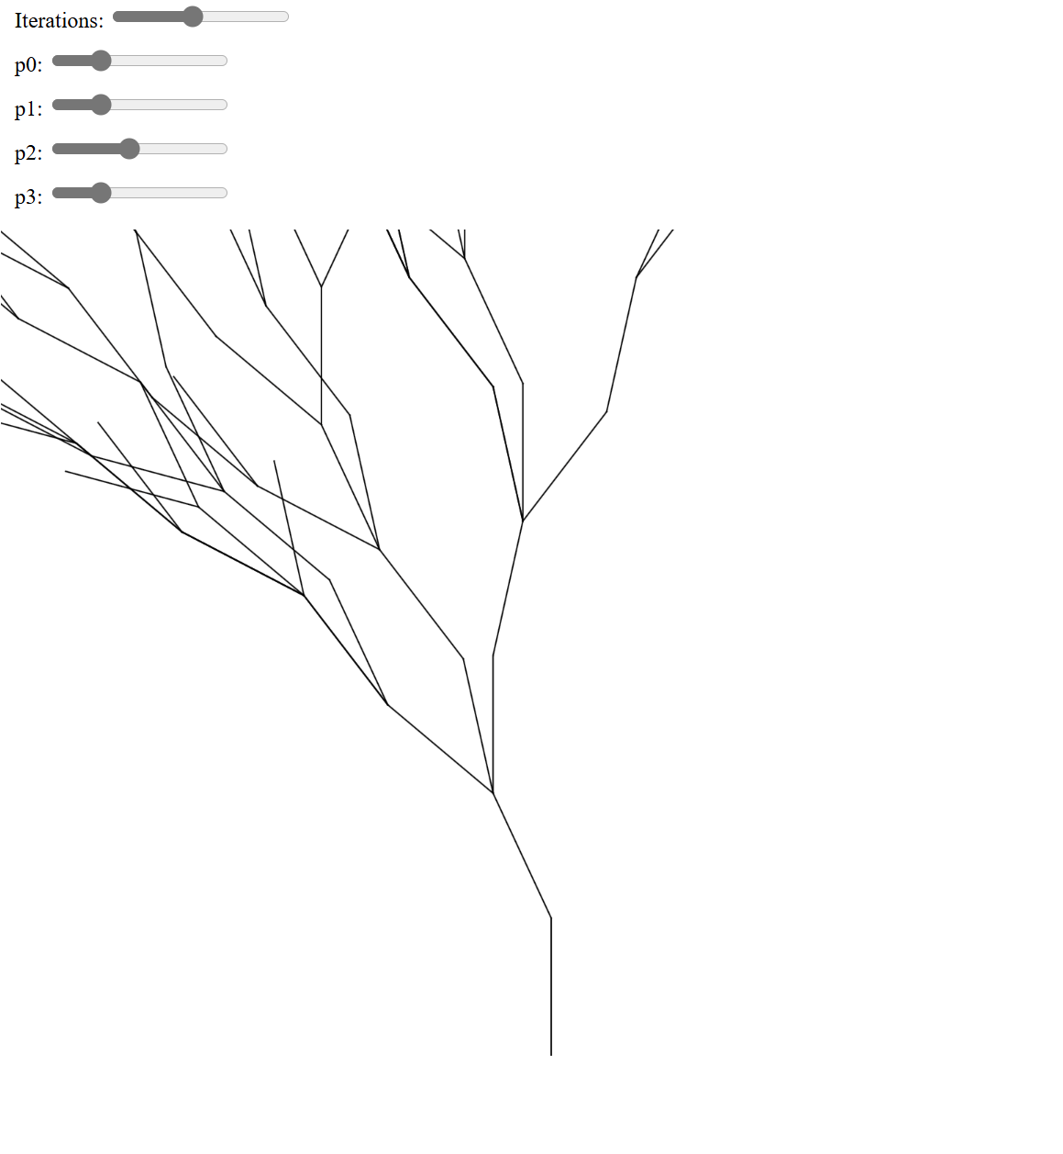

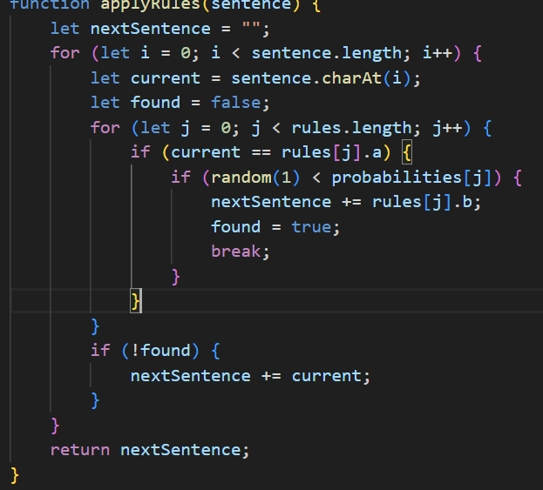

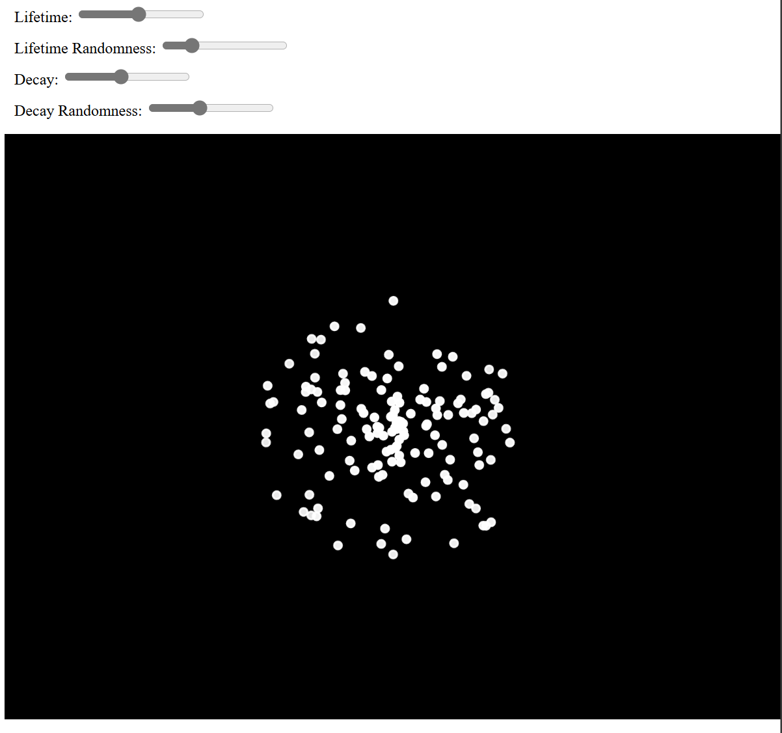

Particle Systems

Another way of generating effects is via a particle system. Now, you can have all sorts of objects act as particles, for example you might have modeled a bubble and now want many of them spawning from a fountain full of soap and bursting after some time. Traditionally a particle system will have very small objects as particles and there will be a lot of them. Together they will make up a fancy effect.

Depending on the needs, there will be different components in a particle system. Here we present a really simple one.

First we have an emitter, where all the particles spawn. This emitter can just be a location in your space. All of the particles start from that location and move in some trajectory. In our example each particle will pick a random direction in which it will move. There will also be random speed for each particle, random from some range that is. We can call the trajectory + speed a velocity and denote it vi𝑣𝑖.

Now, the particles will continue to spawn from the emitter with some rate and travel with their velocity (unless other forces change it). After some time a particle may die. We can call this time the time to live. If that time has passed from the particle's spawn, then we remove the particle. Otherwise our all scene will be filled with particles and more continue to spawn.

There might be some effects we want to do, when a particle reaches the end of its life. For example we can increase the opacity to make it seem to fade away. We might also change the color or play the bursting animation if it is a bubble. In the current example we just decrease the opacity when there is a decay number of milliseconds left for the particle to live.

A good programming pattern to use here is a worker pool pattern. We create a pool of particles when we create the emitter. When a particle dies, it returns to the pool and becomes available to spawn again. This of course assumes that we have a big enough pool. If you change the particle's lifetime to first into very small value and then to a too large value, then you can see a pulsating effect from the emitter. This happens because the particle pool becomes empty. Particles live longer, there are more of them in the scene at once.

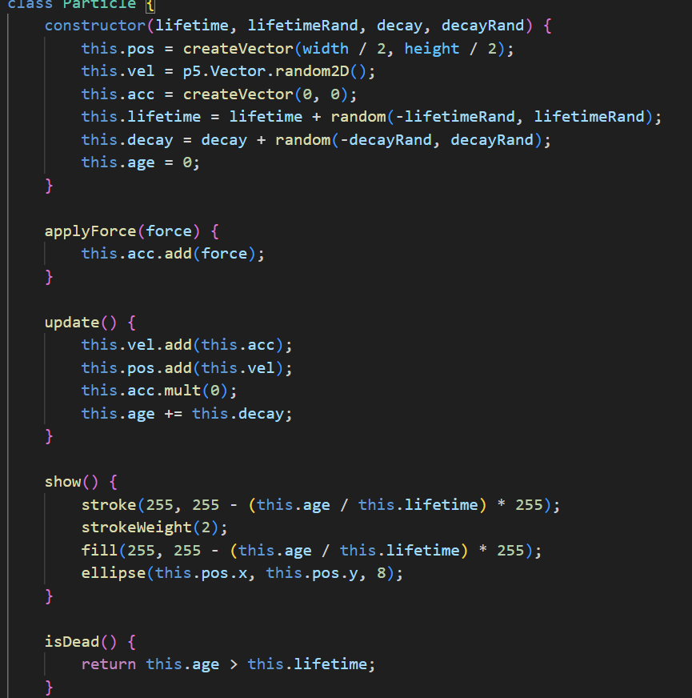

But you do not have to have an emitter and particles constantly spawning and dying. There might already be a number of particles visible and we want some kind of behavior assigned for them. Previously we just had a random velocity for the particles.

There is an algorithm called Boids that tries to mimic the flocking of birds. It is a particle system that follows a couple of simple rules:

Cohesion – Each particle tries to move towards the center of mass of all the particles. If the mass is the same, then we can sum all of the positions and find the average of them to get the center of the mass.

Separation – Each particle tries to avoid other particles. If it becomes too close to one, it will move away from it.

Alignment – Each particle tries to follow the average velocity of other particles. This is quite similar to the center of mass, we sum all the velocities and find the average.

Those are the basic rules. Of course one can add more rules to those. For example the particles might try to follow some moving target. Or they might collide with walls or avoid obstacles.

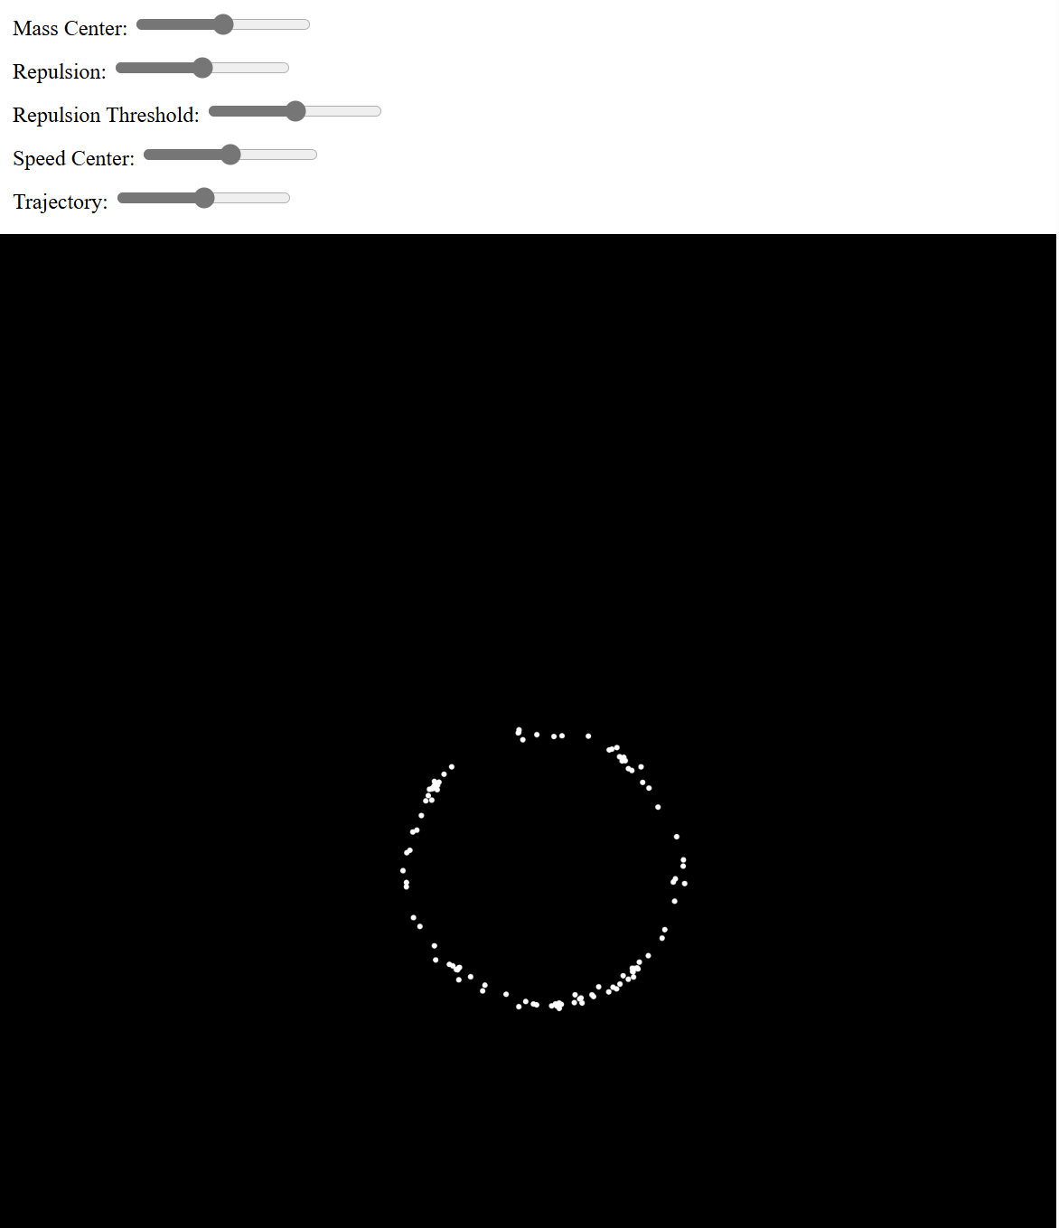

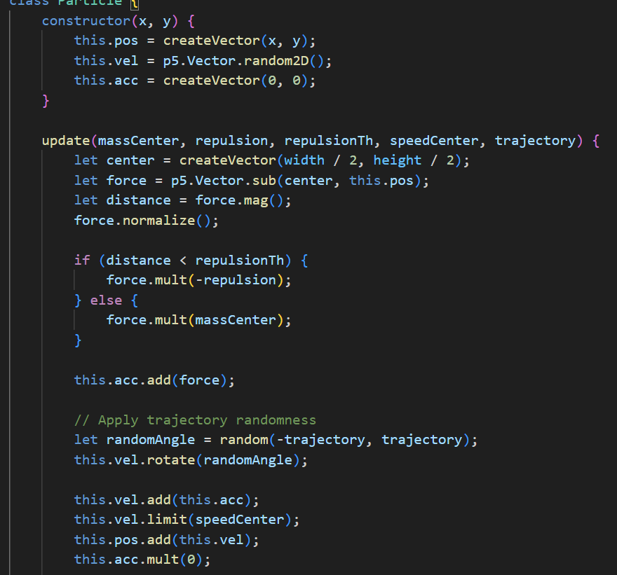

Ray Tracing, Space Partitioning, BVH

So far we have rendered our scene via the standard graphics pipeline. That is, we sent the geometry to the GPU, where it was rasterized and each fragment colored. Fragment coloring took into account the light source, material properties and used some lighting model to calculate the color value. The scene was drawn from the geometry to the pixel values.

There is another approach that tries to render from the pixel values to the geometry. It is computationally much more expensive, but may allow for some more realistic effects to be easily achieved. The idea behind ray trace rendering is that for each pixel we send a ray to the scene. This ray starts from the viewer location and goes through the pixel we want a value for. Then we need to find out what geometric object ray hits first and the actual hit point. We can calculate a color for that hit point using a lighting model the same way as before. Although it might be more clever to cast another ray from that hit point to the light source, to see if the light is actually visible. Furthermore, we can reflect the ray from the hit point and repeat the process, in order to model reflective materials.

The majority of the computations here will go into determining what object a ray hits first. If we have objects consisting of triangles, then in the simplest approach we need to calculate ray-triangle intersection testing for each ray for each triangle. This can become really slow. There are many data structures that can improve this by organizing the triangles in a way, where we can determine which triangles might be on the ray's path, and which are certainly not.

We will be looking at the idea of ray casting, ray tracing and those data structures.

Some definitions:

Ray – a mathematical object that has an origin and a direction.

Ray casting – technique of constructing a ray and finding out what it intersects.

Ray tracing – technique of doing ray casting recursively, reflecting the rays as they hit the geometry.

Data structure – way of organizing the data so, that some operations are effective (usually have a lower complexity class)

Spatial indexing – way of organizing the spatial data so that spatial queries are effective.

Tree – an hierarchical data structure, acyclic and connected graph with one of the nodes classified as a root.

Ray Tracing

One way to render a scene is by casting rays from the viewer through each pixel we need a color value for. For each ray, we can find, which triangle it intersects first. On the hit point, we can calculate the color via some lighting model. If the surface is reflective, then we can reflect another ray from the hit point and take into account the color value it receives by some reflectivity coefficient.

color=0.5⋅color+0.5⋅rayCast(hit,reflectedDirection)𝑐𝑜𝑙𝑜𝑟=0.5⋅𝑐𝑜𝑙𝑜𝑟+0.5⋅𝑟𝑎𝑦𝐶𝑎𝑠𝑡(ℎ𝑖𝑡,𝑟𝑒𝑓𝑙𝑒𝑐𝑡𝑒𝑑𝐷𝑖𝑟𝑒𝑐𝑡𝑖𝑜𝑛)

This is a recursive process and needs to terminate after some number of bounces. The actual coefficients will probably become way too small to visually affect the result as well.

Besides reflecting a ray, there can also be refractive materials. Instead of a mirror sphere, you could have a glass sphere, that will let light pass through, but change its direction a bit. So you might want to cast another ray inside the geometric object. Although in that case you do not want to do back face culling for the ray-triangle intersection. Light will change direction whenever the material it passes through changes in density. So when the ray exits the glass sphere, it should change the direction again.

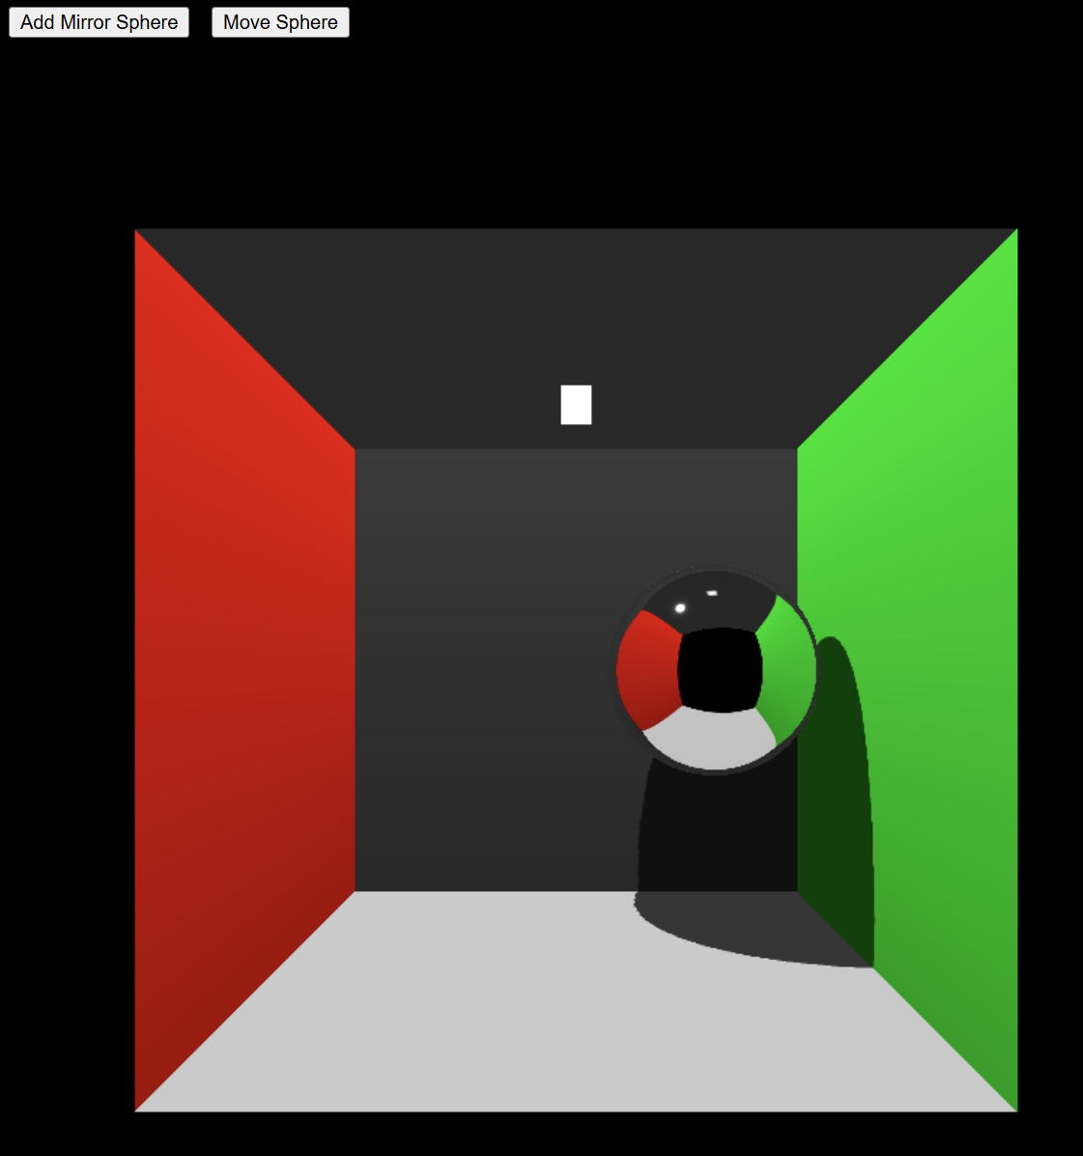

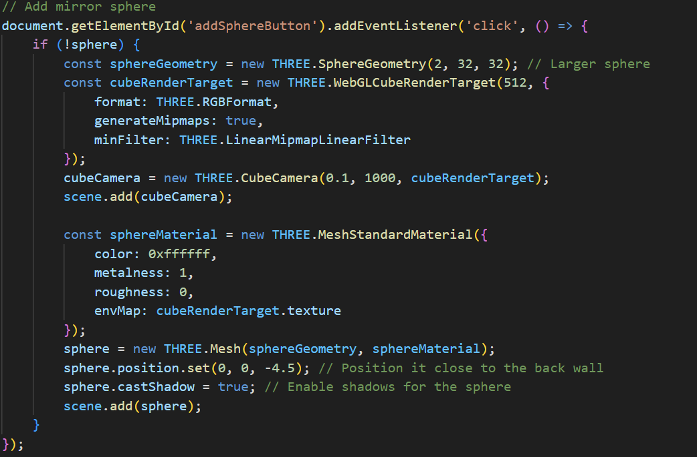

Global Illumination

While the techniques we have seen so far are quick to compute (with the exception of ray tracing), often times they can seem a bit unrealistic. With textures and effects one could create an experience that will be sufficient for some people. However, one aspect that has been missing is global illumination. Currently we have been dealing with local illumination, which means that each surface is illuminated only by the light sources. In reality the light bounces around in the environment and a surface is actually illuminated from all directions and by different wavelengths of light.

That is why the [Cornell Box](http://en.wikipedia.org/wiki/Cornell_box) scene is often used to model the effects of global illumination. The red and green walls will reflect red and green light to the floor, ceiling and objects in the middle. Furthermore, the floor will also reflect white light to the objects from the bottom. Previously we approximated this with an ambient light parameter, which was often constant. Now we can try to see, if we could actually find out what light and from where is illuminating the surfaces indirectly.

This idea is summed up via the [rendering equation](http://en.wikipedia.org/wiki/Rendering_equation). Material color is affected by the light coming in from all of the directions along the hemisphere of the surface (around the surface normal). Depending on the surface properties (how much diffuse, how much specular – usually this and more is described via a specific [bidirectional reflectance distribution function](http://en.wikipedia.org/wiki/Bidirectional_reflectance_distribution_function)). If we have a totally diffuse surface and a point light source, then this idea could be described with the following image.

Path Tracing

We can not calculate the infinite integral in the rendering equation directly. That means that we can not sample infinitely many directions in order to find out the exact and correct color of our material. [Path tracing](http://en.wikipedia.org/wiki/Path_tracing) will try to estimate that color by sampling in a random direction, sending many such rays per pixel and averaging the result. There are actually several variants of path tracing, some are more optimal and converge sooner then others.

The basic idea, however, can be described as follows:

Shoot a ray through the pixel into the scene, find the first intersection.

Reflect the ray from the hit point to a random direction.

If ray hits the light source, return the emittance of the light source.

Repeat the steps 2-3 some number of times (could even be a random number of times).

If the ray did not hit the light source during those steps, do not consider that ray.

If the ray hit the light source, then recurse back and take the BRDF-s of the surfaces into account.

Repeat the steps 1-6 a large number of times per pixel.

Average all the rays that hit the light source.

So this means that first we just shoot one ray through the pixel. We will bounce it in a random direction. If it hits the light source, then we consider the illumination originating from the light source. As you remember, point lights and directional lights are not exactly realistic, for a correct result you should have an area light source that emits a large number of luminance.

Then we shoot another ray and bounce it in a random direction. This ray may not hit anything at all and will not be considered in the total average for the pixel in hand.

Third ray could hit some other material. If that happens, you can randomly decide if you will stop and consider that ray as a miss. Or you will bounce it again in a random direction and consider all of the cases it might hit or miss.

If you repeat this a large number of times per pixel and average the result, then the final image will approximate a realistic result.

Because many of the rays will be misses, this is not a that valid approach for a real-time rendering. However, we could consider following optimizations:

Have a closed scene, a ray will always hit something.

After a number of bounces, direct the ray towards the light source.

Alternatively, in each hit, consider the local illumination of the hit point as the emittance originating from the material (add it to the overall result).

As you can see, with 0 bounces, the scene is exactly like it would be rendered via the standard graphics pipeline, ie has only local illumination. With 1 bounce you should see the red and green colors reflected to the ceiling, floor, back wall and the sphere in the middle. Notice that the sphere is grayish from the bottom, because the floor on the bottom has originally gray color. Now, if you specify 2 bounces, then the sphere will also be red and green from the bottom, because now the floor color is taken into account together with 1 bounce of indirect illumination.

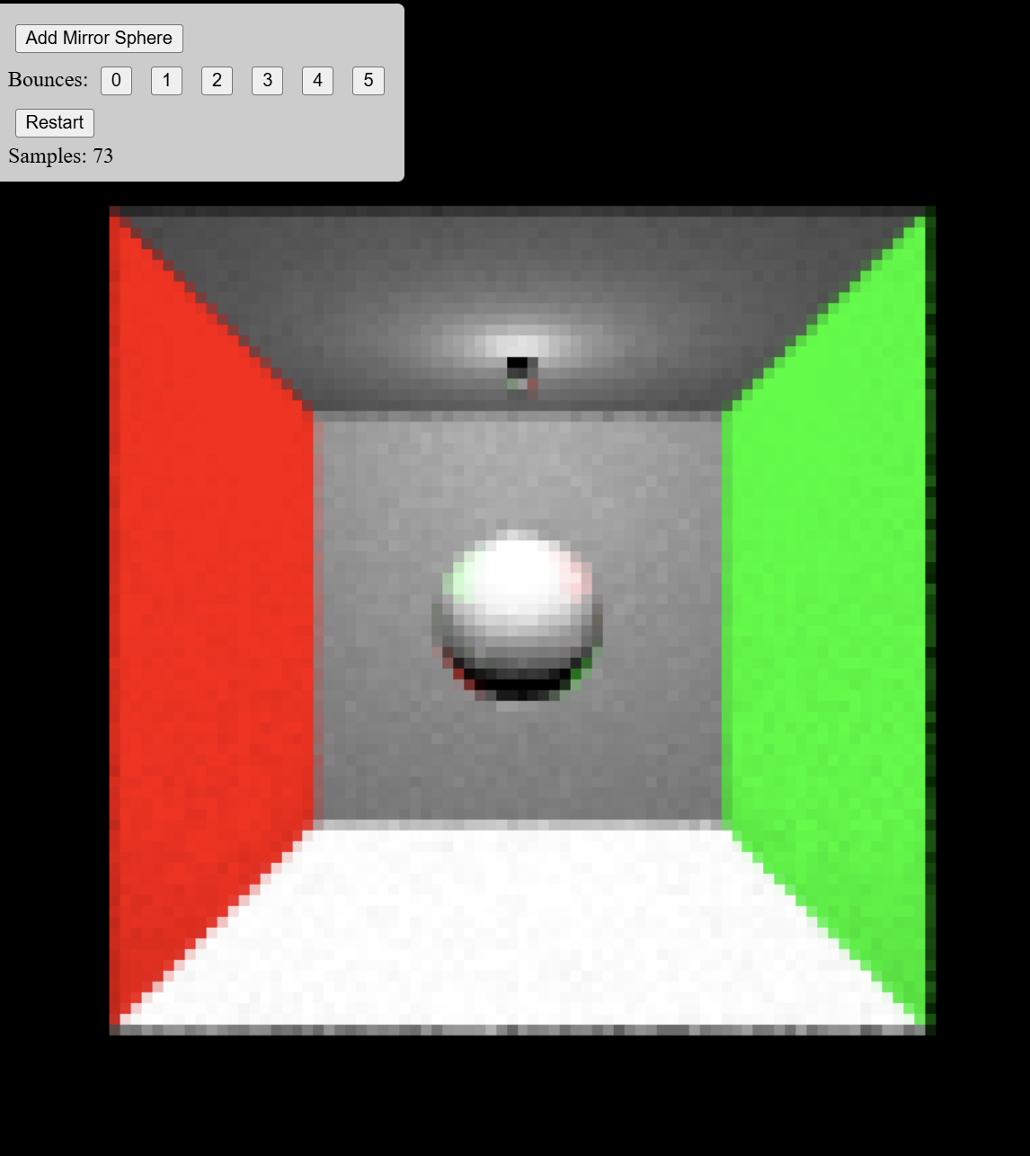

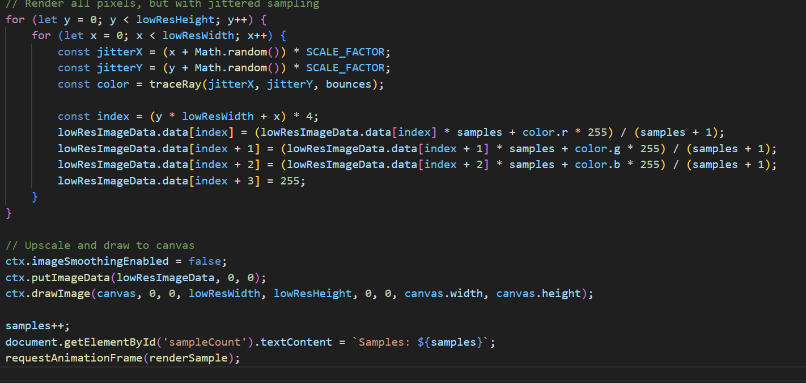

Shadows

Although this is the last topic in this module, shadows contribute a lot to the visual effect of the scene. Through shadows humans distinguish more clearly movement and depth of objects. Shadows are important, but also require more complexity to get right. Compared to light calculations, where we can have some (often quite a lot) deviation from reality, for shadows it is more easily detectable if something is wrong. There are a number of techniques that can be used to create shadows for the objects. Through history some have been more popular than others. In this topic we will see real-time techniques shadow mapping and shadow volume, also known as stencil shadows.

First let us think about what shadows actually are. They indicate the absence of some direct light. Another object is in the way of our point in shadow and the light source. In reality the light sources have some area. We use differently shaped lamps to distribute the light from the bulb around. Because of that area, there will be parts of our scene that will be illuminated by only a portion of the light. If you have an object in front of an area light source, then depending on the distance and areas, some places can be in complete shadow (umbra), some can be in half-shadow (penumbra, antumbra).

Umbra – Full shadow.

Penumbra – Half-shadow formed in the partially shadowed area.

Antumbra – Half-shadow formed, when different penumbras meet.

Hard shadow – Shadow with hard edges, the umbra.

Soft shadow – Shadow with soft edges.

Global Illumination Shadows

Well, in the global illumination we often can get realistic shadows with little effort. In order to estimate, where the light is travelling, we already are taking into account the scene geometry. Let us look closer at path tracing. Previously we applied a lighting model directly in all of the hit points of rays. This ignores the possibility that the hit point might not be directly visible from the light source. So, in order to find out if that is the case, we can send another ray directly into the light from the hit point. If it hits the light source, the point can have a light calculation applied on it for that light source. If it hits something else, then the point will be in the shadow.

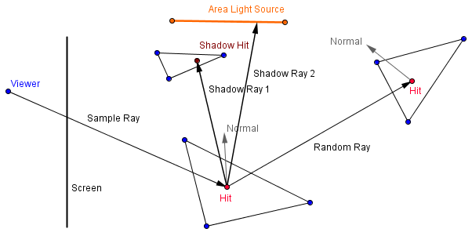

On the right there is an extension of the path tracer from the last topic, that now shoots 4 shadow rays into random positions on the 4 quarters of the area light source. Depending on how many of the shadow rays actually hit the light source, the light contribution from that light source will be accounted.

You can see that there will be an umbra and a penumbra of the cube on the floor.

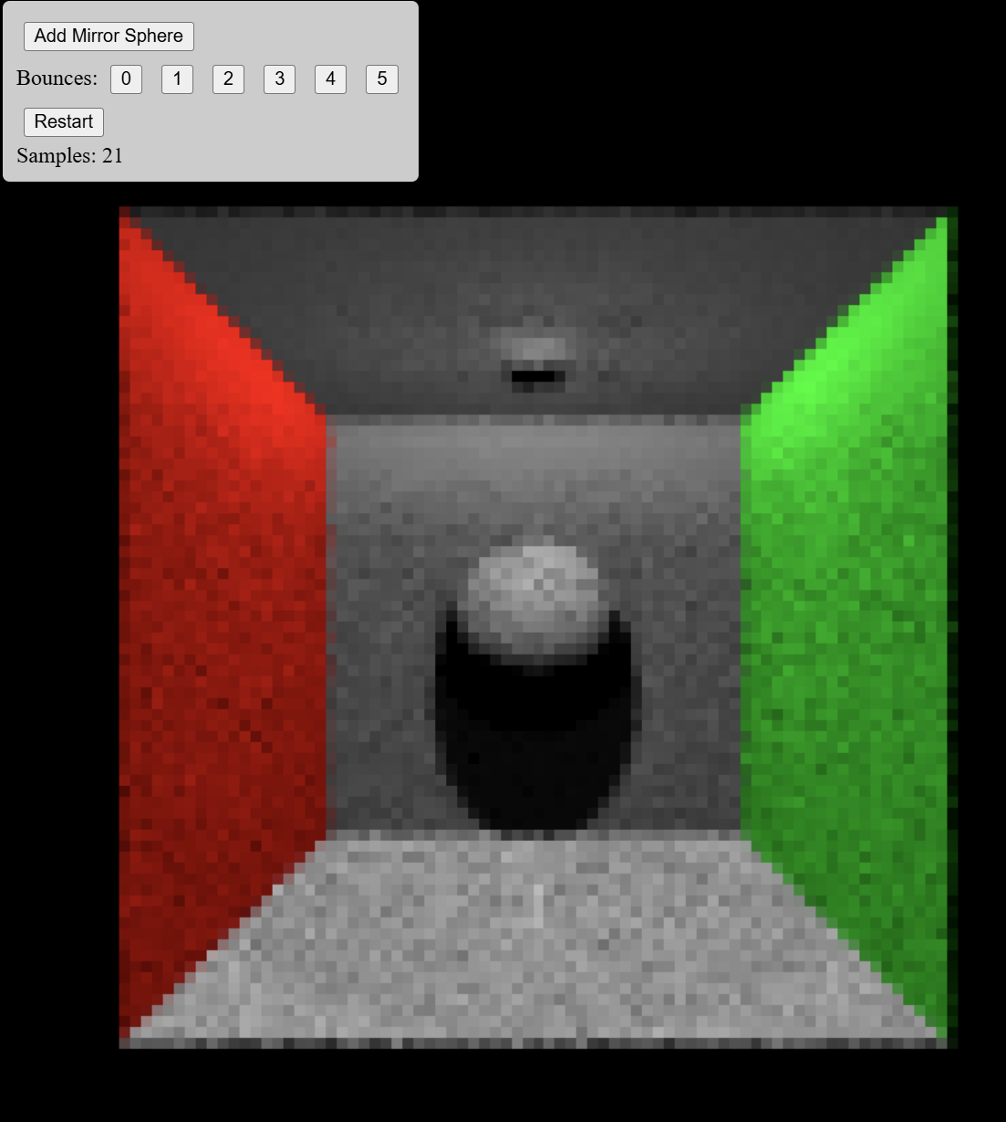

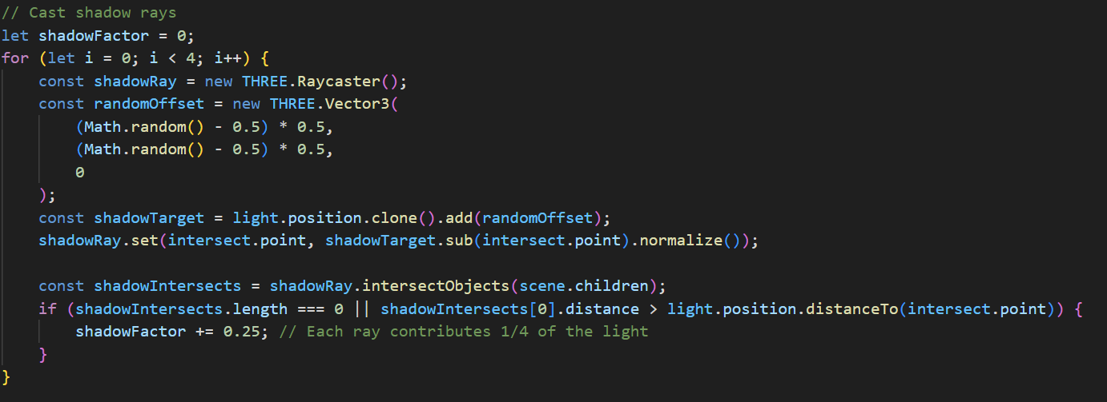

Shadow Mapping

For your standard graphics pipeline rendering way, [shadow mapping](http://en.wikipedia.org/wiki/Shadow_mapping) is currently quite a popular technique. We again want to know, if a fragment we are rendering, is in the shadow or not. Is there something between our fragment and the light source? This is same as asking, is that point visible from the light source or is it occluded by some other object?

We can find that out, if we render our scene from the light source. That will create the depth buffer as seen from there. After this we can check for each fragment, is the value inside the depth buffer less than the value our current point would have. This gives us an easy way to find occluded fragments, but it does have some problems.

First, we need to render from the light source using a camera, whose view volume corresponds with the volume that is illuminated by that light source. Generally that would need to include the entire view volume of our normal camera. Also, depending on the type of the light source, we would need to use different projections. For a directional light source, we can use an orthographic camera, because we want to know the nearest objects to the near plane.

As you can see from the image above, specifying too low far plane will result in some of the fragments (currently F3𝐹3) not being visible from the light source. This means that if we check for something behind them, we will not get a shadow cast from them.

Second problem is that we get a skewed resolution for the shadow map (the depth buffer rendered from the light source). Rendering normally from the light source, creates us a buffer that has resolutions of objects corresponding to the location of the light source. If we render from the normal camera, then we want more resolution for the objects closer to it and less for the objects further away. This resolution is not conveyed in the shadow map and thus we get aliasing around the edges of the shadows. Although, there are methods that try to improve this using [trapezoidal shadow maps](http://www.comp.nus.edu.sg/~tants/tsm.html).

Shadow mapping is currently popular, because newer versions of OpenGL support that in the hardware level. There are [specific samplers](https://www.opengl.org/wiki/Sampler_(GLSL)#Shadow_samplers) for sampling a depth texture and doing the comparison.

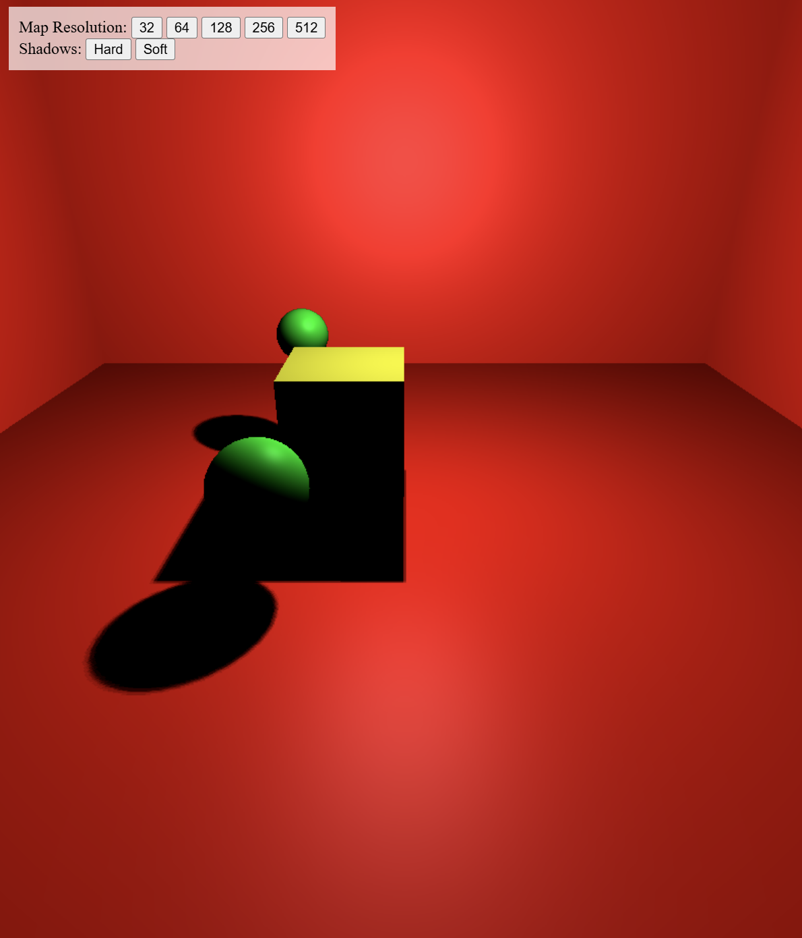

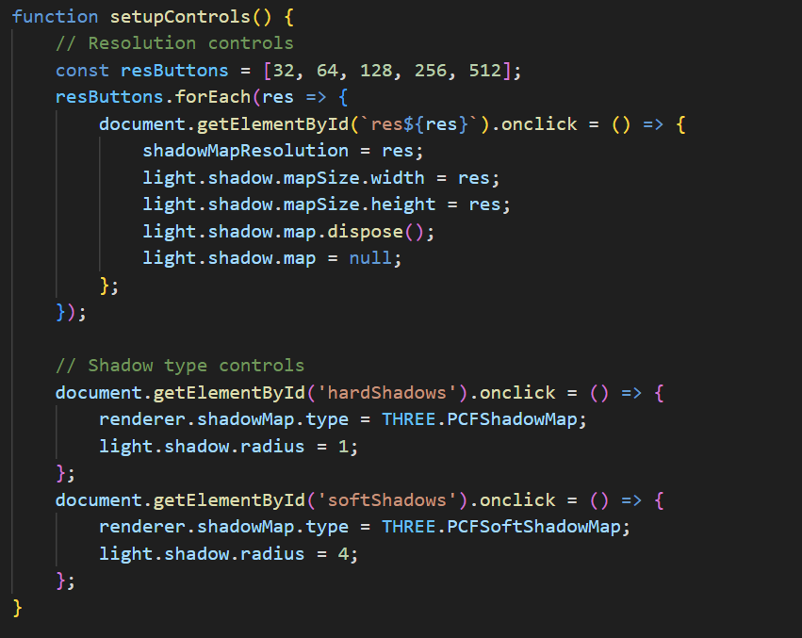

1. Lengyel, E. (2011). Mathematics for 3D Game Programming and Computer Graphics (3rd ed.). Cengage Learning.
2. Hughes, J. F., van Dam, A., McGuire, M., Sklar, D. F., Foley, J. D., Feiner, S. K., & Akeley, K. (2013). Computer Graphics: Principles and Practice (3rd ed.). Addison-Wesley.
3. Dunn, F., & Parberry, I. (2011). 3D Math Primer for Graphics and Game Development (2nd ed.). A K Peters/CRC Press.
4. Shirley, P., Ashikhmin, M., Marschner, S., et al. (2009). Fundamentals of Computer Graphics (3rd ed.). A K Peters/CRC Press.
5. <https://en.wikipedia.org>
6. <https://www.cl.cam.ac.uk/teaching/2000/AGraphHCI/SMEG/node3.html>
7. <https://pages.mtu.edu/~shene/COURSES/cs3621/NOTES/spline/Bezier/bezier-der.html>
8. https://www.thepolygoners.com/tutorials/GIIntro/GIIntro.htm